Parent Guide for Ashlawn School

A Parents’ Guide to Getting Started with “Edulink One”

There are two ways to use Edulink One: through a web browser like Google Chrome or through an app you can download to use on your mobile device. The Edulink One app is available for iOS and Android devices.

Web Browser Instructions
If you do not have a device suitable for the app, you can access the same great features online at edulinkone.com. This can also be found on the Ashlawn website at https://ashlawn.org.uk/parents/useful-links/ and click on Edulink One The school postcode is CV225ET
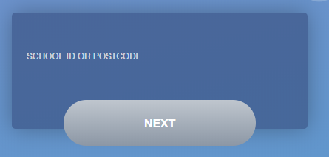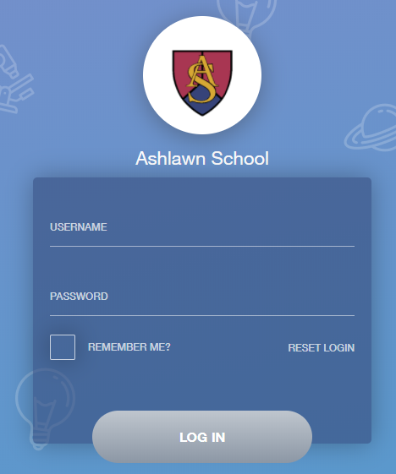
Your username and password which will have been sent out to you from the school.
Once you have filled in all three boxes with your login details, click LOG IN to get started.

Downloading and Using the App
The Edulink One app is available for iOS and Android devices. You can download from these links or search in the App or Play stores.
Apple App Store
https://itunes.apple.com/gb/app/edulink-one/id1188809029?mt=8&ign-mpt=uo%3D4
Android Google Play
https://play.google.com/store/apps/details?id=com.overnetdata.edulinkone&hl=en

If you are using the mobile app you will see the screen to the left.
The SCHOOL POSTCODE is CV225ET
Followed by your USERNAME & PASSWORD which will have been sent out to you from the school.
Once you have filled in all three boxes with your login details, click LOG IN to get started.
If you forget your username or password, please contact the school.

Main Screen

Once logged in you will see the main screen in Edulink One, where you will be able to navigate through the different sections of Edulink One to view a selection of information about your child/children.
Please see an example of the main screen. The various options may vary between schools.
If you have more than one student in school, it’s easy to switch between each one. Just select which would like to view in the top right-hand corner.

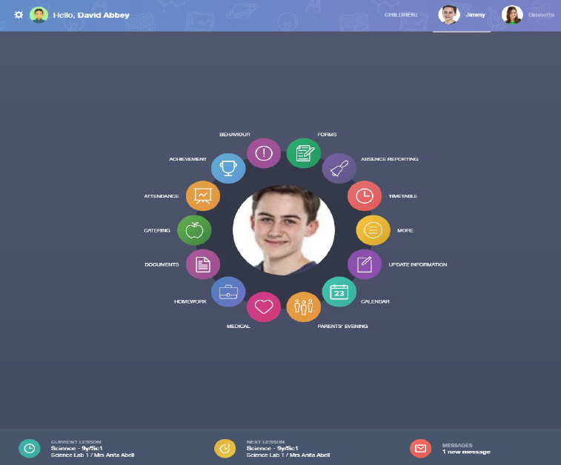
The messages button will let you know if you have any unread messages from the school.

This bar shows you what lesson your child is currently in, along with the next lesson in their timetable.

Behaviour
The behaviour button will give you access to view behaviour records, detentions and lesson behaviour, which have been assigned to your child. Information on detentions and graphs on lesson behaviour are also shown.

Behaviour Records Tab
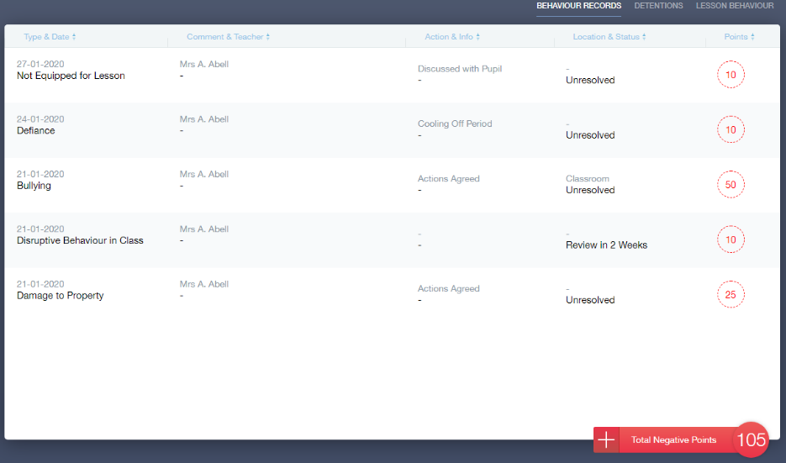
This tab will show you detailed information about any behaviour incidents which have been logged on Edulink One by staff. As the example below shows, each behaviour incident that has been recorded will show you on which day this has happened and various details about the incident.
Detentions Tab
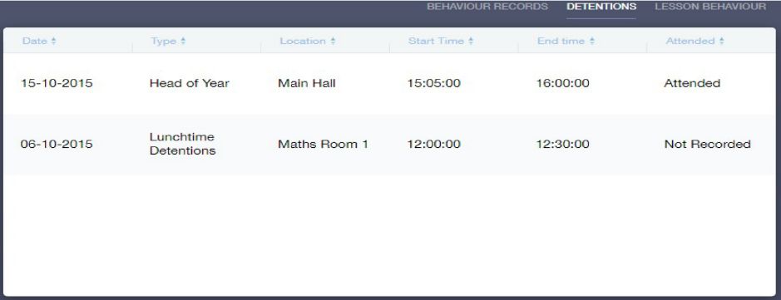
The detentions tab will show you any detentions which have been assigned to your child, including the date, start and finish times, the location and whether or not your child has attended.

Achievement
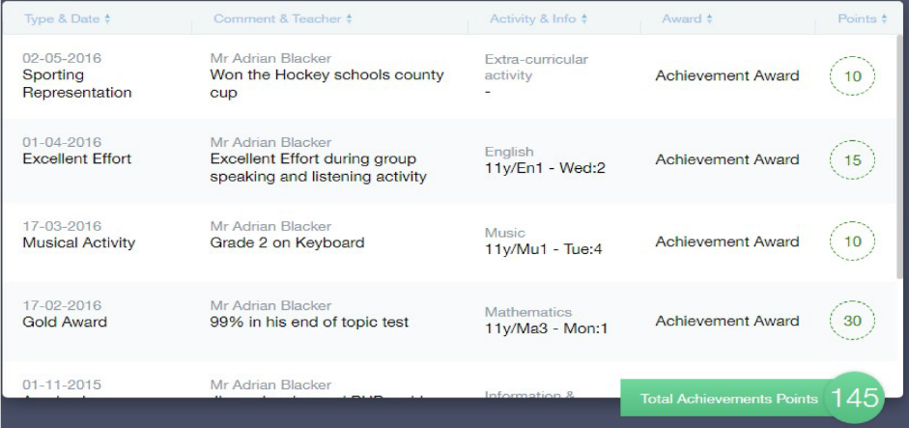
This section is where you can view information on positive achievements which have been awarded to your child. Very similar to the behaviour section, you are able to see who awarded the points and the reason for the award.
See the example below.

Documents
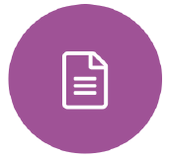
In this section you will find all the individual documents related to your child that have been shared by the school
Historical documents from previous years will be stored here and will be available for you to download in PDF format whenever you choose.

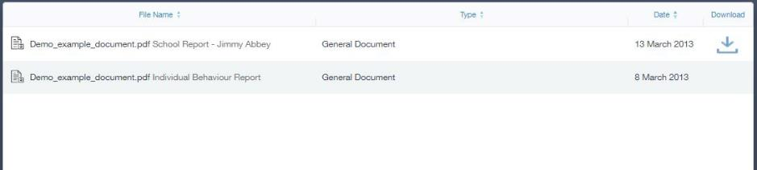

Medical Info
This section contains medical information which you have supplied to the school regarding your child. Details on medical conditions, medical notes, medical practices, and medical events such as appointments can all be viewed here. Allergy lists and other attachments are able to be downloaded in PDF format.

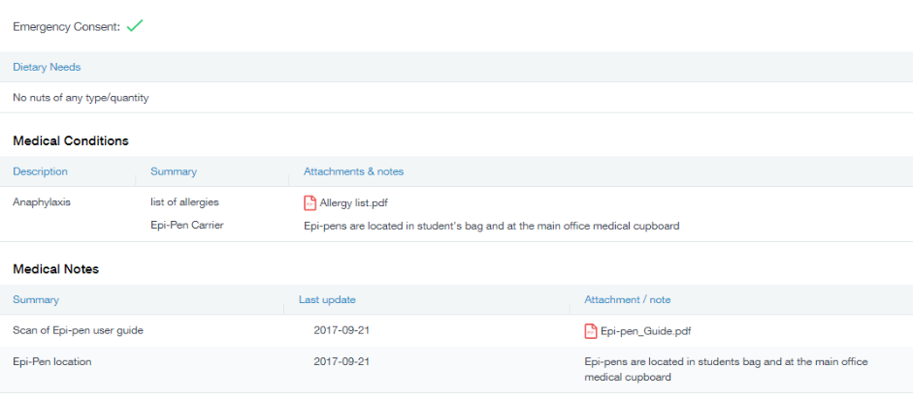

Update Information
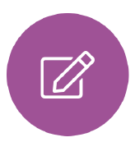
This section shows you the contact information that the school has on record for yourself and your children.
Here you can review the contact information the school holds for you, but you will also be able to update this with any changes that may occur to this information. When updated information is submitted through Edulink One, this will be picked up by the designated personnel in school in charge of updating records. It will be checked by them and approved.
This side allows you to select whose details you want to check / change.
This side allows you to read and edit the current contact information for the selected person.

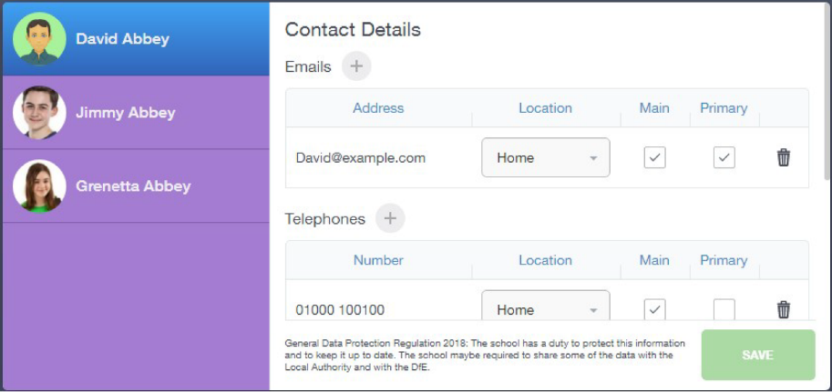
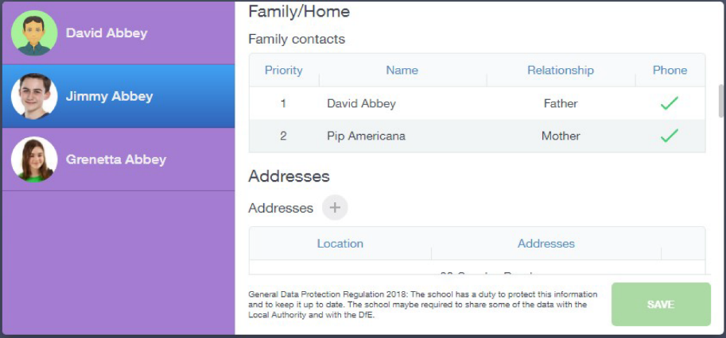

Absence Reporting
This feature allows you to send a direct message to the school’s student services to notify the school of your child’s absence or upcoming absence.
The example below shows how pick the time and date period for the absence request and the reason as to why the absence is occurring.

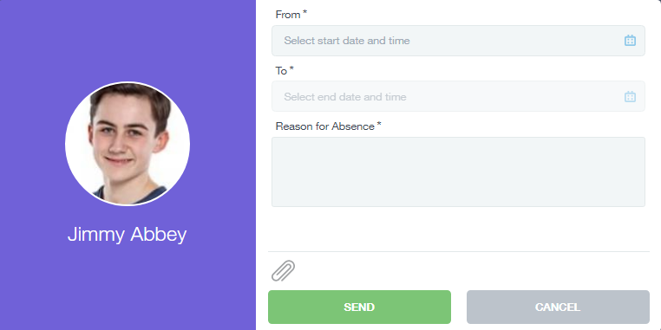

Links
This section contains links to resources for students to use.
There are also links specific for parents.

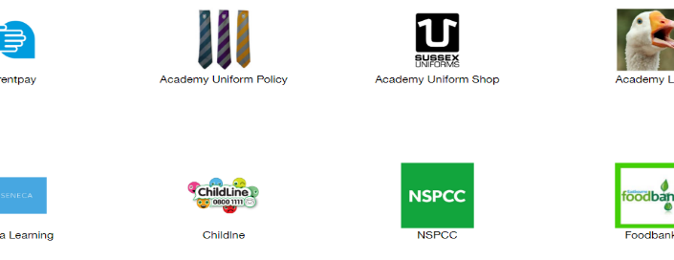

Exams
The exams section contains detailed information about upcoming external exams that your child will be sitting.
It includes times and dates along with the exam name and location. Your child also has access to this so they can keep track of upcoming exams themselves.

Exam Timetable
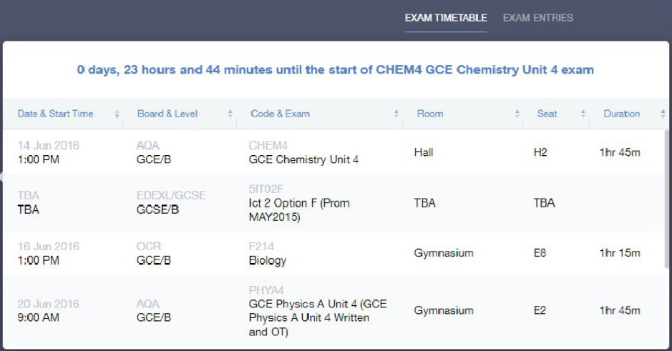

Exam Entries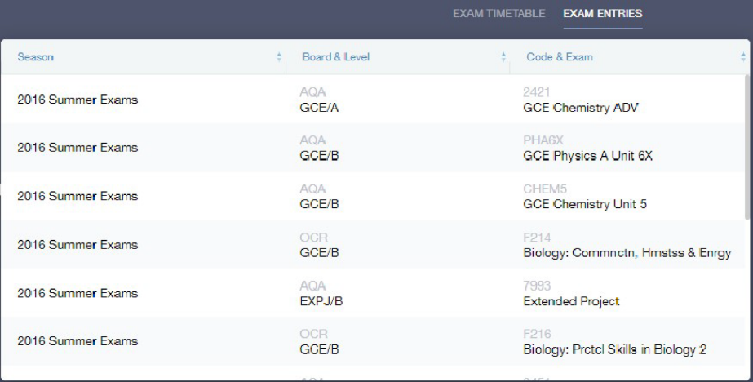

Timetable
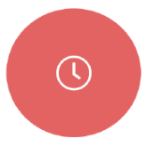
Parents and students both have access to this section, which allows you to view your child’s school timetable. This shows you information on what lessons your child has each day and who the teachers are for those lessons.
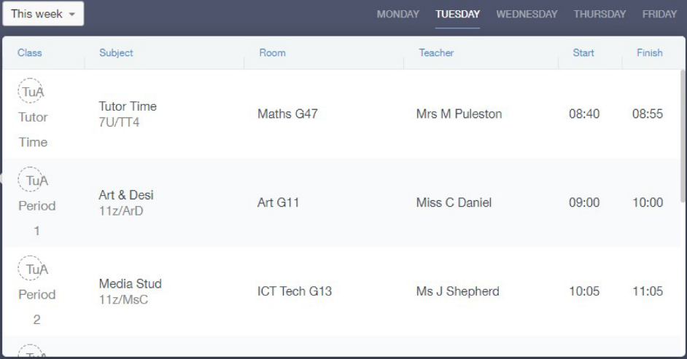

Account Info
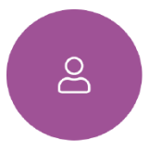
Here you can view the current address details we have on file for your child, other information on your child’s year group, house and tutor are also available.

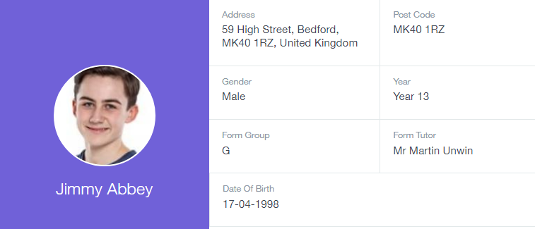

Messages
The message button can be found in the bottom right of the screen. Here you can read messages that have been sent through to you from staff at the school. You can reply back to messages here directly. You can also write and send messages to one or more teachers and your child’s tutor.

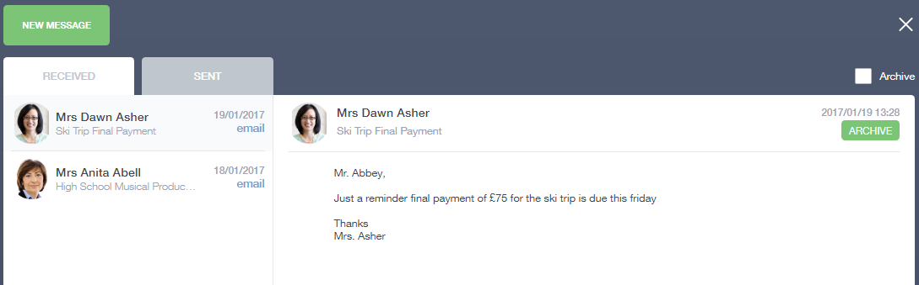
In the example below, the received tab is where any messages sent to you from the school will be. You have the option to read and reply from here. The sent box will store messages you’ve sent through previously.

Sending a new message
To begin sending a new message you will need to click the green new message button as shown in the picture above.
Next you will have to select your child/children.
Once selected click the next step button.
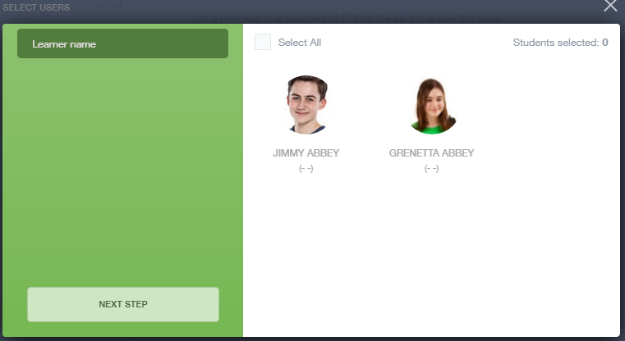

Next, chose the person to send your message to. As you can see in the example below it is broken down into teachers and form tutors.
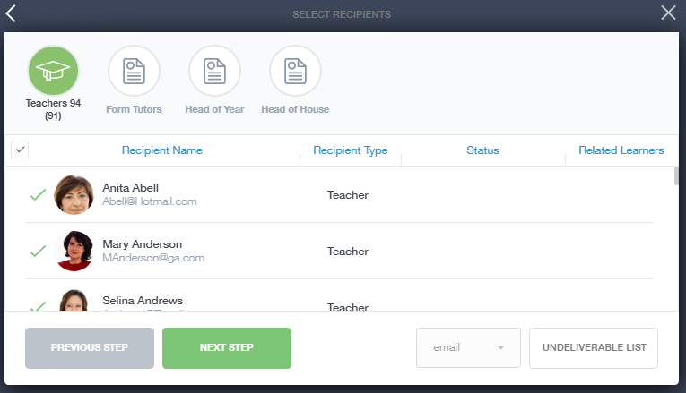
Depending on who you want to send to, you can pick from the relevant boxes. The default option is to pre-select all teachers. You can see this below as each teacher has a green tick beside. This means if you send a message now, it would go to all the selected teachers. To deselect specific teachers just click on the green tick or unselect all using the smaller black tick. Click next when done.
Deselect all
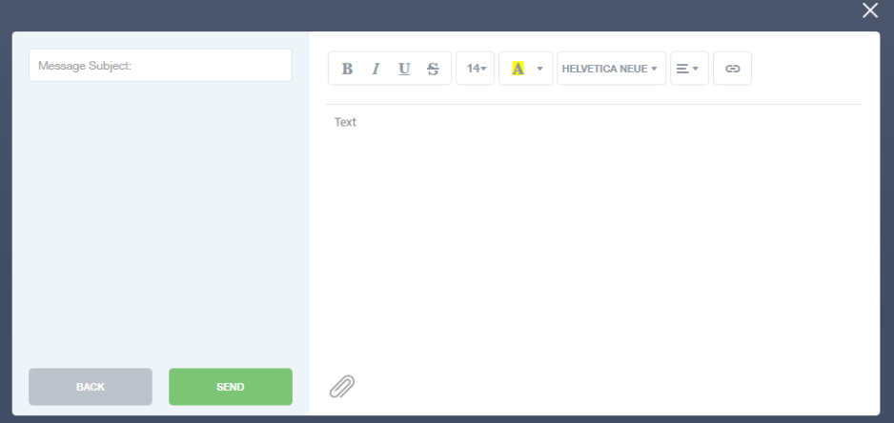
You will now see a message box – see below. Here is where you write your message and message subject. You can also click the paper clip to attach files if needed. Once completed, you can click the send button.

Homework
The homework section will operate as a standalone homework system where teachers will set homework through EduLink One. Students can see what homework has been set when it is due and they can also mark it as completed. There may be links to Google Classroom tasks.
The Student and Parent will see the homework in a list format this can be organised by clicking on the headings.
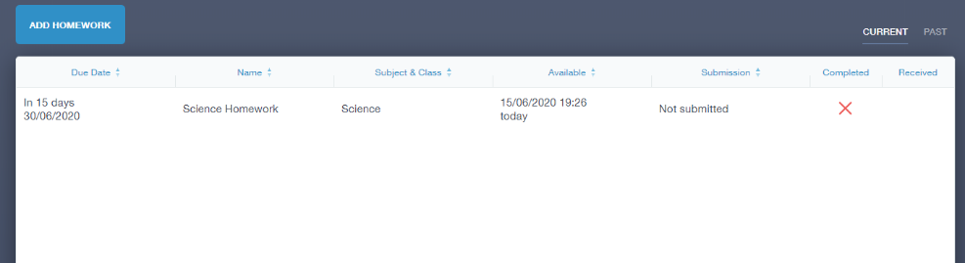
The Student can then click on the text of the homework to read the homework requirements. To exit this just click on the X in the top right corner.
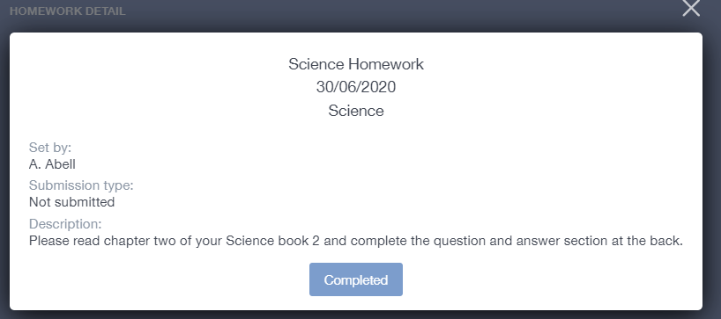
Once the student has completed the homework assignment they can click Completed.
Parents can only view set homework.
For work that is to be returned the Teacher may ask for the work to be emailed or sent to a Teams or Google classroom location or any shared drive solution the school may use. 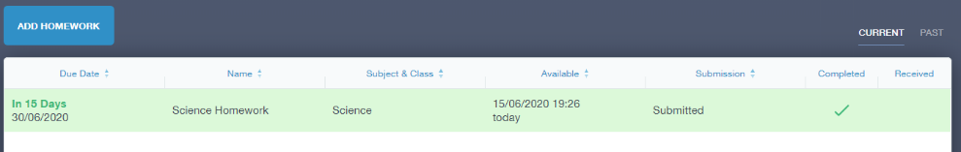
Once the student has click completed. They will need to wait for the teacher to review the work.
If the teacher has an issue with the homework, then they will contact the student and mark the work as received but not completed as per below.
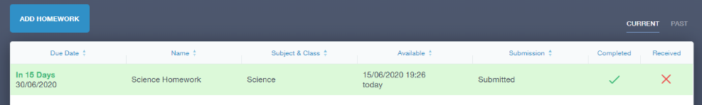
If the teacher is happy with the completed work, they will mark the work as completed and it will appear like so.
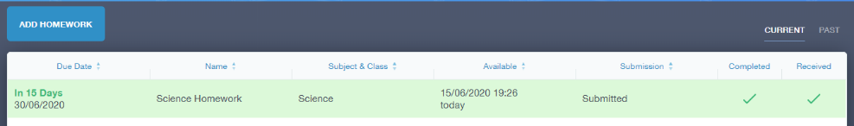

Please Note: Students can add their own homework using the Add Homework option this will not be reviewed by the teacher but can be used to help students create a study plan, self-assessments, etc.
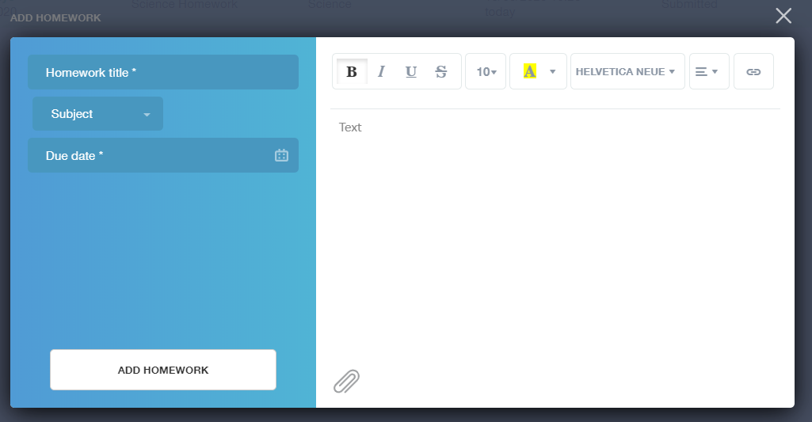
They would need to provide a title, subject and due date and some text of what this self-assessment is about. This could be used to show Teachers of extracurricular activities.
