
SPANISH A LEVEL SUMMER HOMEWORK
due 1st week back

- Grammar work (pages 2-6)

- Present tense:

LEARN THE PRESENT TENSE FROM THE VERBS BELOW:
- QUIZLET FOLDER TO PRACTICE THE VERBS IN THE PRESENT TENSE:

https://quizlet.com/theAlejandra_Sanchez/folders/present-tense-a-level?i=4gssjw&x=1xqt

- Past tense:

LEARN THE PAST TENSE FROM THE VERBS BELOW:
- QUIZLET FOLDER TO PRACTICE THE VERBS IN THE PAST TENSE:

https://quizlet.com/theAlejandra_Sanchez/folders/past-tense-a-level?i=4gssjw&x=1xqt

- Future tense (2 forms):

LEARN THE FUTURE TENSE FROM THE VERBS BELOW:
- QUIZLET FOLDER TO PRACTICE THE VERBS IN THE FUTURE TENSE:

https://quizlet.com/theAlejandra_Sanchez/folders/future-tense-a-level?i=4gssjw&x=1xqt

2) Write a paragraph in Spanish describing the boy’s routine using the pictures (page 7)

3) Watch / listen to authentic Hispanic material (pages 8-10)

Note:
Over the two years, we will be analysing the film “María llena eres de gracia” and the book “Rimas y leyendas” by Bécquer.
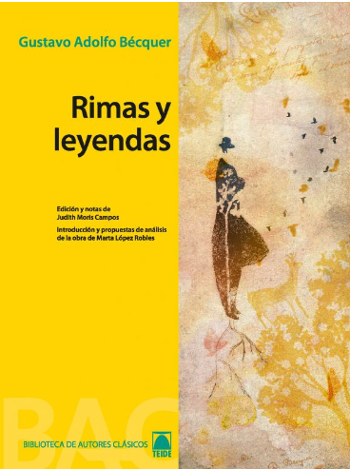


Regular and common irregular verbs – present tense
AR VERBS | AR VERBS | ER VERBS | ER VERBS | IR VERBS | IR VERBS
o | ending of “I” for AR verbs | o | ending of “I” for ER verbs | o | ending of “I” for IR verbs
as | ending of “you (sing.)” for AR verbs | es | ending of “you (sing.)” for ER verbs | es | ending of “you (sing.)” for IR verbs
a | ending of “he/she” for AR verbs | e | ending of “he/she” for ER verbs | e | ending of “he/she” for IR verbs
amos | ending of “we” for AR verbs | emos | ending of “we” for ER verbs | imos | ending of “we” for IR verbs
áis | ending of “you (plural)” for AR verbs | éis | ending of “you (plural)” for ER verbs | ís | ending of “you (plural)” for IR verbs
an | ending of “they” for AR verbs | en | ending of “they” for ER verbs | en | ending of “they” for IR verbs
Hablar | To speak | Comer | To eat | Vivir | To live
hablo | I speak | como | I eat | vivo | I live
hablas | you (sing.) speak | comes | you (sing.) eat | vives | you (sing.) live
habla | he speaks | come | he eats | vive | he lives
hablamos | we speak | comemos | we eat | vivimos | we live
habláis | you (plural) speak | coméis | you (plural) eat | vivís | you (plural) live
hablan | they speak | comen | they eat | viven | they live
Ser | To be | Estar | To be | Hacer | To do
soy | I am | estoy | I am | hago | I do
eres | You (sing.) are | estás | You (sing.) are | haces | You (sing.) do
es | He is | está | He is | hace | He does
somos | We are | estamos | We are | hacemos | We do
sois | You (plural) are | estáis | You (plural) are | hacéis | You (plural) do
son | They are | están | They are | hacen | They do
Ir | To go | Poder | To be able to | Querer | To want
voy | I go | puedo | I can | quiero | I want
vas | You (sing.) go | puedes | You (sing.) can | quieres | You (sing.) want
va | He goes | puede | He can | quiere | He wants
vamos | We go | podemos | We can | queremos | We want
vais | You (plural) go | podéis | You (plural) can | queréis | You (plural) want
van | They go | pueden | They can | quieren | They want
Tener | To have | Ver | To see | Venir | To come
tengo | I have | veo | I see | vengo | I come
tienes | You (sing.) have | ves | You (sing.) see | vienes | You (sing.) come
tiene | He has | ve | He sees | viene | He comes
tenemos | We have | vemos | We see | venimos | We come
tenéis | You (plural) have | veis | You (plural) see | venís | You (plural) come
tienen | They have | ven | They see | vienen | They come
Decir | To say / tell | Saber | To know | Pensar | To think
digo | I say / tell | sé | I know | pienso | I think
dices | You (sing.) say / tell | sabes | You (sing.) know | piensas | You (sing.) think
dice | He says / tells | sabe | He knows | piensa | He thinks
decimos | We say / tell | sabemos | We know | pensamos | We think
decís | You (plural) say / tell | sabéis | You (plural) know | pensáis | You (plural) think
dicen | They say / tell | saben | They know | piensan | They think
Dar | To give | Dormir | To sleep
doy | I give | duermo | I sleep
das | You (sing.) give | duermes | You (sing.) sleep
da | He gives | duerme | He sleeps
damos | We give | dormimos | We sleep
dais | You (plural) give | dormís | You (plural) sleep
dan | They give | duermen | They sleep

Regular and common irregular verbs – past tense
AR VERBS | AR VERBS | ER VERBS | ER VERBS | IR VERBS | IR VERBS
é | ending of “I” for AR verbs | í | ending of “I” for ER verbs | í | ending of “I” for IR verbs
aste | ending of “you (sing.)” for AR verbs | iste | ending of “you (sing.)” for ER verbs | iste | ending of “you (sing.)” for IR verbs
ó | ending of “he/she” for AR verbs | ió | ending of “he/she” for ER verbs | ió | ending of “he/she” for IR verbs
amos | ending of “we” for AR verbs | imos | ending of “we” for ER verbs | imos | ending of “we” for IR verbs
asteis | ending of “you (plural)” for AR verbs | isteis | ending of “you (plural)” for ER verbs | isteis | ending of “you (plural)” for IR verbs
aron | ending of “they” for AR verbs | ieron | ending of “they” for ER verbs | ieron | ending of “they” for IR verbs
Hablar | To speak | Comer | To eat | Vivir | To live
hablé | I spoke | comí | I ate | viví | I lived
hablaste | you (sing.) spoke | comiste | you (sing.) ate | viviste | you (sing.) lived
habló | he spoke | comió | he ate | vivió | he lived
hablamos | we spoke | comimos | we ate | vivimos | we lived
hablasteis | you (plural) spoke | comisteis | you (plural) ate | vivisteis | you (plural) lived
hablaron | they spoke | comieron | they ate | vivieron | they lived
Ser | To be | Estar | To be | Hacer | To do
fui | I was | estuve | I was | hice | I did
fuiste | You (sing.) were | estuviste | You (sing.) were | hiciste | You (sing.) did
fue | He was | estuvo | He was | hizo | He did
fuimos | We were | estuvimos | We were | hicimos | We did
fuisteis | You (plural) were | estuvisteis | You (plural) were | hicisteis | You (plural) did
fueron | They were | estuvieron | They were | hicieron | They did
Ir | To go | Poder | To be able to | Querer | To want
fui | I went | pude | I could | quise | I wanted
fuiste | You (sing.) went | pudiste | You (sing.) could | quisiste | You (sing.) wanted
fue | He went | pudo | He could | quiso | He wanted
fuimos | We went | pudimos | We could | quisimos | We wanted
fuisteis | You (plural) went | pudisteis | You (plural) could | quisisteis | You (plural) wanted
fueron | They went | pudieron | They could | quisieron | They wanted
Tener | To have | Ver | To see | Venir | To come
tuve | I had | vi | I saw | vine | I came
tuviste | You (sing.) had | viste | You (sing.) saw | viniste | You (sing.) came
tuvo | He had | vio | He saw | vino | He came
tuvimos | We had | vimos | We saw | vinimos | We came
tuvisteis | You (plural) had | visteis | You (plural) saw | vinisteis | You (plural) came
tuvieron | They had | vieron | They saw | vinieron | They came
Decir | To say / tell | Saber | To know | Pensar | To think
dije | I said / told | supe | I knew | pensé | I thought
dijiste | You (sing.) said / told | supiste | You (sing.) knew | pensaste | You (sing.) thought
dijo | He said / told | supo | He knew | pensó | He thought
dijimos | We said / told | supimos | We knew | pensamos | We thought
dijisteis | You (plural) said / told | supisteis | You (plural) knew | pensasteis | You (plural) thought
dijeron | They said / told | supieron | They knew | pensaron | They thought
Dar | To give | Dormir | To sleep
di | I gave | dormí | I slept
diste | You (sing.) gave | dormiste | You (sing.) slept
dio | He gave | durmió | He slept
dimos | We gave | dormimos | We slept
disteis | You (plural) gave | dormisteis | You (plural) slept
dieron | They gave | durmieron | They slept

THE FUTURE TENSE (going to)
- How is it formed? verb “to go” conjugated + a + infinitive

EG :
voy a jugar = I’m going to play
vamos a beber = we’re going to drink
va a escribir = he’s going to write

THE FUTURE TENSE (will)
- How is it formed? infinitive + endings for the future tense
- Endings?
“I” ⇾ inf. + -é “We” ⇾ inf. + -emos “You (sing.)” ⇾ inf. + -ás “You (plural)” ⇾ inf. + -éis “He/She/it” ⇾ inf. + -á “They” ⇾ inf. + -án
EG : jugaré = I will play beberemos = we will drink escribirá = he will write

- EXCEPTIONS!

HABER (THERE BE): | habrá | SALIR (TO GO OUT): | saldré
HACER (TO BE): | haré | VENIR (TO COME): | vendré
QUERER (TO WANT) | querré | SABER (TO KNOW): | sabré
DECIR (TO SAY/TELL): | diré | TENER (TO HAVE): | tendré
PODER (TO BE ABLE TO): | podré

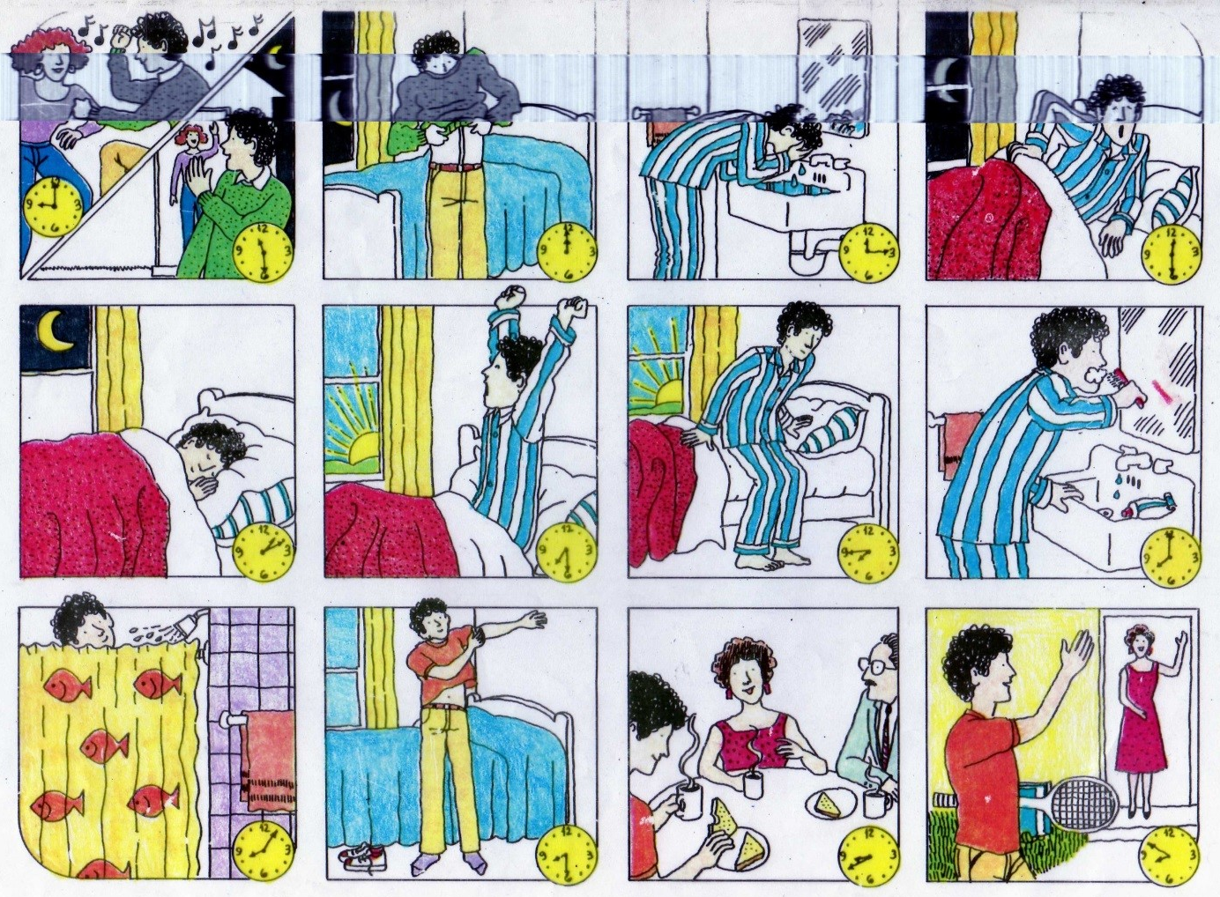

HISPANIC CULTURAL RESOURCES :

- What to read / listen ( online)
www.abc.es
www.elmundo.es
www.20minutos.es
www.larazon.es
www.elpais.com
www.hola.com
www.diezminutos.es
www.semana.es
http://www.rtve.es/
https://primerasnoticias.com/
https://www.rtve.es/television/cocina/
https://www.rtve.es/television/ciencia-y-futuro/
https://www.rtve.es/television/viajes-turismo/
https://www.rtve.es/temas/futbol/817/
https://www.rtve.es/play/colecciones/concursos/1459/

- Trendy Hispanic artists to listen to:

Rosalía / Quevedo / Aitana / Pablo Alborán / Rels B / Nathy Peluso / Abraham Mateo / Shakira / Ana Mena / Vicco / Melendi / Estopa / Malú / Camilo / Prince Royce / Romeo Santos

- The Best SPANISH Songs of All Time (top 100) https://www.youtube.com/playlist?list=PL5AB5121B1C573654

- Podcasts
- https://podcast.duolingo.com/spanish Many podcasts with explanations and context in English interspersed with Spanish segments with transcripts.
- https://radiolingua.com/coffeebreakspanish/ Pick a level and click on free podcasts.
- http://www.audiria.com/capitulos.php Short videos. Click to see the text.
- https://coffeebreaklanguages.com/category/coffee-break-spanish/ Podcasts. Varied topics.

- Spanish radio:

- https://emisora.org.es/los-40-principales/
- https://www.ondacero.es/directo/
- https://www.marca.com/radio.html
- https://cadenaser.com/
- https://www.europafm.com/directo/
- https://play.radiole.com/

- What to watch:

Netflix

- The Snow girl
- Society of the snow
- The girl in the mirror
- God’s crooked lines
- The occupant
- The chalk line
- Love, divided
- Cable girls
- The Asunta Case
- Innocent
- Olympo
- Welcome to Eden
- Between Lands
- The Gardener
- Raising Voices
- Billionaire’s Bunker

Amazon prime

- Women on the verge of a nervous breakdown
- All about my mother
- Food and shelter
- Grey eyes
- Ma Ma
- The Queen of Spain

Some useful web pages:
http://www.ver-taal.com/
https://www.dw.com/es/actualidad/s-30684
https://www.todo-claro.com/e_index.php
https://holaquepasa.com/spanish-grammar/
www.wordreference.com
www.rae.es
https://www.bbc.co.uk/bitesize/subjects/z4dqxnb
https://oye.languageskills.co.uk/year/10-and-11
https://www.thestudentroom.co.uk/gcse/subjects/spanish/
https://www.languagesonline.org.uk/Hotpotatoes/spanishindex.html
https://quizlet.com/
https://neiljones.org/
https://www.lightbulblanguages.co.uk/resources-spanish.htm
https://conjuguemos.com/activities/spanish/verb/1

