Kendal at Home Brain Health Guide

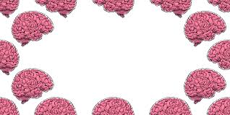

This work is designed to give you an ideal grounding for you’re a level psychology course.

Complete the tasks in the booklet to prepare to begin your course. This will look at the key topics you will cover over the first year of psychology.

Good luck and enjoy

Miss Robinson and Miss Webster

Any questions: [robinsonl@ashlawn.tlet.org.uk](mailto:robinsonl@ashlawn.tlet.org.uk)

The AQA course

Year 1 will consist of paper 1 and paper 2 topics.

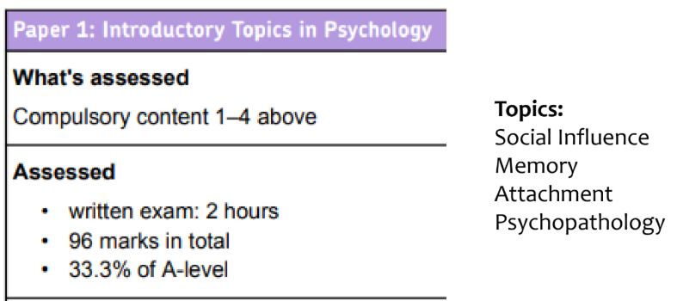

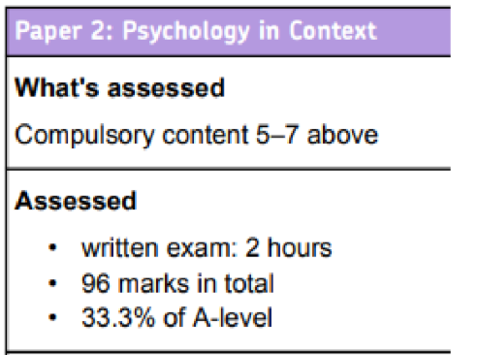

Year 2 will consist of:

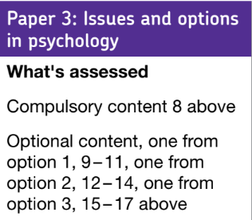

You can access the online textbook at: [www.illuminate.digital/aqapsych1](http://www.illuminate.digital/aqapsych1)

Username: SASHLAWNCV22

Password: STUDENT

Task 1: Social influence

This task will get you researching studies independently and summarising them. 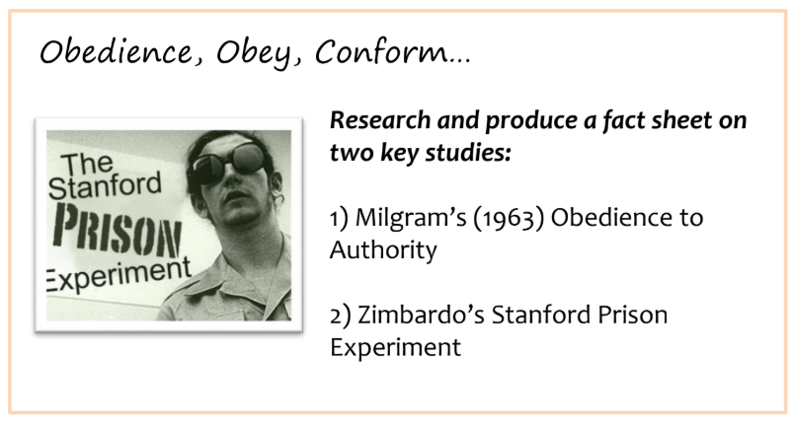

Zimbardo’s research is no longer taught at A level as he was recently removed from the specification. However, it is still an influential and important piece of research in psychology.

Taking it further………………

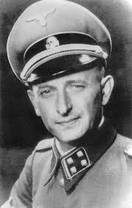

Explain how obedience research could explain why German people followed orders in Nazi Germany.

Watch Zimbardo discussing the psychology of evil

Task 2: Memory

This task will help you to become more familiar with models of memory. 



Taking it further………………………

How could psychologists use research on memory to provide advice to:

* Police working with eye witnesses
* Teachers planning revision activities
* Actors learning lines for a play

Task 3: Debates in psychology

This task will help you become more familiar with critical thinking skills and being able to provide a balanced argument.

Most people assume psychology is an easy or ‘soft’ subject which is not a science. It is often considered a soft science or a social science whereas subjects such as physics, chemistry and biology are referred to as hard sciences.

It is your job to come to a conclusion as to whether or not Psychology IS a hard science.

Research arguments for and against psychology as a science to produce a debate on this.

Consider:

1. The subject content
2. Research methods used

| FOR Psychology as a science | AGAINST Psychology as a science |
| --- | --- |
|  |  |

Task 4: Approaches

Research the approaches in psychology. Create a timeline or roadmap of when these approaches were first developed, the key researchers and what they believe influences human behaviour.



Extension: Book review 

Choose a book that has a psychological element to it and write a review. The book could be either fiction or non-fiction.

There are a list of fiction and non-fiction suggestions below but feel free to choose your own!

| Fiction | Non-fiction |
| --- | --- |
| One flew over the cuckoo’s nest – Ken Kesey  We need to talk about Kevin – Lionel Shriver  Val McDermid’s Carol Jordon and Tony Hill series  The silent patient – Alex Michaelides  Eleanor Oliphant is completely fine – Gail Honeyman  Before I go to sleep – S J Watson  The midnight library – Matt Haig | The man who mistook his wife for a hat – Oliver Sacks  Psycho-logical – Dean Burnett  Picking up the pieces – Paul Britton  Hidden Valley Road – Robert Kolker  The anxious generation – Jonathan Haidt  The skeleton cupboard – Tanya Byron  The Jigsaw man – Paul Britton |