
Exam board: OCR
Physics
A level
Transition booklet
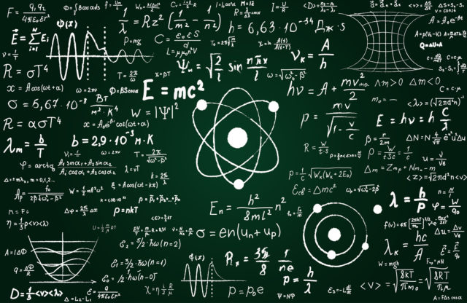

Site | Ashlawn | Houlton
Teaching team | Mrs S Murphy  murphys@ashlawn.tlet.org.uk  Mr I hardiman  hardimani@ashlawn.tlet.org.uk  Mr A Hutchinson  hutchinsona@ashlawn.tlet.org.uk  Mr J Keller  kellerj@ashlawn.tlet.org.uk | Mr K Docherty  dochertyk@houlton.tlet.org.uk  Dr J Towey  toweyj@houlton.tlet.org.uk

Deadline for submission of transition work: Friday 12th september
(Assessment will follow submission)
This booklet will assist you in getting better prepared to study A Level Physics at Ashlawn school. You must work through the booklet and self assess to identify the topics/areas for improvement. Write a brief comment on your progress in the comments box as you complete each topic.This help will inform you with what you must revise prior to beginning the AS Physics course. Bring your copy of the completed booklet to your first A Level Physics lesson along with your prepared presentation.

The A Level course
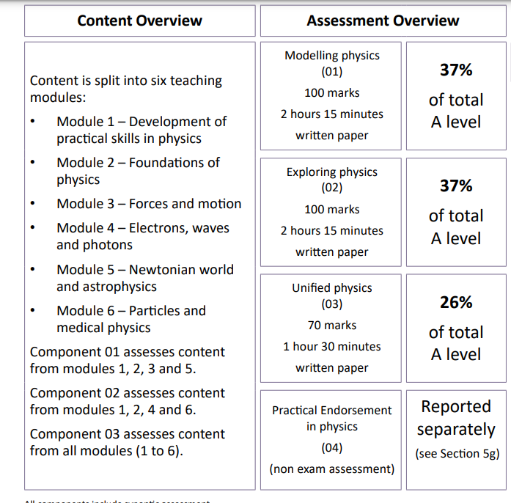
You can find the full specification by following this link
https://www.ocr.org.uk/Images/171726-specification-accredited-a-level-gce-physics-a-h556.pdf

What you need to be successful in A level physics

Skills:


- strong mathematical skills, particularly in algebra, calculus, and trigonometry
- problem-solving abilities
- capacity to apply theoretical concepts to practical scenarios
- Graphical skills
- effective revision techniques
- Communication skills
- Resilience
- Time management
- Teamwork skills

Equipment:
(if you struggle with acquiring these please email Miss Kennedy)

- Calculator
- Mathematical set
- Formula booklet

https://www.ocr.org.uk/Images/363796-units-h156-and-h556-data-formulae-and-relationships-booklet.pdf
(please print this off and have it on hand all the time)
- Suitable folder
- Book (this will be provided by the teacher)

Read, watch, listen and visit
For your A level we would like you to explore physics further over the summer. Here are a few ways you can do that (not all can be achieved but theres a few places you can visit and do some research on)
Unit | Read | Watch | Listen | Visit
Motion and vectors | https://www.forbes.com/sites/startswithabang/2020/05/05/this-is-how-physics-not-math-finally-resolves-zenos-famous-paradox/ | F1: drive to survive  https://www.channel4.com/programmes/speed-with-guy-martin/on-demand/58642-003 |  | Silverstone (F1)  motor museum
Newtons laws and forces |  | Theory of everything  8.01x - Lect 7 - Weight, Weightlessness in Free Fall, Weight in Orbit | newtons laws PODCAST | Newtons tree: woolsthorpe manor
Moments and pressure |  | 8.01x - Lect 27 - Fluid Mechanics, Hydrostatics, Pascal's Principle, Atmosph. Pressure |  | Cromford mill
Materials | Viscosity: what is it?
Space | https://space.mit.edu/home/tegmark/PDF/multiverse_sciam.pdf | The planets by Brian cox | https://www.preposterousuniverse.com/podcast/2018/07/10/episode-2-carlo-rovelli-on-quantum-mechanics-spacetime-and-reality/ | Kennedy space centre  national space center  https://www.ligo.caltech.edu/page/what-are-gw
Electricity |  | Shock and Awe: The Story of Electricity -- Jim Al-Khalili BBC Horizon |  | Cern (switzerland) - particle accelerator
Waves |  |  |  | The Eagle: watson and crick announced discovery of DNA using X - rays  Aurora borealis (Iceland)
Quantum |  | Parallel Worlds, Parallel Lives - Part I  Parallel Worlds, Parallel Lives - Part II | Podcast:quantum physics
Medical | medical updates 2023

Year 12 induction summer homework

Task 1:
Your task is to plan and prepare a 5 minute presentation on Electricity. An accompanying powerpoint/google slide is necessary.

Electricity
Must include the following information:
- What is potential difference?
- What is current?
- What is resistance?
- How are these concepts related?
- How do these concepts behave in series and parallel circuits?
- Are there any models/analogies which can be used to highlight your point.

The presentation should be pitched at the level of an A Level student and should therefore be as detailed and accurate as possible. You may also wish to include any information which you feel is relevant but not mentioned above.

The aim of this homework is so that your future teacher can identify misconceptions early and to ensure that students have a firm understanding of a key concept before starting the course.

A selection of presentations will be made to the class in the first week of term.

If you have any questions about this homework, please email kennedys@ashlawn.tlet.org.uk

Task 2: complete the following topics in the booklet

Topic | Title | Completed  (date) | Comments.  Do you need more practice?  Are you confident with this area?  What areas of weakness have you identified?
1 | Prefixes and units
2 | Significant Figures
3 | Rearranging Equations

- Prefixes
In Physics we have to deal with quantities from the very large to the very small. A prefix is something that goes in front of a unit and acts as a multiplier. This sheet will give you practice at converting figures between prefixes.

Symbol | Name | What it means |  | How to convert
P | peta | 10¹⁵ | 1000000000000000 |  | ↓ x1000
T | tera | 10¹² | 1000000000000 | ↑ ÷ 1000 | ↓ x1000
G | giga | 10⁹ | 1000000000 | ↑ ÷ 1000 | ↓ x1000
M | mega | 10⁶ | 1000000 | ↑ ÷ 1000 | ↓ x1000
k | kilo | 10³ | 1000 | ↑ ÷ 1000 | ↓ x1000
 |  |  | 1 | ↑ ÷ 1000 | ↓ x1000
m | milli | 10⁻³ | 0.001 | ↑ ÷ 1000 | ↓ x1000
μ | micro | 10⁻⁶ | 0.000001 | ↑ ÷ 1000 | ↓ x1000
n | nano | 10⁻⁹ | 0.000000001 | ↑ ÷ 1000 | ↓ x1000
p | pico | 10⁻¹² | 0.000000000001 | ↑ ÷ 1000 | ↓ x1000
f | femto | 10⁻¹⁵ | 0.000000000000001 | ↑ ÷ 1000
Convert the figures into the prefixes required.
s | ms | μs | ns | ps
0.00045 | 0.45 | 450 | 450 000  or 450 x10³ | 450 x 10⁶
0.000000789
0.000 000 000 64

mm | m | km | µm | Mm
1287360
295

- Significant figures
1. All non-zero numbers ARE significant. The number 33.2 has THREE significant figures because all of the digits present are non-zero.
2. Zeros between two non-zero digits ARE significant. 2051 has FOUR significant figures. The zero is between 2 and 5
3. Leading zeros are NOT significant. They're nothing more than "place holders." The number 0.54 has only TWO significant figures. 0.0032 also has TWO significant figures. All of the zeros are leading.
4. Trailing zeros when a decimal is shown ARE significant. There are FOUR significant figures in 92.00 and there are FOUR significant figures in 230.0.
5. Trailing zeros in a whole number with no decimal shown are NOT significant. Writing just "540" indicates that the zero is NOT significant, and there are only TWO significant figures in this value.
(THIS CAN CAUSE PROBLEMS!!! WE SHOULD USE POINT 8 FOR CLARITY, BUT OFTEN DON’T - 2/3 significant figures is accepted in IAL final answers - eg 500/260 = 1.9 to 2 sf. Better 5.0 x 10² / 2.6 x 10² = 1.9)
8. For a number in scientific notation: N x 10^{x}, all digits comprising N ARE significant by the first 5 rules; "10" and "x" are NOT significant. 5.02 x 10⁴ has THREE significant figures.
For each value state how many significant figures it is stated to.
Value | Sig Figs | Value | Sig Figs | Value | Sig Figs | Value | Sig Figs
2 |  | 1066 |  | 1800.45 |  | 0.070
2.0 |  | 82.42 |  | 2.483 x 10⁴ |  | 69324.8
500 |  | 750000 |  | 0.0006 |  | 0.0063
0.136 |  | 310 |  | 5906.4291 |  | 9.81 x 10⁴
0.0300 |  | 3.10 x 10⁴ |  | 200000 |  | 40000.00
54.1 |  | 3.1 x 10² |  | 12.711 |  | 0.0004 x 10⁴

When adding or subtracting numbers
Round the final answer to the least precise number of decimal places in the original values.
Eg. 0.88 + 10.2 – 5.776 (= 5.304) = 5.3 (to 1d.p. , since 10.2 only contains 1 decimal place)
(Khan Academy- Addition/ subtraction with sig fig excellent video- make sure you watch .)
Add the values below then write the answer to the appropriate number of significant figures

Value 1 | Value 2 | Value 3 | Total Value | Total to correct sig figs
51.4 | 1.67 | 3.23
7146 | –32.54 | 12.8
20.8 | 18.72 | 0.851
1.4693 | 10.18 | –1.062
9.07 | 0.56 | 3.14
739762 | 26017 | 2.058
8.15 | 0.002 | 106
152 | 0.8 | 0.55

When multiplying or dividing numbers
Round the final answer to the least number of significant figures found in the initial values.
E.g. 4.02 x 3.1 ⎟ 0.114 = (109.315…) = 110 (to 2s.f. as 3.1 only has 2 significant figures.
Multiply the values below then write the answer to the appropriate number of significant figures
Value 1 | Value 2 | Total Value | Total to correct sig figs
0.91 | 1.23
8.764 | 7.63
2.6 | 31.7
937 | 40.01
0.722 | 634.23

Divide value 1 by value 2 then write the answer to the appropriate number of significant figures
Value 1 | Value 2 | Total Value | Total to correct sig figs
5.3 | 748
3781 | 6.50
91 x 10² | 180
5.56 | 22 x 10⁻³

When calculating a mean

- Remove any obvious anomalies (circle these in the table)
- Calculate the mean with the remaining values, and record this to the least number of decimal places in the included values
E.g. Average 8.0, 10.00 and 145.60:
1) Remove 145.60
2) The average of 8.0 and 10.00 is 9.0 (to 1 d.p.)

Calculate the mean of the values below then write the answer to the appropriate number of significant figures
Value 1 | Value 2 | Value 3 | Mean Value | Mean to correct sig figs
1 | 1 | 2
435 | 299 | 437
5.00 | 6.0 | 29.50
5.038 | 4.925 | 4.900
720.00 | 728.0 | 725
0.00040 | 0.00039 | 0.000380
31 | 30.314 | 29.7

- Rearranging equation
Rearrange each equation into the subject shown in the middle column.
Equation |  | Rearrange Equation
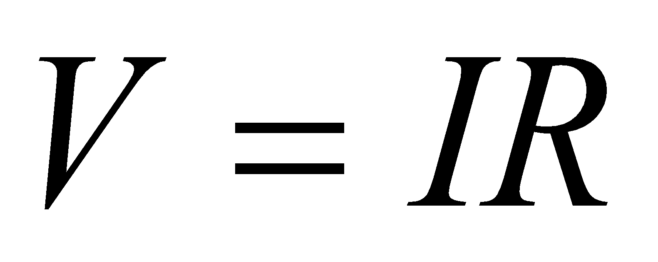 | R
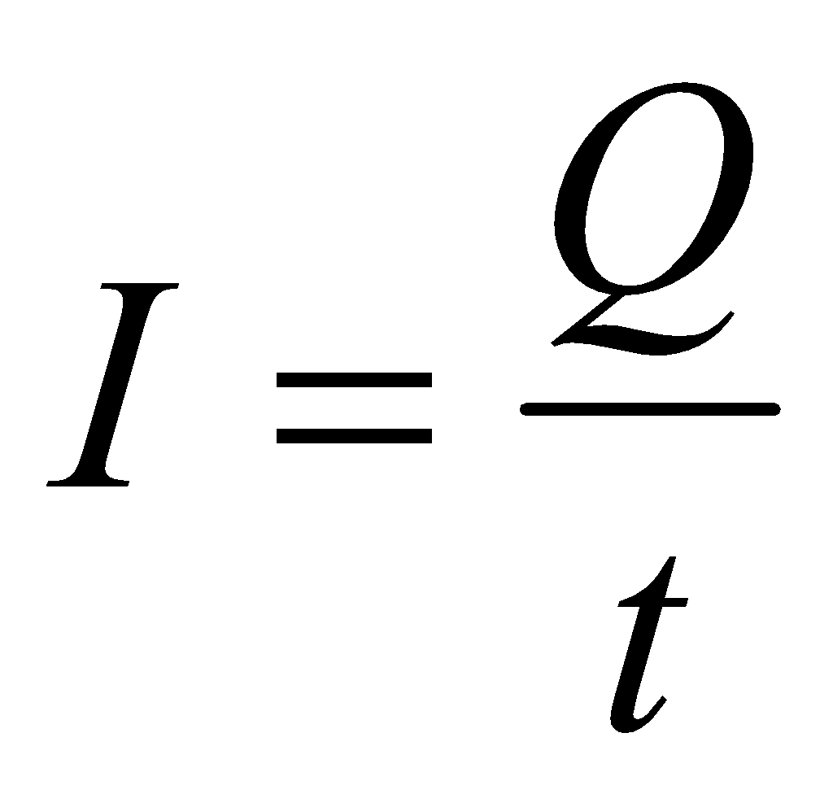 | t
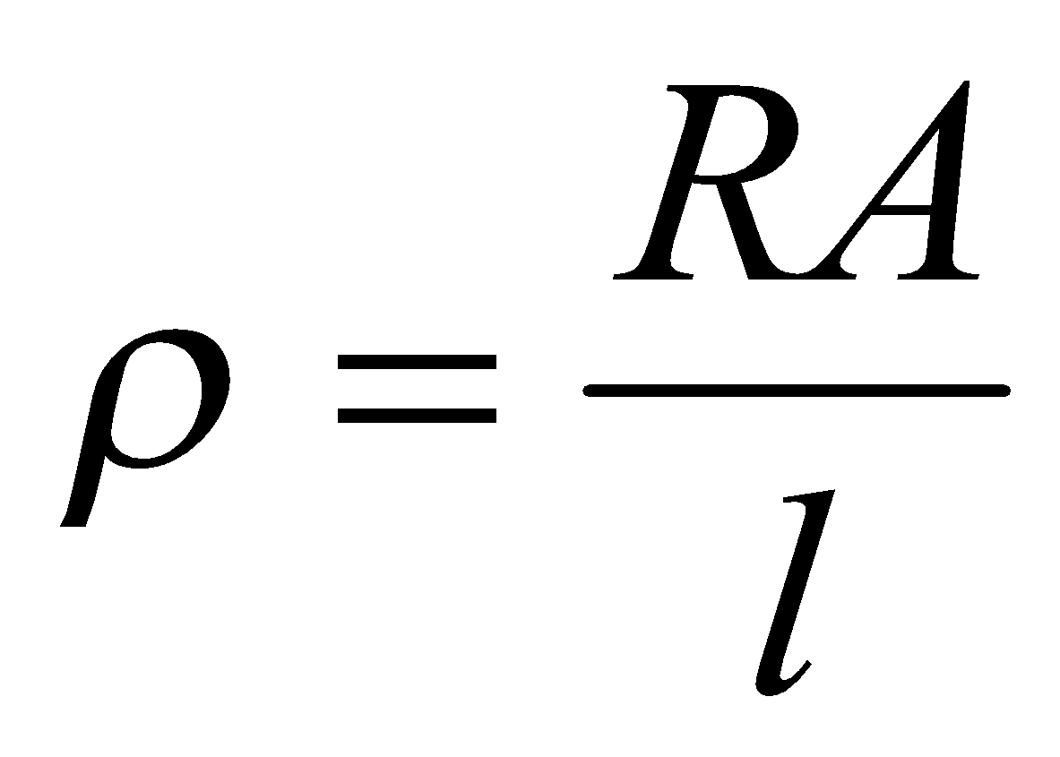 | A
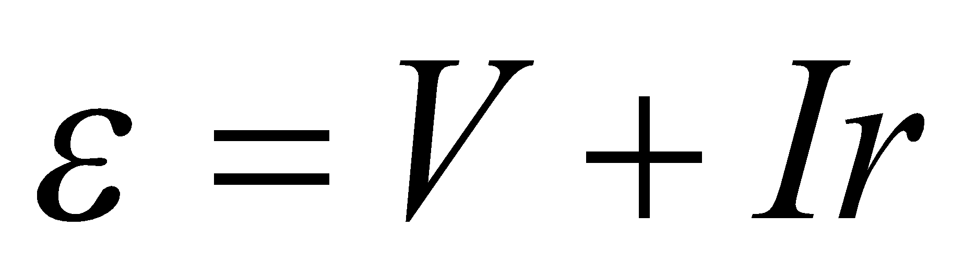 | r
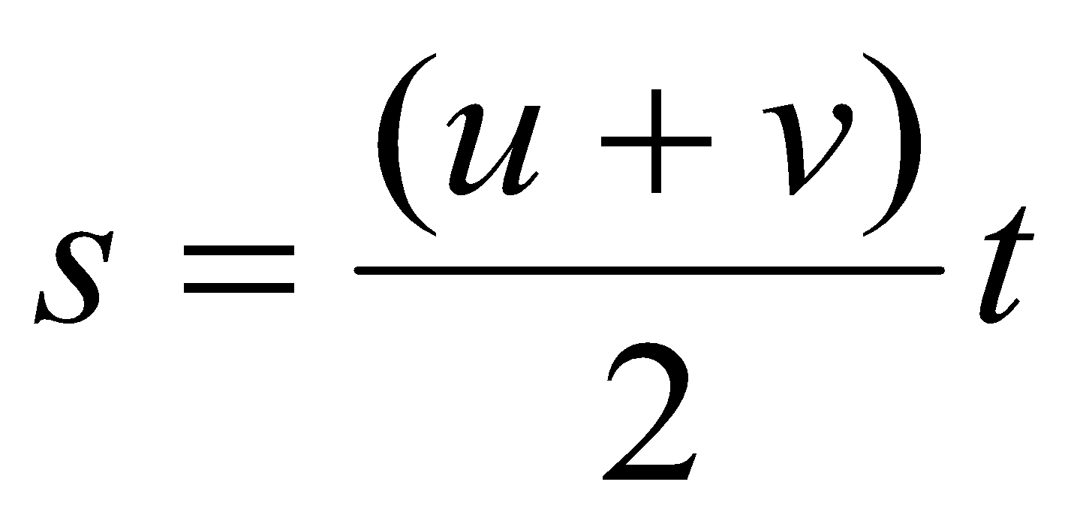 | u
 | g
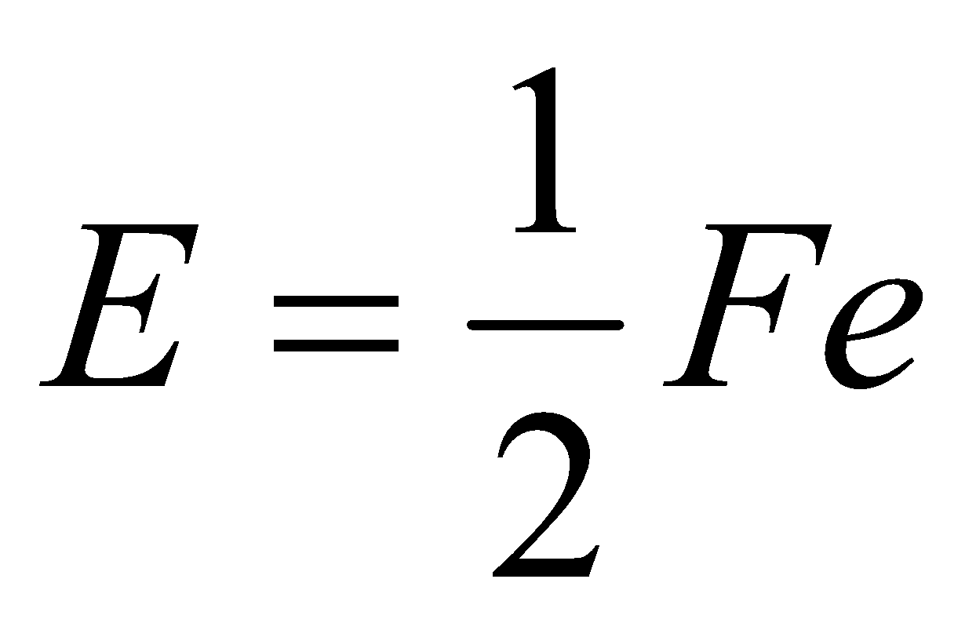 | F
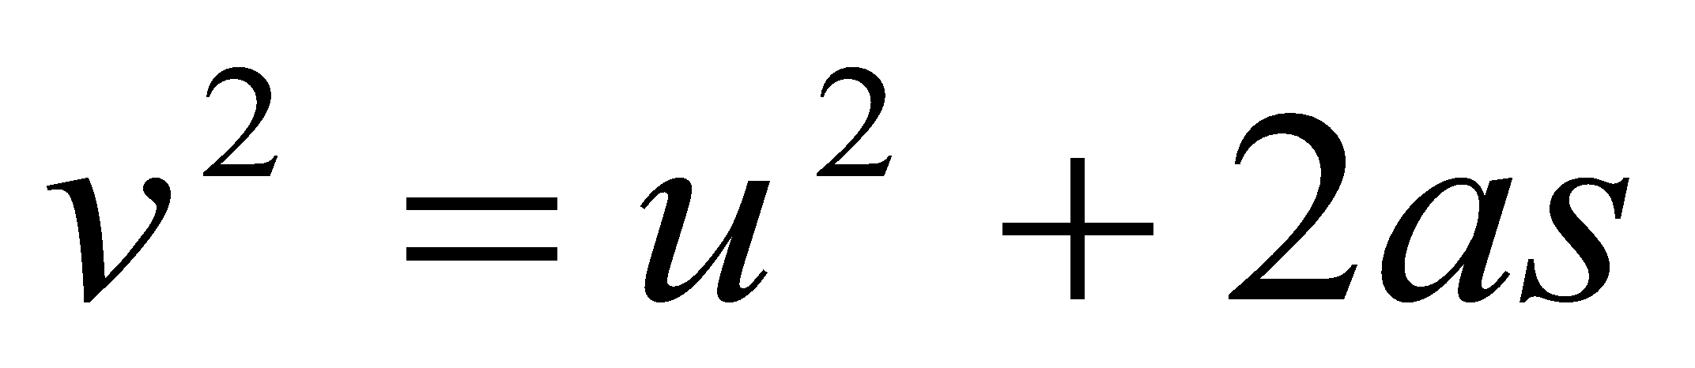 | u
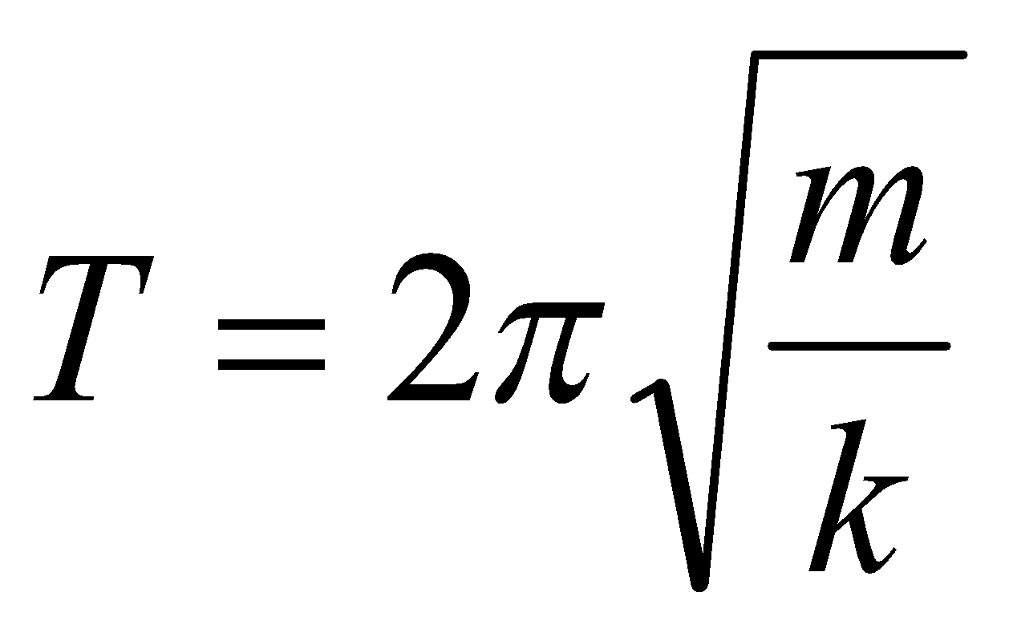 | m

