Ashlawn School



A level

Physical Education

Transition Pack

Hi there,

We are delighted that you are thinking of studying A level Physical Education in September. The step up from GCSE work to A level can be tough and many students must adjust to the increased demands of workload, independence and responsibility. At the same time, students get the opportunity to study the subjects that they have been most interested in or are now shaping their pathway into University or apprenticeships. In order to give yourself the best start in Autumn with your new course, we suggest that you complete the following preparation tasks to the best of your ability.

Before you start the preparation tasks . . . perhaps you might like to know a bit about A level PE at Ashlawn:

**The Course**

At our Sixth Form we follow the OCR course. The course is suited to students who have a genuine interest in sporting excellence and the science behind it. The two-year course covers 7 theoretical units per year and 1 personal sporting performance. Units include Anatomy and Physiology, Exercise Physiology, Biomechanics, Sports Psychology, and Skill Acquisition.

The course is 70% theory and 30% practical over the two years. The course is demanding both practically and theoretically therefore **students must** be competitively taking part in a sport/activity outside of sixth form.

**Non examined assessment. (Your practical assessment and coursework)**

The non-examined assessment makes up 30% of the course. Students will need to be assessed in one practical sport and will be required to collect video evidence during the two-year course.

Here is a link to the specification for the non-examined assessment, should you wish to look into this further: [OCR AS and A Level Physical Education NEA Guide](https://www.ocr.org.uk/Images/234840-as-and-a-level-guide-to-non-exam-assessment.pdf)

**Recommended pre reading or documentaries to watch**

This is not essential before you start the course but the greater your understanding of different sports and concepts, the more likely you are to be successful.

**Text books (we have these in school but it’s always helpful to have your own)**

<https://www.hachettelearning.com/sport-and-pe/ocr-a-level-pe-year-1-and-year-2>

**Exam tips**

<https://theeverlearner.com/blog/en/the-changing-rooms/how-to-make-your-ocr-pe-exams-a-breeze>

**Key terms**

<https://www.ocr.org.uk/Images/http-stgprd-ocr.ucles.internal-images-281629-glossary-of-terms.pdf>

**Useful documentaries / clips**

Ted Talk – Inside the mind of champion athletes: <https://www.youtube.com/watch?v=yG7v4y_xwzQ>

Sport Psychology in the NFL: [How this Sports Psychologist Trains NFL Players' Brains | The Assist | GQ Sports](https://www.youtube.com/watch?v=2v6_Mq3fGbU)

What makes elite athletes thrive under pressure: [What makes elite athletes thrive or dive under pressure?](https://www.youtube.com/watch?v=N8TBavtJu0o)

LeBron James on being a leader: [LeBron James on Leadership](https://www.youtube.com/watch?v=OVfW8Yt3GDc)

Netflix - Icarus Netflix (no link - subscription required).

The English Game Russia’s Hooligan Army- https: [Russia’s Hooligan Army (2017) | Watch Free Documentaries Online](https://watchdocumentaries.com/russias-hooligan-army/)

Tyler Hamilton on being Lance Armstrong’s teammate https: [Tyler Hamilton | The Truth About Doping in Cycling | Full Talk and Q&A](https://www.youtube.com/watch?v=UM7mdreB-Yc&t=1114s)

**Help and advice:**

If you would like to speak to a member of the Physical Education department with any questions or queries that you may have please contact the following:

**Head of Faculty for PE and Health:** Mr Riley

**Email:** [rileyl@ashlawn.tlet.org.uk](mailto:rileyl@ashlawn.org.uk)

**Applied Anatomy and Physiology / Exercise Physiology / Biomechanics:** Mr Riley

**Email:** [rileyl@ashlawn.tlet.org.uk](mailto:rileyl@ashlawn.org.uk)

**Sports Psychology / Skill Acquisition:** Miss Ashmore

**Email:** [ashmorer@ashlawn.tlet.org.uk](mailto:ashmorer@ashlawn.org.uk)

**Sport and Society / Contemporary Issues in Physical Activity and Sport:** Ms Hobson

**Email:** [hobsonc@ashlawn.tlet.org.uk](mailto:hobsonc@ashlawn.org.uk)

**Physiology transition work - Mr Riley**

1. Watch the clip from EverLearner so you gain an understanding of one of the platforms we use frequently.

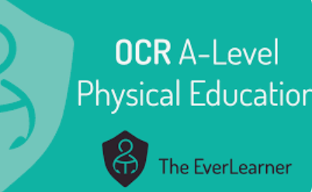

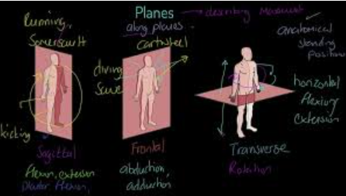

1. Download the attached booklet. [Physiology Transition Booklet.pdf](https://drive.google.com/file/d/1536UJOD5-7ub57tJjG8NGr0HcjhG7j2e/view?usp=sharing)
2. Research the listed topics.
3. Complete the document as a hard copy. Ready to hand in during our first lesson.

**Psychology transition work - Miss Ashmore**

These next few tasks will help you for the Sports Psychology unit. Sport psychology is the study of how psychology influences sports, athletic performance, exercise, and physical activity. Some [sports psychologists](https://www.verywellmind.com/what-is-a-sport-psychologist-3120695) work with professional athletes and coaches to improve performance and increase motivation. Other professionals utilise exercise and sports to enhance people’s lives and well-being throughout the entire lifespan.

Professional sports psychologists often help athletes cope with the intense pressure that comes from competition and overcome problems with focus and motivation. They also work with athletes to improve performance and recover from injuries. But sports psychologists do not just work with elite and professional athletes. They also help regular people learn how to enjoy sports and learn to stick to an exercise program

**Tasks:**

**Personality**:

Think of 4 words that you would use to describe your personality. Then, if you can, ask the people you live with to also describe your personality in just 4 words (this can often be a difficult task for people to do)

When you have done this, please research the following personality types:





Once you have done this and wrote down a suitable description, can you find the science behind why someone is believed to be an introvert/extrovert. HINT – it is to do with something called the reticular activating system (RAS).

Now look back at your four words and the words given to you by your family members. Would you class yourself as being a Type A/B personality and are you more likely to be introverted/extroverted? Please write up your findings.

**Aggression**

Task – Define Assertion and Aggression

There are currently four theories that try to explain why sports performers show aggressive behaviour in sport. For each of the theories, create a PowerPoint slide to try to explain each. Try using google and YouTube to get the information that you need.





**Motivation & Arousal**

First task – define both motivation and arousal.

Second task – find out what classifies as intrinsic motivation and extrinsic motivation. Then create a list of as many motivators as you can for two professional athletes and identify if they are intrinsic/extrinsic.

Task three -As a performer’s arousal increases, the state of readiness and expectation increases, but if the arousal gets too high, a performer can lose concentration and feel over-arousal. It is essential to understand three theories that try to explain how arousal affects performance. Research please, into the three graphs/theories of arousal and display your knowledge. These are:

* Drive Theory
* Inverted U Theory
* Catastrophe Theory

If you are struggling, get onto YouTube to get a basic understanding of this topic which will then help you to understand the theories.

**Socio-cultural issues in physical activity and sport transition work - Ms Hobson**

You are going to complete some research around a topic from each Section of this paper.

***3.1: Sport & Society - Global Sporting Events - The Modern Olympic Games***

The modern Olympic Games began in 1896, inspired by the ancient Olympic Games by Baron Pierre de Coubertin. Held every four years, they promote global unity and athletic excellence, showcasing elite competitors from around the world in a celebration of sport and international cooperation.

**Task 1** - research the background of The Modern Olympic Games (1896)

Discuss the aims of the Games

Discuss the philosophy behind why they were reintroduced

Guidance - Research the work carried out by Baron Pierre de Coubertin and William Penny Brookes.

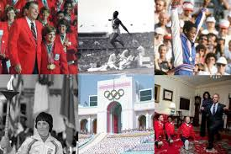

**Task 2** - Research the political exploitation of the Olympic Game

– Berlin 1936, Third Reich Ideology

– Mexico City 1968 ‘Black Power’ demonstration

– Munich 1972 Palestinian terrorism

– Moscow 1980 boycott lead by USA

– Los Angeles 1984 boycott by Soviet Union

Explain how countries tried to use the Olympic Games as a tool to promote their political ideology. I am happy for this to be done as a research project on word or as a PowerPoint presentation. Add as much detail as you possibly can. Please discuss in detail the Nations and people involved, the rationale behind what happened and the legacy of the actions that occurred.

Use this article to gain a small insight into what we are looking for in your answer.

<https://www.theguardian.com/politics/politicspast/page/0,9067,892902,00.html>

| Read | Watch | Listen | Do |
| --- | --- | --- | --- |
| **\*\*Brian Wilson (2002): “The ‘Anti‑Jock’ Movement: Reconsidering Youth Resistance…”\*\***  This seminal article examines how marginalized youth critique hyper-masculine sports culture, linking to engagement patterns, stereotyping, gender, and class dynamics.  <https://journals.humankinetics.com/view/journals/ssj/19/2/article-p206.pdf> | **\*\*TEDx: “Sport’s Role in Our Society” by Thomas Nabbs\*\***  Insightful talk on how sport fosters community identity, social cohesion, and cultural practices.  Watch on YouTube:<https://www.youtube.com/watch?v=UnANbbVLDS8> | **Podcast: A Level PE Podcast - Spotify.**  Subscribe to this Podcast on Spotify - Useful topics covered in discussions directly from the specification. Are there any other relevant Podcasts?  <https://open.spotify.com/show/2OdlFWjyC0sV1GUxPxACt0>. | **Quizlet:** **OCR A Level PE - Hosting Global Sporting Events**  Learn the key terms associated with Hosting Global Sporting Events. Complete some of the other learning tasks around these Key Terms and Concepts on this Quizlet set.  <https://quizlet.com/gb/938470049/ocr-a-level-pe-hosting-global-sporting-events-flash-cards/> |

***3.2: Contemporary Issues - Ethics and Deviance in Sport – Drugs and Doping***

Performance Enhancing Drugs is a topic that you should be familiar with from GCSE PE. Doping and drugs in sport is a topic studied in both the Physiology and Contemporary Issues units of A level PE.

**Task 1 Video – If you have Netflix take a look at the following documentary – Icarus (2017). (Possibly also available to watch via Youtube)**

Icarus 2017 - When filmmaker Bryan Fogel sets out to uncover the truth about doping in sports, a chance meeting with a Russian scientist transforms his story from a personal experiment into a geopolitical thriller. Dirty urine, unexplained death and Olympic gold are all part of the exposure of the biggest scandal in sports history.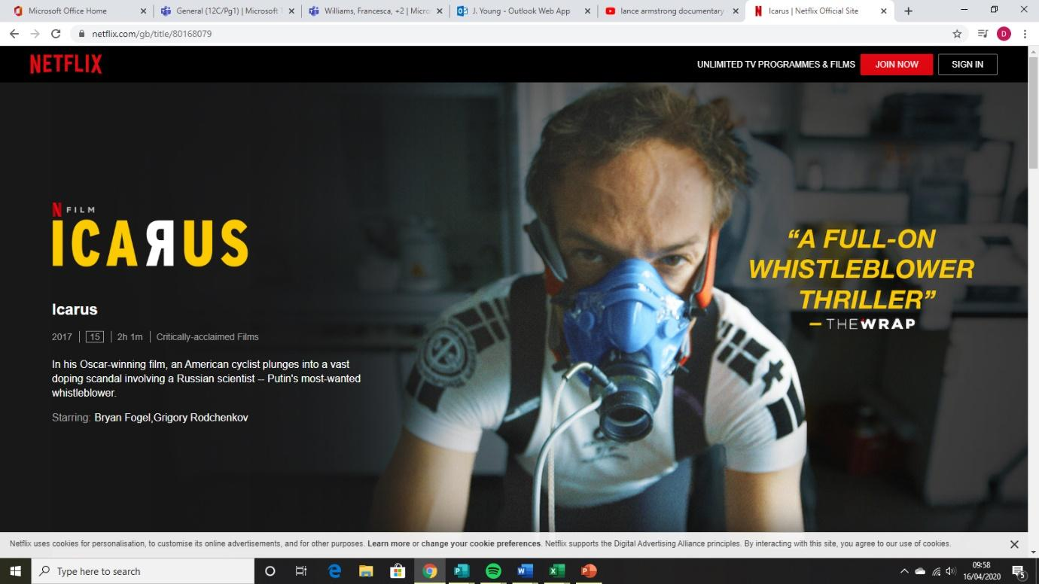

**Task 2 – Reasons why elite performers use doping and illegal drugs**

It is thought that some elite performers use doping and illegal drugs because of:

* Pressure from coaches
* Political Pressures
* High monetary rewards for winning and lucrative sponsorship deals
* Some performers think ‘everyone else is doing it’

Have a look at the following sports performers who have tested positive for banned substances. Create a brief information case study for each performer based upon your findings. Include:

* Who is the performer/elite? What is their sport? Nationality? Age?
* What did each performer test positive for?
* What are the benefits of those drugs?
* Any information for why they felt they needed to use banned substances
* Any punishments put into place following their positive testing?



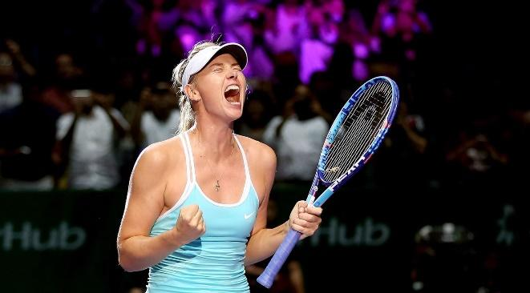

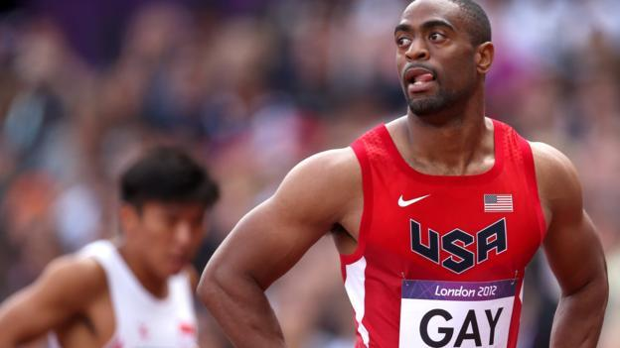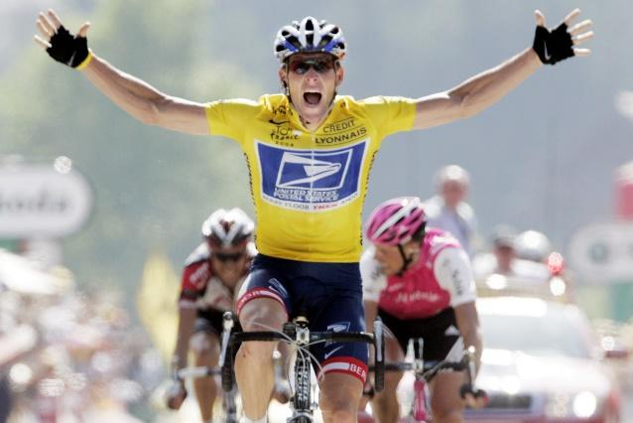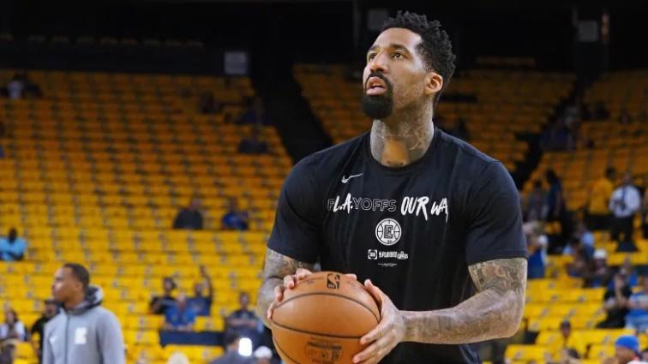

***Final Task – Strategies to stop the use of doping and illegal drugs***

Have a go at the ‘PlayTrue Quiz’ and see how much you already know about the work being done to try and keep sport ‘Drug Free’.

<https://www.wada-ama.org/en/what-we-do/education-prevention>

| Read | Watch | Listen | Do |
| --- | --- | --- | --- |
| **.**Helen Jefferson Lenskyj: Inside the Olympic Industry\*\***  Focus on gender, power, and social impacts of the Olympic movement—covering commercialization, media influence, ethics, inequality.  Accessible chapter preview via ResearchGate:<https://www.researchgate.net/publication/301979150_The_Olympic_Industry_Sex_Power_and_Politics> | **\*\*TED: “How sports and the media influence our beliefs” by Jason Peterson\*\***  Explores how media, sponsorship, and tech shape public perception of athletes and broader society.  Watch on TED.com:  <https://www.ted.com/talks/jason_peterson_how_sports_and_the_media_influence_our_beliefs> | \*\***BBC Sounds: “**Life Scientific: Technology, Sport and Health**” with Steve Haake talking to** Jim al-Khalili** This episode dives into how technology improves sporting ability <https://www.bbc.co.uk/sounds/play/m000mcy6> | **Quizlet: OCR A Level PE - Drugs and Doping**  Learn the key terms associated with Hosting Drugs and Doping. Complete some of the other learning tasks around these Key Terms and Concepts on this Quizlet set.  https://quizlet.com/gb/684400347/ocr-a-level-pe-contemporary-socio-cultural-issues-drugs-and-doping-flash-cards/ |