KS5 Further Biology Opportunities
Work will be set weekly for every student via Google Classroom. This work is compulsory. Some students may find that they wish to be completing extra biology work during their day and so a list of extra activities has been compiled to cater for this.

Free Open University courses

These courses range in difficulty and time, but when completed you can print certificates of completion and topics may aid understanding as part of undergraduate study. If nothing else they are very interesting.

Full range of titles can be found: https://www.open.edu/openlearn/free-courses/full-catalogue
I have selected a few below

Title | Hours to complete | Level | Hyperlink
Alcohol and human health | 6 | Introductory | Alcohol and human health - OpenLearn - Open University - SDK125_2
What is a genome made of? | 4 | Introductory | What is the genome made of? - OpenLearn - Open University - SK195_2
Infection and immunity | 12 | Introductory | SDK100_1 - OpenLearn - Open University - SDK100_1
Biofuels | 5 | Introductory | Biofuels - OpenLearn - Open University - S173_1
Meiosis and mitosis | 8 | Introductory | Meiosis and mitosis - OpenLearn - Open University - S103_5
Studying mammals | 10 | Introductory | Studying mammals: A winning design - OpenLearn - Open University - S182_1
The science of nutrition and healthy eating | 24 | Introductory | SNHE_1 - OpenLearn - Open University - SNHE_1
Understanding antibiotic resistance | 24 | Introductory | UAR_1 - OpenLearn - Open University - UAR_1
Pain and aspirin | 9 | Introductory | Pain and aspirin - OpenLearn - Open University - SK185_1
Learning, thinking, doing | 16 | Introductory | Learning, thinking and doing - OpenLearn - Open University - T205_1
Histology, microscopy, anatomy and disease | 12 | Introductory | OUFL_008 - OpenLearn - Open University - OUFL_008
Vaccination | 14 | Intermediate | Vaccination - OpenLearn - Open University - S320_1
The oceans | 15 | Intermediate | The oceans - OpenLearn - Open University - S206_1
Gene manipulation in plants | 10 | Intermediate | Gene manipulation in plants - OpenLearn - Open University - S250_1
Early development | 20 | Intermediate | Early development - OpenLearn - Open University - SK220_1

Websites
Learn Genetics: https://learn.genetics.utah.edu/
DNA from the Beginning: http://www.dnaftb.org/
Living Conservation: https://www.zsl.org/conservation
The Hidden Life of a Cell: https://www.dailymotion.com/video/xzh0kb
SciShow: https://www.youtube.com/user/scishow

BBC iPlayer
The Wonder of Animals
Super Smart Animals
Tomorrow’s Food
Secrets of Skin

Netflix
Our Planet
Life
Diagnosis
What the Health
The Hunt
72 Dangerous Animals

Seneca
You can create a login for Seneca to practice topics and answer questions.

Recommended Reading
Kick back this summer with a good read. The books below are all popular science books and great for extending your understanding of Biology.
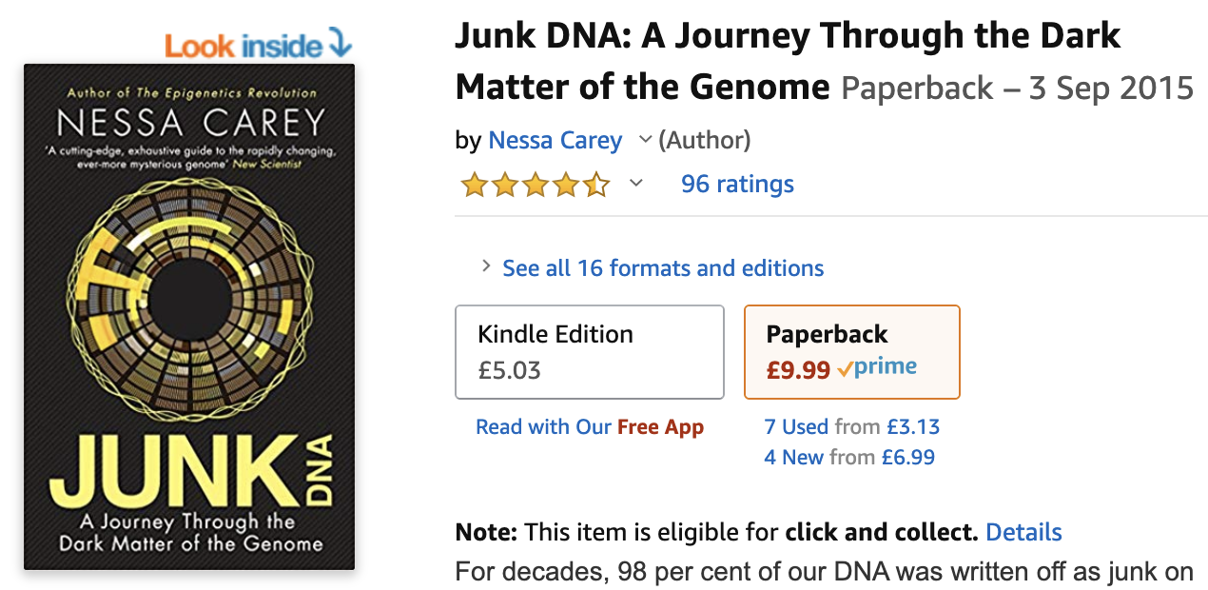
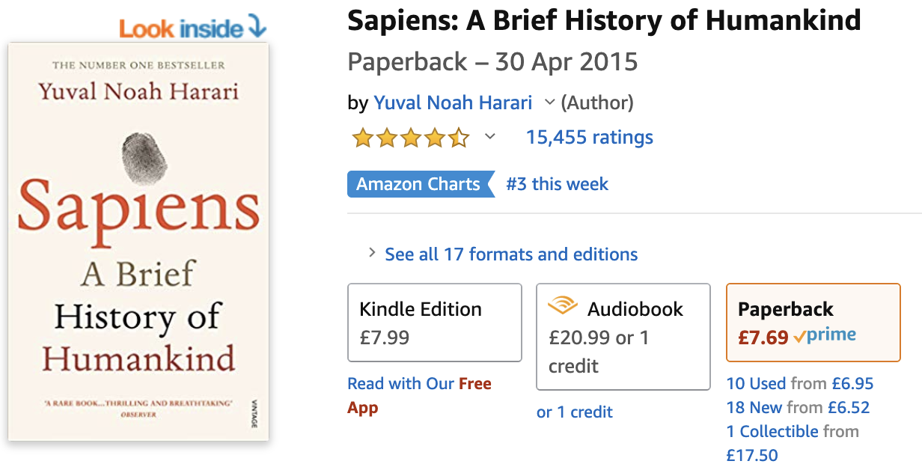
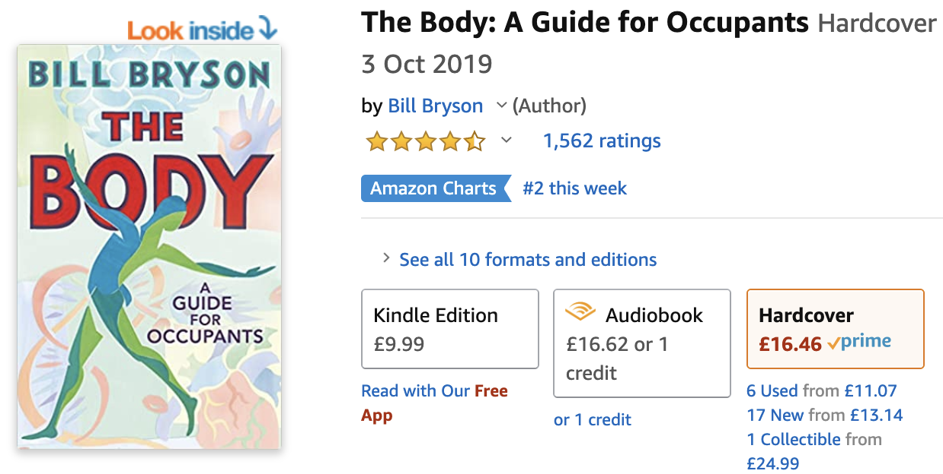
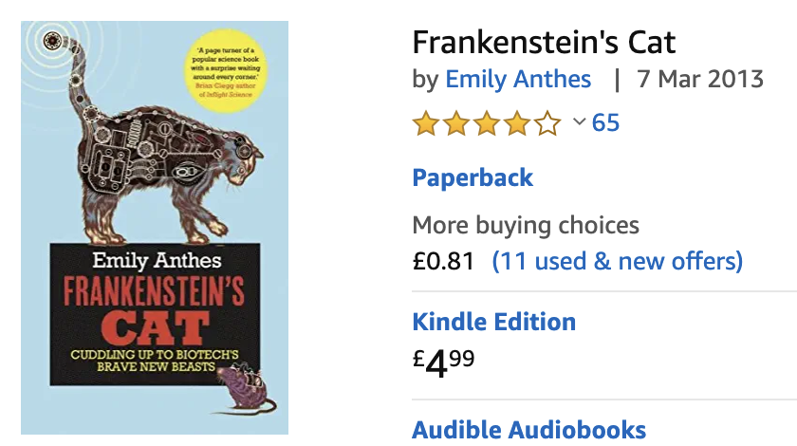
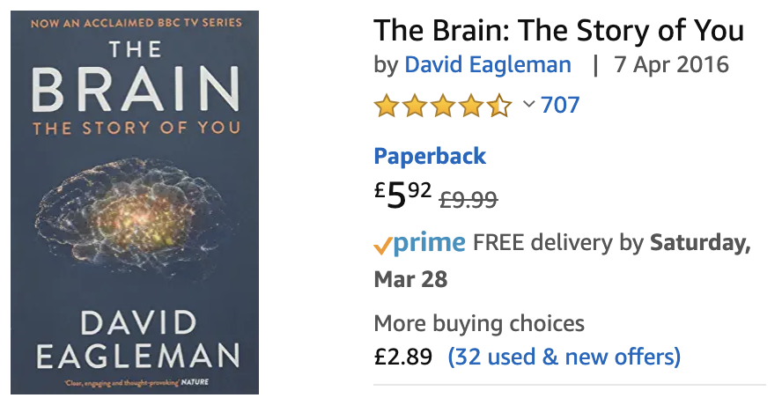
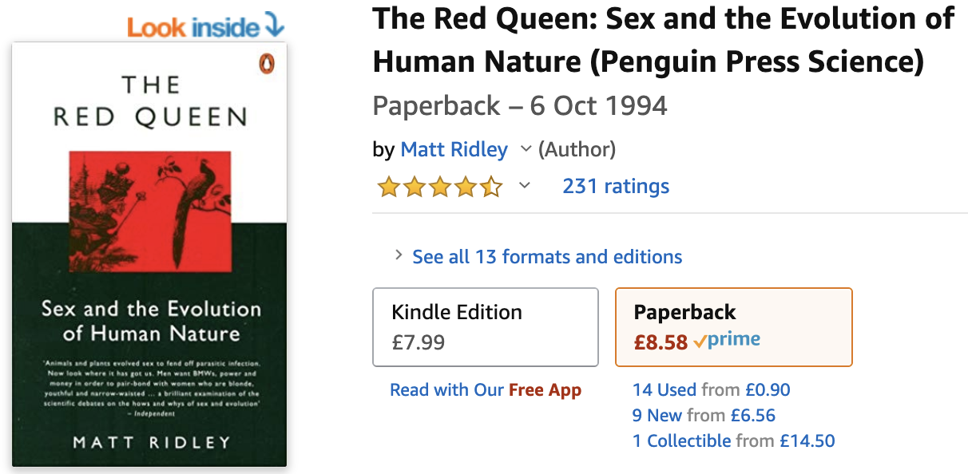

Recommended Films

Everyone loves a good story and everyone loves some great science. Here are some of the picks of the best films based on real life scientists and discoveries. You won't find Jurassic Park on this list, we’ve looked back over the last 50 years to give you our top 5 films you might not have seen before. Great watching for a rainy day.

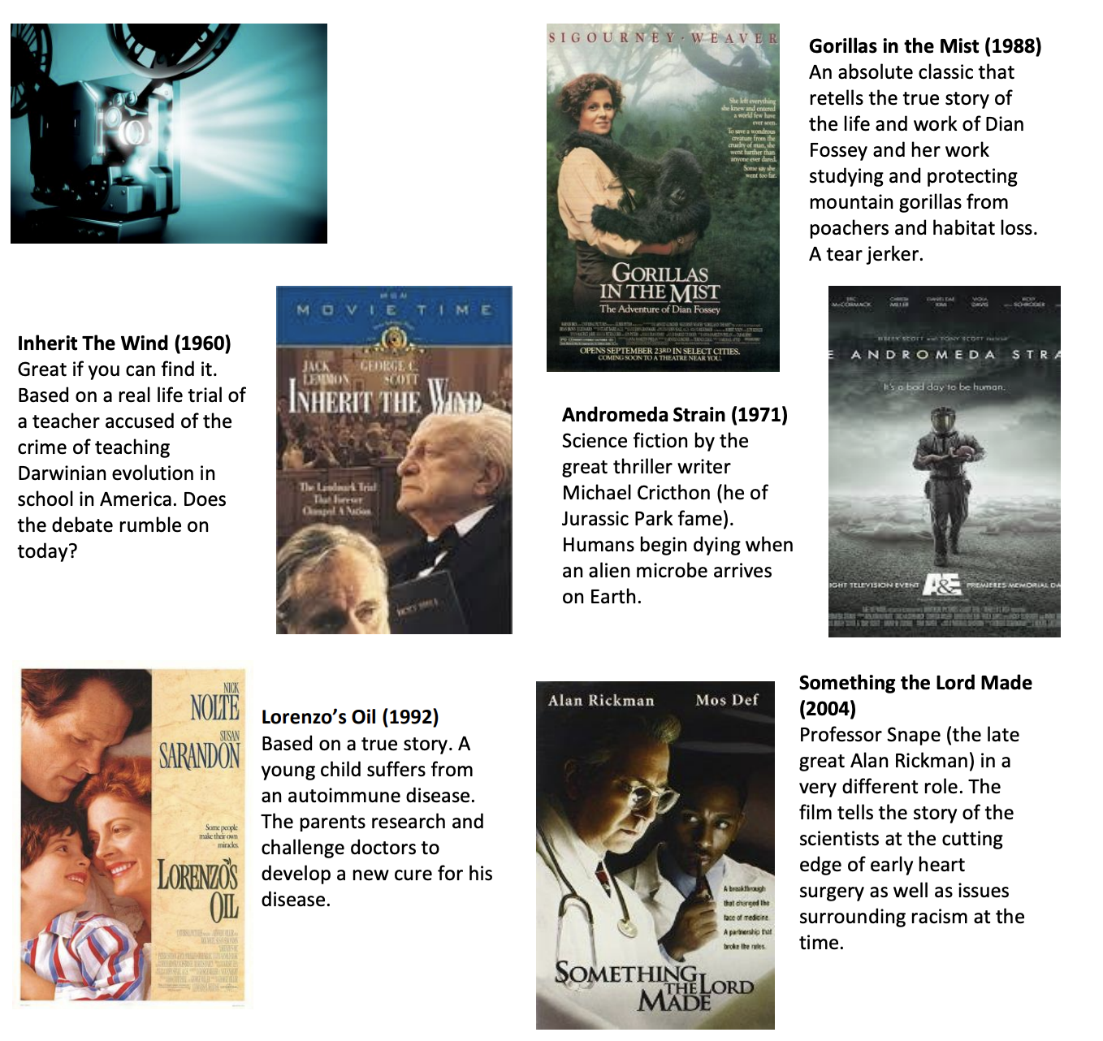

Presentation Recommendations

If you have 30 minutes to spare, here are some great presentations (and free!) from world leading scientists and researchers on a variety of topics. They provide some interesting answers and ask some thought-provoking questions. Use the link or scan the QR code to view:

