**L3 Ext. Cert in Health & Social Care**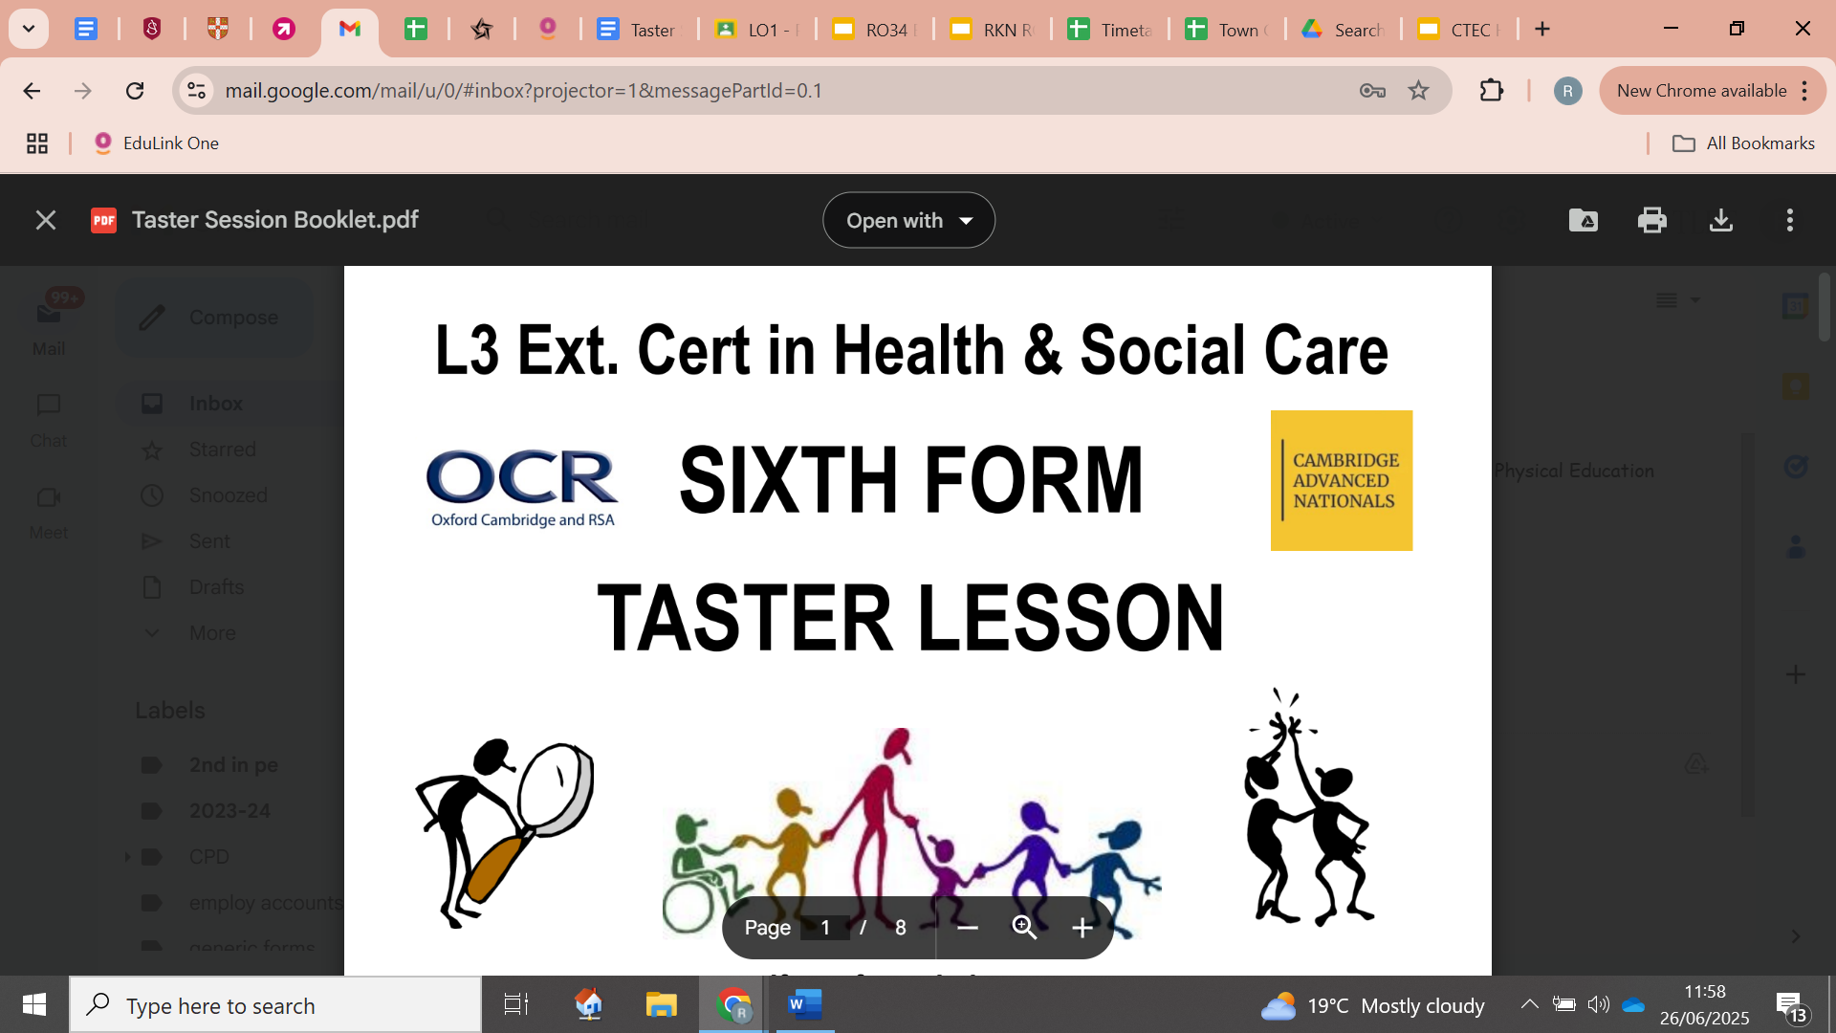

**SIXTH FORM**

**TRANSITION BOOKLET**



**Name: _________________________**

**If you fancy being an:**

*Art Therapist, Audiologist, Aunt, BSL Interpreter, Care Worker, Child Minder, Children’s Nurse, Clinical Photographer, Clinical Psychologist, Counsellor, Dad, Dental Nurse, Diagnostic Radiographer, Dietitian, District Nurse, Drugs & Alcohol Outreach Worker, Early Years Teacher, EAL Teacher, Emergency Call Handler, Emergency Medical Technician, Foster Carer, Health Play Specialist, Health Visitor, Learning Disability Nurse, Learning Mentor, Mental Health Nurse, Midwife, Mum, Music Therapist, Nanny, Optometrist, Paramedic, Personal Assistant, Phlebotomist, Physiotherapist, Podiatrist, Probation Officer, Prosthetist,*

*Occupational Therapist, Radiotherapist, Scout Leader, Social Worker, Speech & Language Therapist, Support Worker, Uncle or Youth Worker…*

**Health & Social Care could be a perfect sixth form choice!**

| **UCAS**  **POINTS** | **A**  **LEVEL** | **OCR LEVEL 3 GRADE** |
| --- | --- | --- |
| 56 | A* | DISTINCTION* |
| 48 | A | DISTINCTION |
| 40 | B |  |
| 32 | C | MERIT |
| 24 | D |  |
| 16 | E | PASS |

The 2 year Level 3 AAQ Health & Social Care Extended Certificate is equivalent to an A level - it’s “worth” the same to many universities, but it’s assessed and graded very differently.

The course is made up of 6 units - 4 are full of internally marked coursework assignments, and 2 are external exams. You can resubmit your coursework assignments to achieve a higher grade if you want, and you can re-sit each exam if your mark isn’t good enough to get the overall grade you need

The units currently taught are:

RO91 – **ANATOMY & PHYSIOLOGY** (Exam in Y12)

RO94 – **LONG-TERM PHYSIOLOGICAL CONDITIONS** (Coursework in Y12)

RO96 – **SUPPORTING PEOPLE IN RELATION TO SEXUAL HEALTH, PREGNANCY AND POSTNATAL HEALTH** (Coursework in Y12)

RO90 – **PRINCIPLES OF CARE** IN HSC (Exam in Y13)

RO93 – **MENTAL HEALTH CONDITIONS** (Coursework in Y13)

RO92 – **PERSON-CENTRED APPROACH TO CARE** (Coursework in Y13)

We would advise, if your future timetable allows, and if it could be arranged, that you take on a long-term work experience placement. Not just the full week everyone gets in Y12, but a regular, same-time-every-week placement in a health care, social care or childcare setting. Many university and higher apprenticeship courses really value practical, hands-on experience – it shows your commitment, your willingness and will give you the sort of experiences you cannot get in a classroom, no matter how hard we try.

Let’s have a look at one task from each unit to give you a taste of the sort of information and work you might need to do.

For coursework units, there are 24 tasks of graded difficulty; Pass, Merit and Distinction. You’ll be given a set scenario from the exam board to guide you and link your work to.

For exam units, there will be short questions to help you recall facts and information, and longer questions where you’ll need to apply the knowledge you have to a case study.



**Task:** Research and define the following words which are central to the Modern Britain unit. Then, draw a symbol to summarise the term and help you remember it.

| **Term** | **Definition** | **Symbol** |
| --- | --- | --- |
| Adolescence | An important status change following the onset of puberty during which a young person develops from a child into a adult. | Emotional changes that occur during puberty |
| Advocate |  |  |
| Attachment |  |  |
| Care package |  |  |
| Clinical Commissioning Groups (CCGs) |  |  |
| Development |  |  |
| Discrimination |  |  |
| Diversity |  |  |
| Empathy |  |  |
| Ethical |  |  |
| Fine Motor Skills |  |  |
| Growth |  |  |
| Holistic Approach |  |  |
| Milestone |  |  |
| Nature |  |  |
| Nurture |  |  |
| Risk Assessment |  |  |
| Safeguarding |  |  |
| Self-Concept |  |  |
| Self-Esteem |  |  |

**CAREERS IN HEALTH AND SOCIAL CARE**

True or False?

* A district nurse will only work with the elderly.
* A palliative care nurse will get involved with everyone who gets coronavirus.
* Adult social workers support people with poor mental health.
* Domiciliary carers provide care in the home.
* Only phlebotomists are allowed to take blood.
* Auxiliary nurses help support other nurses to do their roles.

On ‘The front line’…….

* What does it mean when people talk about being ‘on the front line’?
* Government declares a ‘pandemic’…….
* What does it mean when people talk about the situation as a pandemic?

| Job Role | Definition | Roles and Responsibilities | How do they respond in a pandemic? |
| --- | --- | --- | --- |
| District Nurse |  |  |  |
| Auxiliary Nurse |  |  |  |
| Palliative Care |  |  |  |
| Phlebotomist |  |  |  |
| Domiciliary Carer |  |  |  |
| Adult Social Worker |  |  |  |

**RO90 – PRINCIPLES OF CARE IN HSC (Exam)**

This unit looks at the attitudes, values and skills needed to care for people in health and social care settings. You will learn about supporting equality, diversity and rights; how identifying discriminatory practice, potential hazards and legislation can reduce risks; and how best practice, policies and procedures can protect service users.

One piece of legislation that protects the rights of citizens of the UK is called The Equality Act - it states there are 9 “Protected Characteristics“ that cannot be used to discriminate by law.

This means that you cannot be treated differently to other 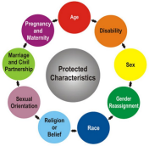

people, or be given fewer or worse opportunities if one of

these characteristics applies to you.

Choose 2 different HSC settings and 2 different characteristics.

Explain something those settings could do to demonstrate

clearly that they value people with these characteristics.

***EXAMPLE: Doctor’s Surgery - Disability.***

*The surgery will need ramps alongside any steps to ensure that service users in wheelchairs are able to access all facilities. They should also have a low reception desk, a hearing aid loop and have forms available in large print for people with hearing and visual impairments.*

**Setting 1 : ______________________ Characteristic 1 : _______________________**

What can the setting do deliberately to make sure people with this characteristic feel valued? ___________________________________________________________________________ ______________________________________________________________________________________________________________________________________________________ ______________________________________________________________________________________________________________________________________________________

**Setting 2 : ______________________ Characteristic 2 : _______________________**

What can the setting do deliberately to make sure people with this characteristic feel valued? ___________________________________________________________________________ ____________________________________________________________________________________________________________________________________________________________________________________________________________________________________________________________________________________________________________

**RO91 - ANATOMY & PHYSIOLOGY (Exam)**

This unit looks at 6 different body systems - what the bits are, how they work together, what the functions are, how they go wrong, what are the risk factors and causes of the problems, the care needs/treatments/medications available and the implications for a person’s life when their bodies “go wrong”.

Let’s focus on eyesight issues.

Some common conditions are:

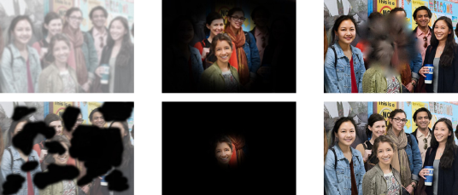______________________ ______________________ ______________________

______________________ ______________________ ______________________

Choose a condition, then look through the glasses that help show what your sight might be like. What are some ways a person would be affected by having this condition? Think P.I.E.S…

Condition: ________________________________________

Effects: _______________________________________________________________________ __________________________________________________________________________________________________________________________________________________________ __________________________________________________________________________________________________________________________________________________________ __________________________________________________________________________________________________________________________________________________________ _____________________________________________________________________________

**RO92 – PERSON-CENTRED APPROACH TO CARE (Coursework)**

This unit looks at the skills and values needed to treat all service users as individuals with their own wants and needs. Getting to know each person you’re caring for individually helps you provide the best care possible.

One tool useful for getting to know people is called the “Good Day / Bad Day Chart”

If people wanted to get to know you and look after you better, what would be on your chart?



**RO93 – MENTAL HEALTH CONDITIONS (Coursework)**

This unit looks at the types, causes and effects of many mental health conditions, and what help, support and treatment is available to individuals.

Mental health conditions are divided into 6 categories - which one’s which?

| Anxiety disorders |  | *Agoraphobia*  *Panic Disorder*  *Borderline Personality Disorder*  *Anorexia*  *Schizophrenia*  *OCD*  *Clinical Depression Bulimia*  *Bipolar*  *Coulrophobia*  *Narcissistic personality Disorder*  *Post-Natal Depression* |
| --- | --- | --- |
| Mood disorders |
| Eating disorders |
| Phobias |
| Personality disorders |
| Psychotic Disorder |

What sort of things in a person’s life might trigger an episode of poor mental health?

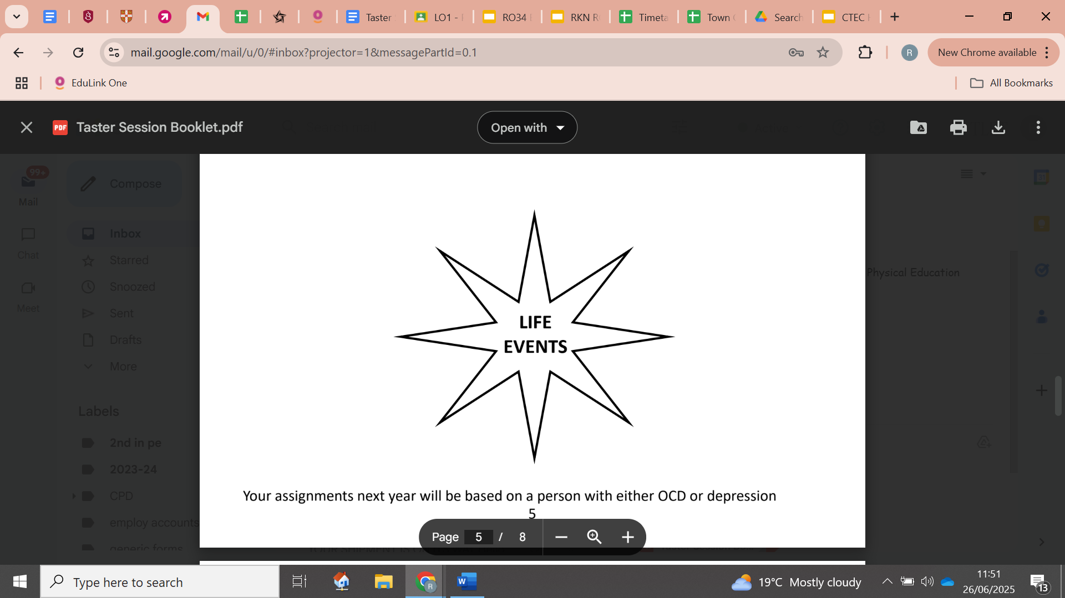

**RO94 - LONG-TERM PHYSIOLOGICAL CONDITIONS (Coursework)**

This unit looks in more detail at the causes and long-term effects of having physical malfunctions in the body and the different methods of monitoring and treating these conditions. You will also look at local services available to help people with different conditions.

There are 4 categories of long-term physiological conditions - which one’s which?

| Neurological  Conditions |  | *Alzheimer’s Disease Multiple Sclerosis Cystic Fibrosis*  *Type 1 Diabetes*  *Emphysema*  *Parkinson’s Disease Sickle Cell Anaemia Rheumatoid Arthritis* |
| --- | --- | --- |
| Degenerative  Conditions |
| Autoimmune  Conditions |
| Genetic  Conditions |

What types of practitioners might be able to support people with long-term physiological conditions?

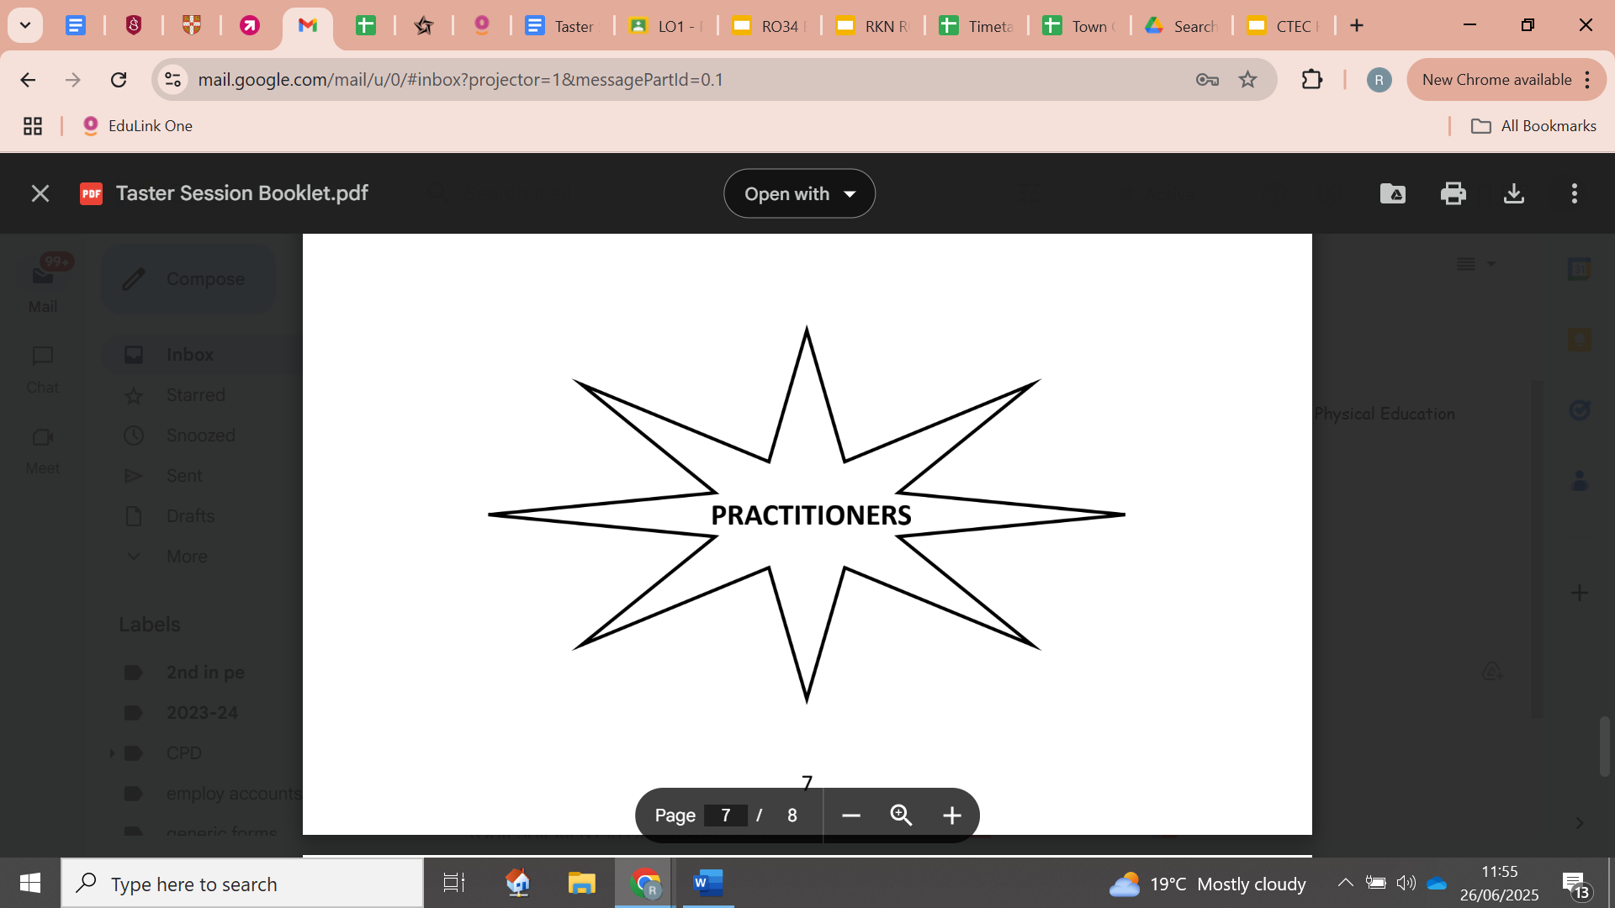

**HEALTH AND SOCIAL CARE IN THE MEDIA**

The role played by health and social care providers is key in a healthy society. One way in which public awareness is raised about health and social care in general and issues that exist within the health and social care sector is through the media. 

Your task is to pick…

➢ x2 Films

➢ x1 Book

➢ x2 Documentaries

You will then be asked to write an essay with the following title: ‘Discuss the portrayal of Health and Social Care within the media’

You must watch/read some of the examples on the previous slides you have picked and create notes to help with your essay. Consider the following:

• What issues, if any, are being raised in the stimulus?

• How does the stimulus present H&SC?

Is the stimulus informative/helpful and why?

• Are there any quotes/scenes etc that stand out to you and why?

• How effective is the stimulus in raising public awareness about H&SC/Issues?

This list is NOT exhaustive there may be other questions/ideas you wish to consider as you watch or read.

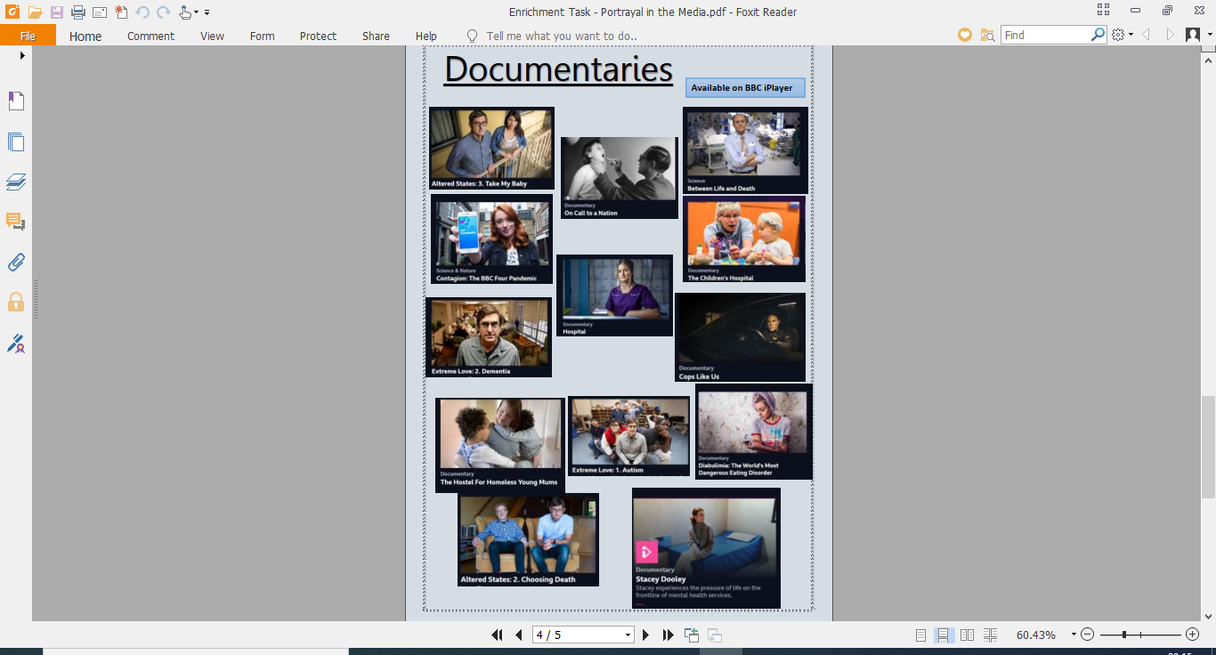

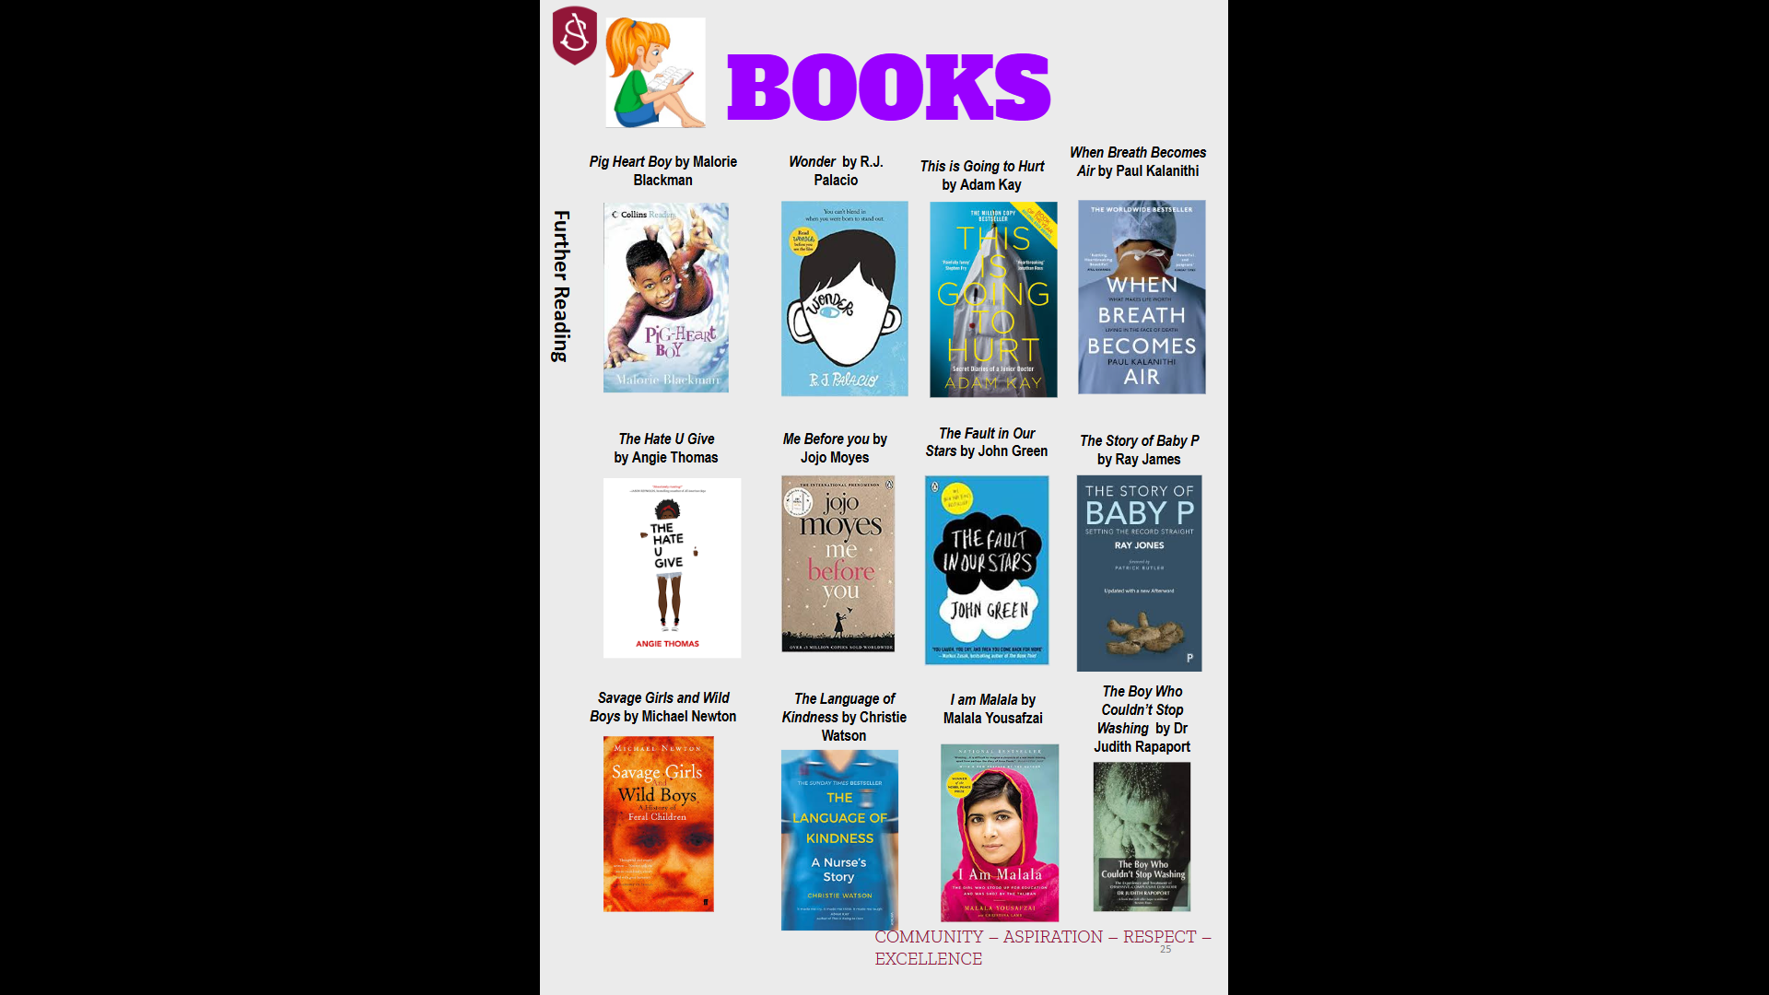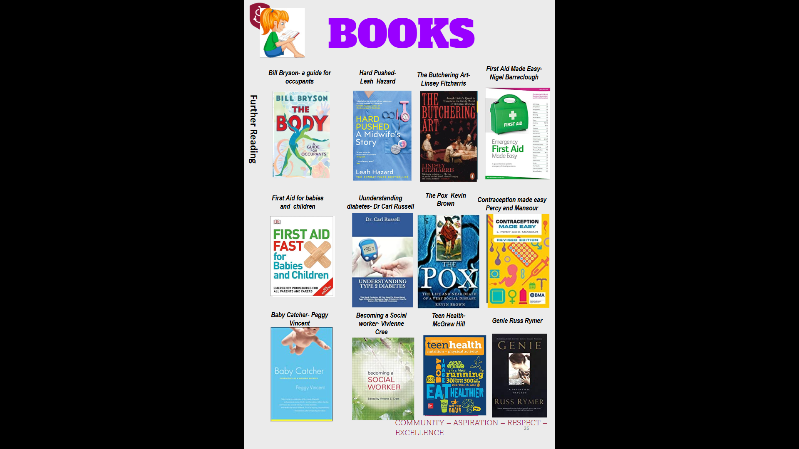

**WEBSITES**

https://www.carehome.co.uk/care_search_results.cfm/searchunitary/Rugby/s earchchtype/carehomenursing

https://www.daynurseries.co.uk/day_nursery_search_results.cfm/searchtown /Rugby

https://www.mencap.org.uk/welcome-our-website

https://www.changepeople.org/

https://www.nhs.uk/conditions/learning-disabilities/

https://learningally.org/

https://dyslexiaida.org/

https://www.mentalhealth.org.uk/learning-disabilities/a-to-z/l/learning-disabil ities

https://www.england.nhs.uk/learning-disabilities/

https://www.gov.uk/government/publications/learning-disability-applying-all our-health/learning-disabilities-applying-all-our-health

https://www.gov.uk/disabled-students-allowances-dsas

https://www.dementiafriends.org.uk/

https://www.nhs.uk/conditions/dementia/about/

https://www.alzheimers.org.uk/get-involved/dementia-friendly-communities/ dementia-friends

https://www.ocr.org.uk/qualifications/cambridge-technicals/health-and-social care/moving-to-ocr/#level-3