

A LEVEL FRENCH
SUMMER HOMEWORK 2026


French summer work due 1st week back

In order to use our quizlet links, you will need to join our Ashlawn Y12 class by clicking here or typing :
⇒ https://quizlet.com/class/23503454/materials

- Grammar work (see p3/4/5)

A) Present tense

Learn the present tense verb forms of all verbs listed below (from English to French) :
- QUIZLET FOLDER POUR PRATIQUER LES VERBES AU PRÉSENT:

B) Future & conditional tenses
Learn the future (WILL) and conditional tenses (use pages below)
- QUIZLETS POUR LE FUTUR / CONDITIONNEL :
futur
conditionnel

2) Authentic material : (see p6)
⇒ watch / listen to authentic French material

3) No et moi


A) purchase NO ET MOI by Delphine de Vigan, Edition “livre de poche” 248 pages :

B) Read the English version of “no et moi”
It can be purchased on “world of books”

Regular and common irregular verbs – present tense
ER VERBS | ER VERBS | IR VERBS | IR VERBS | RE VERBS | RE VERBS
e | ending of JE for ER verbs | is | ending of JE for IR verbs | s | ending of JE for RE verbs
es | ending of TU for ER verbs | is | ending of TU for IR verbs | s | ending of TU for RE verbs
e | ending of HE/SHE for ER verbs | it | ending of HE/SHE for IR verbs | nothing | ending of HE/SHE for RE verbs
ons | ending of NOUS for ER verbs | issons | ending of NOUS for IR verbs | ons | ending of NOUS for RER verbs
ez | ending of VOUS for ER verbs | issez | ending of VOUS for IR verbs | ez | ending of VOUS for RE verbs
ent | ending of THEY for ER verbs | issent | ending of THEY for IR verbs | ent | ending of THEY for RE verbs
Parler | to speak | Finir | to finish | Vendre | to sell
je parle | I speak | je finis | I finish | je vends | I sell
tu parles | you (1) speak | tu finis | you (1) finish | tu vends | you (1) sell
il parle | he speaks | il finit | he finishes | il vend | he sells
nous parlons | we speak | nous finissons | we finish | nous vendons | we sell
vous parlez | you (pl) speak | vous finissez | you (pl) finish | vous vendez | you (pl) sell
ils parlent | they speak | ils finissent | they finish | ils vendent | they sell
être | To be | Avoir | To have | Faire | To do
Je suis | I am | J’ai | I have | Je fais | I do
Tu es | You (1) are | Tu as | You (1) have | Tu fais | You (1) do
Il est | He is | Il a | He has | Il fait | He does
Nous sommes | We are | Nous avons | We have | Nous faisons | We do
Vous êtes | You (pl) are | Vous avez | You (pl) have | Vous faites | You (pl) do
Ils sont | They are | Ils ont | They have | Ils font | They do
Aller | To go | Pouvoir | To be able to | Vouloir | To want
Je vais | I go | Je peux | I can | Je veux | I want
Tu vas | You (1) go | Tu peux | You (1) can | Tu veux | You (1) want
Il va | He goes | Il peut | He can | Il veut | He wants
Nous allons | We go | Nous pouvons | We can | Nous voulons | We want
Vous allez | You (pl) go | Vous pouvez | You (pl) can | Vous voulez | You (pl) want
Ils vont | They go | Ils peuvent | They can | Ils veulent | They want
Devoir | To have to | Prendre | To take | Venir | To come
Je dois | I must | Je prends | I take | Je viens | I come
Tu dois | You (1) must | Tu prends | You (1) take | Tu viens | You (1) come
Il doit | He must | Il prend | He takes | Il vient | He comes
Nous devons | We must | Nous prenons | We take | Nous venons | We come
Vous devez | You (pl) must | Vous prenez | You (pl) take | Vous venez | You (pl) come
Ils doivent | They must | Ils prennent | They take | Ils viennent | They come
Dire | To tell | Boire | To drink | Courir | To run
je dis | I tell | je bois | I drink | je cours | I run
tu dis | You (1) tell | tu bois | You (1) drink | tu cours | You (1) run
il dit | He tells | il boit | He drinks | il court | He runs
nous disons | We tell | nous buvons | We drink | nous courons | We run
vous dites | You (pl) tell | vous buvez | You (pl) drink | vous courez | You (pl) run
ils disent | They tell | ils boivent | They drink | ils courent | They run
Croire | To believe | Mettre | To put | Suivre | To follow
je crois | I tell | je mets | I put | je suis | I follow
tu crois | You (1) tell | tu mets | You (1) put | tu suis | You (1) follow
il croit | He tells | il met | He puts | il suit | He follows
nous croyons | We tell | nous mettons | We put | nous suivons | We follow
vous croyez | You (pl) tell | vous mettez | You (pl) put | vous suivez | You (pl) follow
ils croient | They tell | ils mettent | They put | ils suivent | They follow
Voir | To see | Savoir | To know
je vois | I see | je sais | I know
tu vois | You (1) see | tu sais | You (1) know
il voit | He sees | il sait | He knows
nous voyons | We see | nous savons | We know
vous voyez | You (pl) see | vous savez | You (pl) know
ils voient | They see | ils savent | They know

LE FUTUR (will)
- Comment on le forme? l’infinitif + les terminaisons du futur (Re verbs, take off the –e)
- Les terminaisons? (these are like the verb ‘avoir’ in the present tense)
JE+ -ai NOUS + -ons
TU + -as VOUS + -ez
IL/ELLE/ON + -a ILS/ELLES + -ont
EG : je jouerai = I will play nous partirons = we will leave elle vendra = she’ll sell

- EXCEPTIONS? Oui!
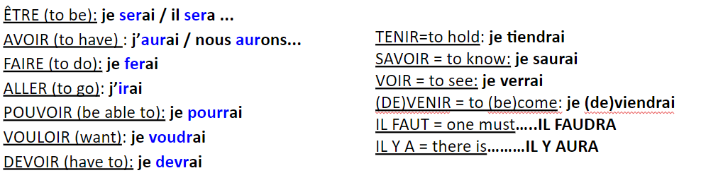

LE CONDITIONNEL (would)
- Comment on le forme? l’infinitif + les terminaisons du conditionnel (Re verbs, take off the –e)
- Les terminaisons? (these are the same as the imperfect…)
JE+ -ais NOUS + -ions
TU + -ais VOUS + -iez
IL/ELLE/ON + -ait ILS/ELLES + -aient
EG : je jouerais = I would play nous partirions = we would leave elle vendrait = she’d sell

- EXCEPTIONS? Oui!
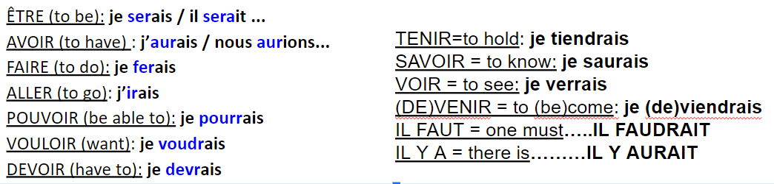

BEYOND THE CURRICULUM

FRENCH CULTURAL RESOURCES

📰  News & current affairs | Le journal en français facile / le Huffington Post France / TV5 Monde / Le courrier international / Le Monde
📸  Instagram accounts | Hugo Decrypte , Brut France , A Cup of French, French with Elle , Youtuber “enjoy phoenix- marie lopez” (for paranormal stories), French teacher Carlito
🎙️  Podcasts | Café Français (to learn French - Spotify)  Babines (on animals - Spotify)  Les pieds sur terre (France culture - 30 min on different societal topics)  → “coup de coeur” for the following episode : “dessine moi le bonheur”  One Thing in a French Day (Spotify)  Intermediate French (Spotify)  Coffee Break French
📺  TV, documentary | ArteTV , France TV documentaires , Culte (Amazon Prime), Lupin (netflix)
🎵  Music & artists | Slimane /Zaho de Sagazan/ Orelsan / Louane / Lomepal/ Aya Nakamura/ Bigflo & oli / Gojira / Julien Doré / Zaz / Zazie / Maître Gims / Angèle / Stromae / Kendji Girac / Soprano / Vianney / Dadju / Niska / Nekfeu / Hoshi / Ninho / Clara Luciani / Indochine / Amadou et Mariam
🎬  Films & séries | - Intouchable (Prime) - drame  - le Fabuleux destin d’Amelie Poulain (Prime) - drame  - Ne le dis a personne (Prime)  - entre les murs (Laurent Cantet - Amazon) - drame, social realism  - Athena (Romain Gavras) - urban drama  - Family Pack (Netflix) - humour  - Asterix & Obelix, the middle Kingdom (netflix)  - Lupin (Netflix)  - 10 pour cent (call my agent) (Netflix)

Nous contacter :
Miss Dubois : duboisa@ashlawn.tlet.org.uk
Miss Cvancigerova: cvancigerovak@ashlawn.tlet.org.uk

