A level English Literature Transition Tasks

In preparation for your new course you must be familiar with the set texts. We will not read them in their entirety in class. Therefore, between now and September you must buy and read the following texts. Please ensure that you buy the correct versions of texts, as this will make looking for quotations easier in class
A Streetcar Named Desire by Tennessee Williams (Modern Classics)
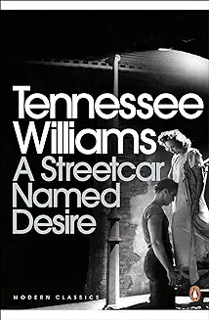
The Handmaid’s Tale by Margaret Atwood (Vintage)
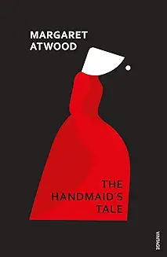

Frankenstein by Mary Shelley (Oxford World’s Classics)
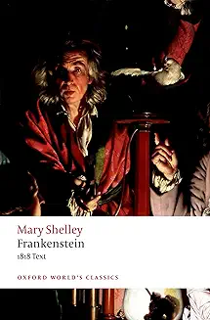

The Poems of the Decade: An Anthology of the Forward Books of Poetry. (to buy only)
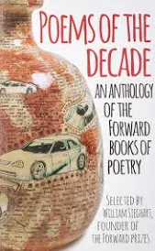

Answer the following questions on each text.
A Streetcar Named Desire by Tennessee Williams
- Who was Tennessee Williams? Produce a short biography of his life
- Research the ‘New America’
- What was the American Civil War about? What divisions did it create?
- What is a ‘Southern Belle’?
The Handmaid’s Tale by Margaret Atwood
- Who was Margaret Atwood? Produce a short biography of her life
- Why might the novel be classed as ‘speculative fiction’?
- What does Puritanism mean and how does it apply to the text?
Frankenstein or The Modern Prometheus by Mary Shelley
- When did The French Revolution take place?
- What is ‘galvanism’? How is it applicable to Frankenstein?
- What is the Age of Enlightenment?
- What is Romanticism?
- What is Physiognomy?
- Who wrote Paradise Lost and what is it about?
- What is the story of Prometheus?
- What loss had Mary Shelley experienced in her life?

Literary Criticism
- Research the following schools of thought
- Marxist literary criticism
- Feminist literary criticism
- Psychoanalytic theory
- Post-colonial theory

- Apply the above theory to the attached extract from White Teeth by Zadie Smith.
Consider:
- How a Marxist critic would read this.
- How a feminist critic would read this.
- How a psychologist would read this.
- How a post-colonialist would read this.
In this extract, fifteen year old Irie Irie is obsessed with her weight and general appearance, mostly because she is also obsessed with Millat Iqbal. Unfortunately for Irie, Millat regards her as his most important friend, and nothing more. To attract Millat, Irie gets her hair straightened and dyed red, an experiment that ends with most 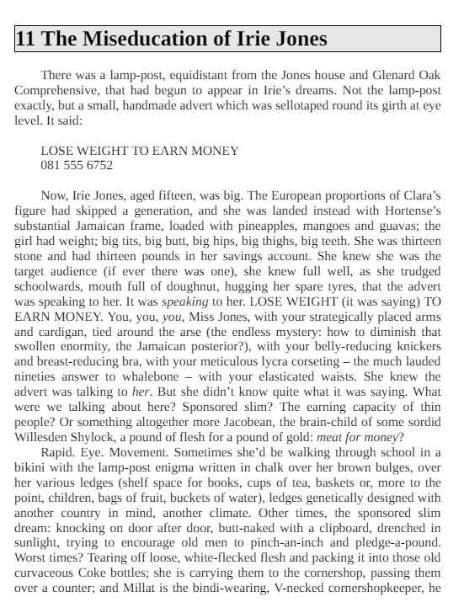of her hair falling out and Irie having to buy expensive extensions.

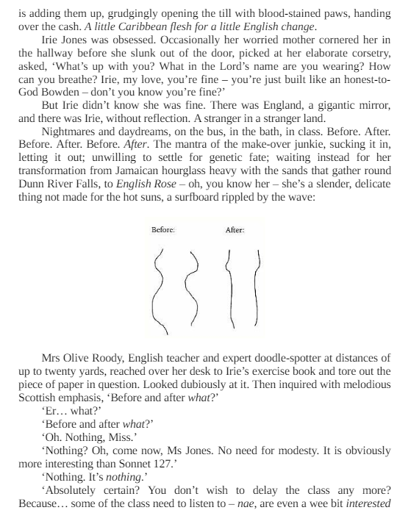

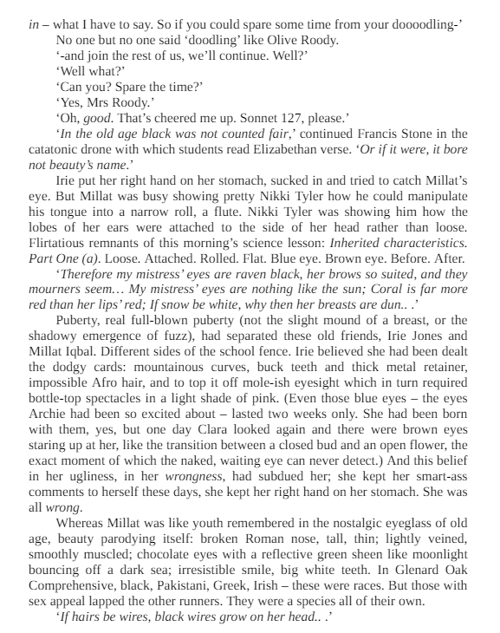

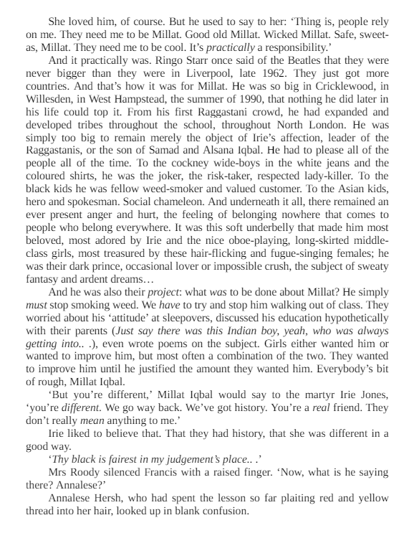

Read |  | Listen (podcasts)
Set Texts:  A Streetcar Named Desire by Tennessee Williams  Othello by William Shakespeare  Poems of the Decade (Anthology)  Romantic Poetry (Anthology)  The Handmaid’s Tale by Margaret Atwood  Frankenstein by Mary Shelley  Recommended Reads:  Wuthering Heights by Emily Bronte  A Thousand Splendid Suns by Khaled Hosseini  White Teeth by Zadie Smith  Oranges are not the Only Fruit by Jeanette Winterson  A Tree Grows in Brooklyn by Betty Smith  The Bloody Chamber by Angela Carter  Brick Lane by Monica Ali  The Colour Purple by Alice Walker  Americanah by Chimamanda Ngozi Adichie  The Bell Jar by Sylvia Plath  The Grapes of Wrath by John Steinbeck  Jane Eyre by Charlotte Bronte  The Great Gatsby by F. Scott Fitzgerald  Atonement by Ian McEwan  Beloved by Toni Morrison  Captain Corelli’s Mandolin by Louis de Bernières  A Farewell to Arms by Ernest Hemingway  The Kite Runner by Khaled Hosseini  The Secret History by Donna Tartt  Rebecca by Daphne du Maurier |  | How to Love Lit  The London Review Bookshop  BBC Open Book  The Classic English Literature Podcast  On the Road with Penguin Classics  The History of Literature  My Shakespeare, The Folio Roadshow
 |  | Watch
Any National Theatre at Home production (great for watching Shakespeare!)

Literature Lessons: A category on TED-Ed that offers literature lessons

The School of Life: A YouTube channel that offers a series on authors and their themes, as well as video essays on various topics.

The Literature Channel: A YouTube channel that provides lectures on the history of English from a professor at the University of Ottawa

