**A level English Literature Transition Tasks**

In preparation for your new course you must be familiar with the set texts. We will not read them in their entirety in class. Therefore, between now and September you must buy and read the following texts. Please ensure that you buy the correct versions of texts, as this will make looking for quotations easier in class

*A Streetcar Named Desire* by Tennessee Williams (Modern Classics)



*The Handmaid’s Tale* by Margaret Atwood (Vintage)

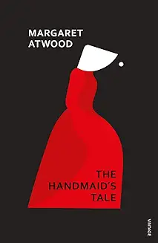

*Frankenstein* by Mary Shelley (Oxford World’s Classics)

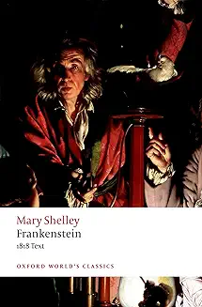

*The Poems of the Decade: An Anthology of the Forward Books of Poetry.* (to buy only)

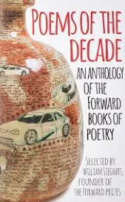

Answer the following questions on each text.

**A Streetcar Named Desire by Tennessee Williams**

* Who was Tennessee Williams? Produce a short biography of his life
* Research the ‘New America’
* What was the American Civil War about? What divisions did it create?
* What is a ‘Southern Belle’?

**The Handmaid’s Tale by Margaret Atwood**

* Who was Margaret Atwood? Produce a short biography of her life
* Why might the novel be classed as ‘speculative fiction’?
* What does Puritanism mean and how does it apply to the text?

**Frankenstein or The Modern Prometheus by Mary Shelley**

* When did The French Revolution take place?
* What is ‘galvanism’? How is it applicable to Frankenstein?
* What is the Age of Enlightenment?
* What is Romanticism?
* What is Physiognomy?
* Who wrote Paradise Lost and what is it about?
* What is the story of Prometheus?
* What loss had Mary Shelley experienced in her life?

**Literary Criticism**

1. Research the following schools of thought

* Marxist literary criticism
* Feminist literary criticism
* Psychoanalytic theory
* Post-colonial theory

1. Apply the above theory to the attached extract from *White Teeth* by Zadie Smith.

Consider:

* How a Marxist critic would read this.
* How a feminist critic would read this.
* How a psychologist would read this.
* How a post-colonialist would read this.

In this extract, fifteen year old Irie Irie is obsessed with her weight and general appearance, mostly because she is also obsessed with Millat Iqbal. Unfortunately for Irie, Millat regards her as his most important friend, and nothing more. To attract Millat, Irie gets her hair straightened and dyed red, an experiment that ends with most 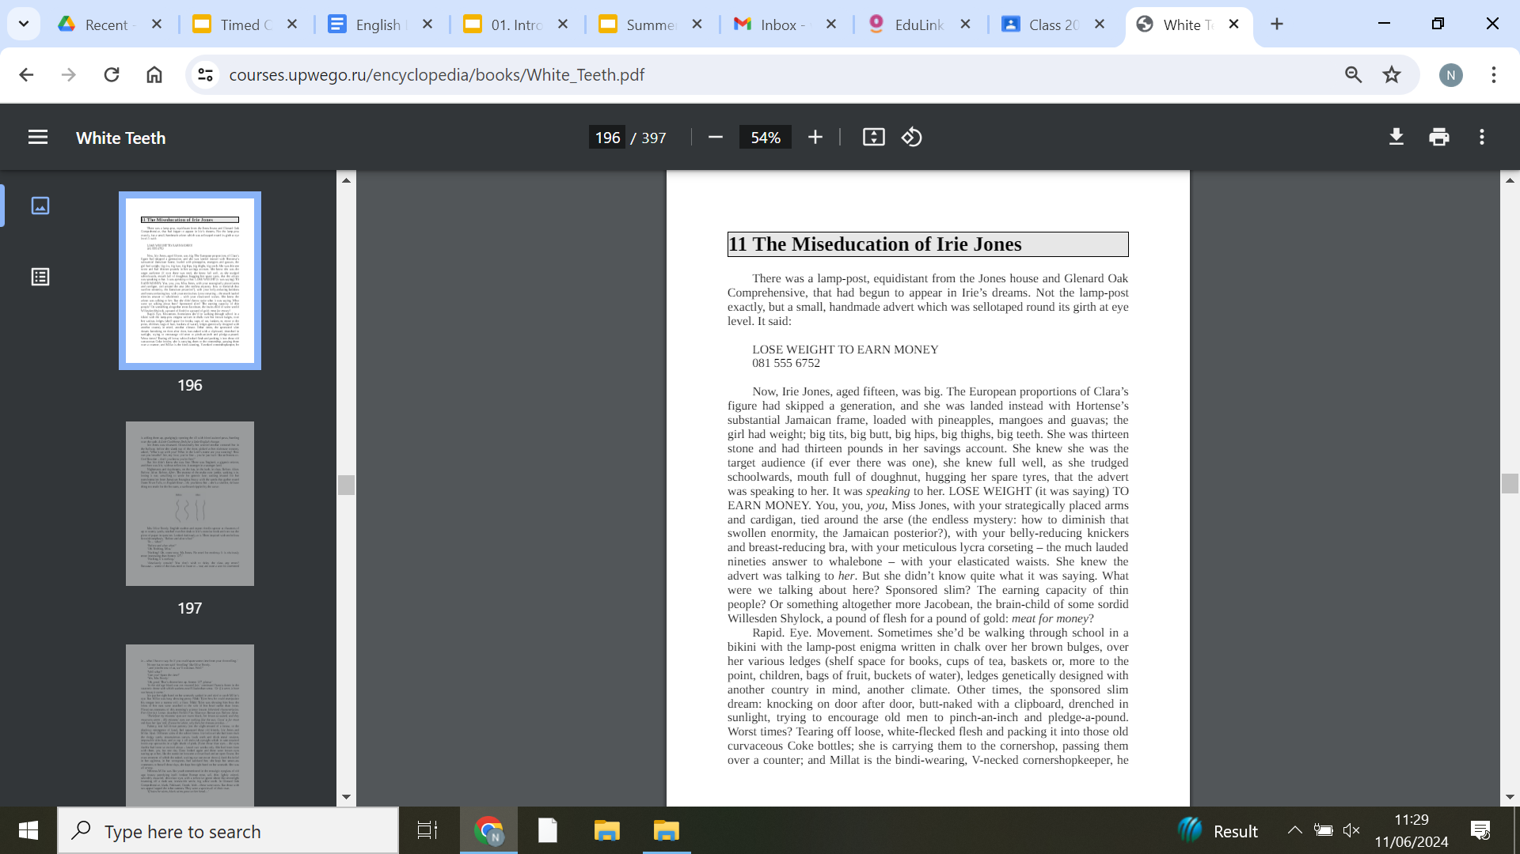of her hair falling out and Irie having to buy expensive extensions.

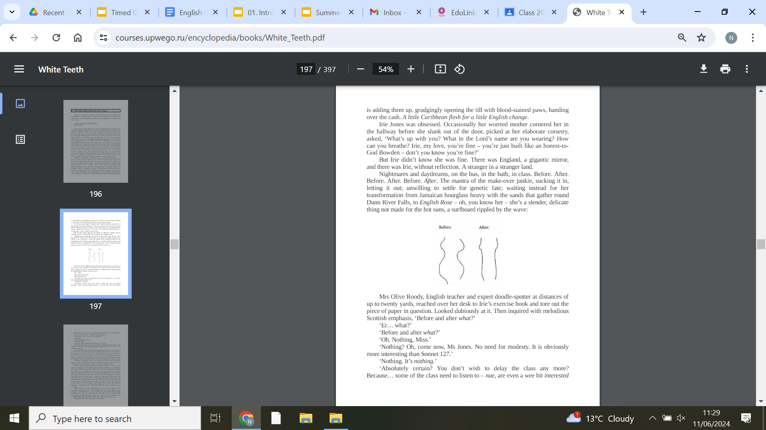

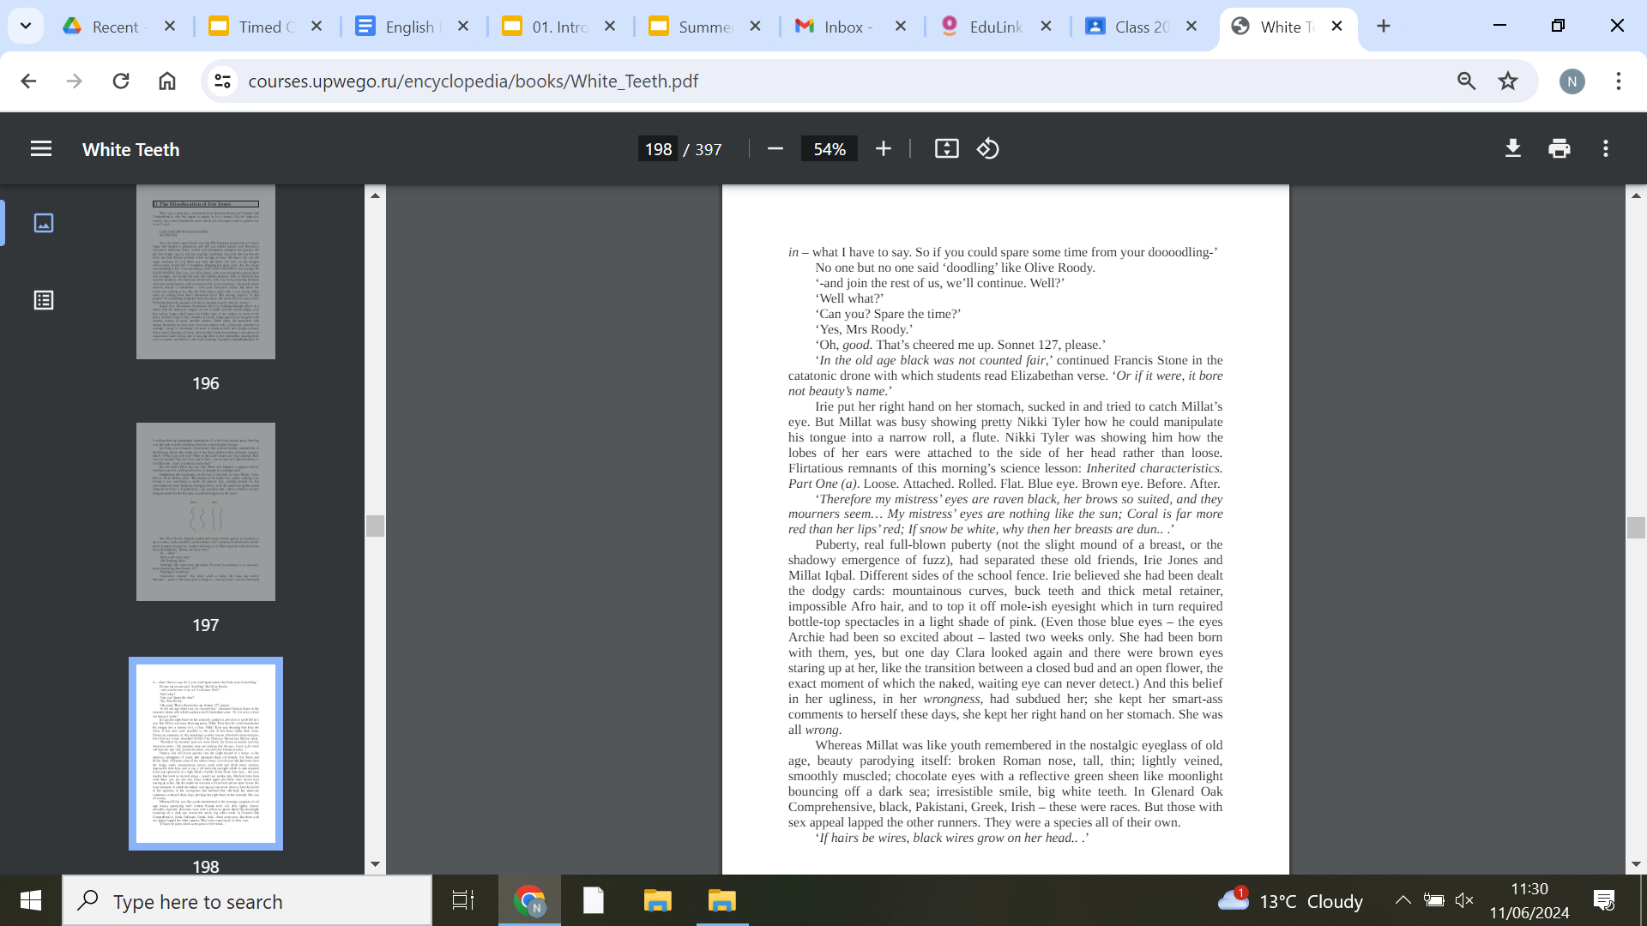

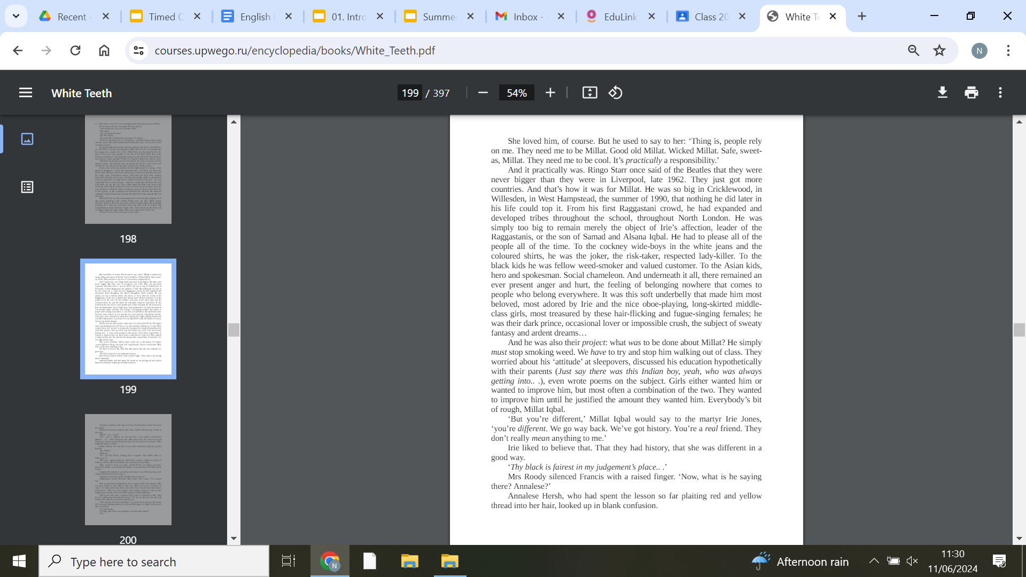

| **Read** | | **Listen (podcasts)** |
| --- | --- | --- |
| Set Texts:  *A Streetcar Named Desire* by Tennessee Williams  *Othello* by William Shakespeare  *Poems of the Decade* (Anthology)  *Romantic Poetry* (Anthology)  *The Handmaid’s Tale* by Margaret Atwood  *Frankenstein* by Mary Shelley  Recommended Reads:  *Wuthering Heights* by Emily Bronte  *A Thousand Splendid Suns* by Khaled Hosseini  *White Teeth* by Zadie Smith  *Oranges are not the Only Fruit* by Jeanette Winterson  *A Tree Grows in Brooklyn* by Betty Smith  *The Bloody Chamber* by Angela Carter  *Brick Lane* by Monica Ali  *The Colour Purple* by Alice Walker  *Americanah* by Chimamanda Ngozi Adichie  *The Bell Jar* by Sylvia Plath  *The Grapes of Wrath* by John Steinbeck  *Jane Eyre* by Charlotte Bronte  *The Great Gatsby* by F. Scott Fitzgerald  *Atonement* by Ian McEwan  *Beloved* by Toni Morrison  *Captain Corelli’s Mandolin* by Louis de Bernières  *A Farewell to Arms* by Ernest Hemingway  *The Kite Runner* by Khaled Hosseini  *The Secret History* by Donna Tartt  *Rebecca* by Daphne du Maurier | | How to Love Lit  The London Review Bookshop  BBC Open Book  The Classic English Literature Podcast  On the Road with Penguin Classics  The History of Literature  My Shakespeare, The Folio Roadshow |
| **Watch** |
| Any National Theatre at Home production (great for watching Shakespeare!)  Literature Lessons: A category on TED-Ed that offers literature lessons  The School of Life: A YouTube channel that offers a series on authors and their themes, as well as video essays on various topics.  The Literature Channel: A YouTube channel that provides lectures on the history of English from a professor at the University of Ottawa |