A level English Language Transition Tasks
Language under the Microscope
Find definitions and examples of the following word classes. You may need to look some of these up.
Word Class | Definition | Example in a sentence
Noun
Verb
Adjective
Preposition
Determiner
First person pronoun
Second person pronoun
Third person pronoun
Possessive pronoun
Demonstrative pronoun
Interrogative pronoun
Relative pronoun
Reflexive pronoun
Indefinite pronoun
Proper Noun
Abstract Noun
Concrete Noun
Auxiliary Verb
Deontic Modal Verb
Epistemic Modal Verb
Dynamic Verb
Stative Verb
Transitive Verb
Intransitive Verb
Comparative Adjective
Superlative Adjective

Answer the questions in full sentences.
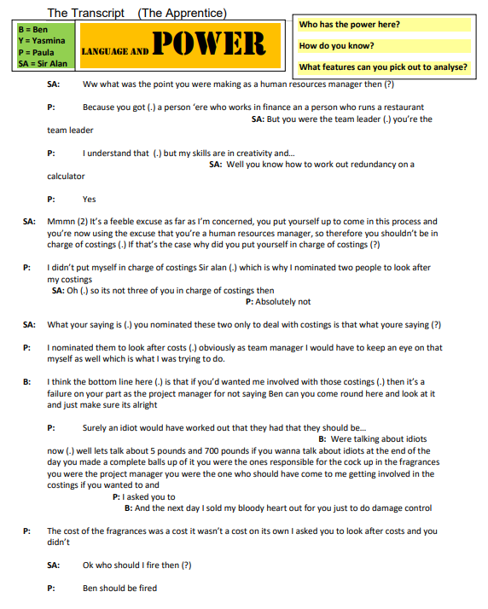

YOUR language: what is it like?
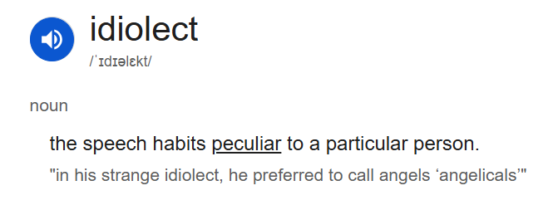
1. Do you use Twitter, Instagram, Snapchat, Facebook, or TikTok? What words do you most often use?
2. How long is your average update?
2. Do you use hashtags – not just for Twitter and Instagram?
3. What words or phrases are fashionable in your year group this year? Do you use them?
4. Do you use any words, grammar or pronunciations that drive your parents mad? What are they?
5. What’s your language history? What does your accent reveal about you/your parents/where you are from / which sounds you like and hate?
6. Do you have any family words that no one else uses? Where did they come from?
7. Look up the last 6 words to be admitted to the Oxford English Dictionary. Any surprises?

The Lighter Side of Idiolects
"'Zerts are what I call desserts. Tray-trays are entrees. I call sandwiches sammies, sandoozles, or Adam Sandlers. Air conditioners are cool blasterz, with a z. I don't know where that came from. I call cakes big ol' cookies. I call noodles long-ass rice. Fried chicken is fri-fri chickychick. Chicken parm is chicky chicky parm parm. Chicken cacciatore? Chicky catch. I call eggs pre-birds or future birds. Root beer is super water. Tortillas are bean blankies. And I call forks . . . food rakes."
(Aziz Ansari as Tom in Parks and Recreation, 2011)

How is language shaped by those who use it?
Using the information from the last pages, write an article for a student newspaper defending the creativity of modern ‘youth-speak’ OR condemning it.

You can use the following article and podcast to generate some ideas:
https://www.theguardian.com/commentisfree/2013/oct/16/banning-slang-harris-academy-alienateyoung-people
https://www.bbc.co.uk/programmes/b08ffvp6

Read |  | Listen (podcasts)
Non-fiction (useful for coursework)  Down and Out in Paris and London by George Orwell  Skating to Antarctica by Jenny Diski  Stuart A Life Backward by Alexander Masters  Hyperbole and a Half by Allie Brosh  The Lost Continent by Bill Bryson  I am The Secret Footballer by Anon  Stasiland by Anna Funder  Why Be Happy When You Could be Normal? by Jeannette Winterson  The Examined Life by Stephen Grosz  Twelve Years a Slave by Solomon Northrop  In Cold Blood by Truman Capote  What the Chinese Don’t Eat by Xinran  A Little Book of Language by David Crystal  Discover Grammar by David Crystal  Rediscover Grammar by David Crystal  The Frameworks of English by Kim Ballard  Advanced English Language by Sara Thorne  The Language Wars: A History of Proper English by Henry Hitchings  Mother Tongue by Bill Bryson  The Language Instinct by Steven Pinker  Eats, Shoots and Leaves: The Zero Tolerance Approach to Punctuation by Lynne Truss  The Etymologicon by Mark Forsyth  The Power of Babel by John McWhorter  Fantabulosa by Paul Baker  Language Change - R L Trask  Online Sources:  www.bbc.co.uk/education/asguru/english/language.shtml  http://www.ucl.ac.uk/internet-grammar  http://englishlangsfx.blogspot.co.uk/  http://www.universalteacher.org.uk/lang/speech.htm  http://englishlangsfx.blogspot.co.uk/  www.babelzine.com  http://www.putlearningfirst.com/language/index.html |  | Linguistic  Jean Aitchison’s series on BBC radio 4’s Reith Lectures  Lingthusiasm podcast  The Allusionist  The Vocal Fries  The History of English Podcast  Word of Mouth on BBC 4, BBC Radio 4 - Word of Mouth - Available now  Internet Fandom Language: BBC Radio 4 - Word of Mouth, The Shipping Forecast: Internet Fandom  LQBTQIA+ and Slang: BBC Radio 4 - Word of Mouth, LGBTQIA+ slang  Words used about women: BBC Radio 4 - Word of Mouth, Words Used About Women  Protest Slogans: BBC Radio 4 - Word of Mouth, Protest Slogans
 |  | Watch
TEDxEastEnd - Paul Kerswill - Who's an Eastender now?
Crash Course Linguistics (series on Youtube)
Steven Pinker: Linguistics as a Window to Understanding the Brain
How language shapes the way we think | Lera Boroditsky

