**A level English Language Transition Tasks**

**Language under the Microscope**

Find definitions and examples of the following word classes. You may need to look some of these up.

| **Word Class** | **Definition** | **Example in a sentence** |
| --- | --- | --- |
| Noun |  |  |
| Verb |  |  |
| Adjective |  |  |
| Preposition |  |  |
| Determiner |  |  |
| First person pronoun |  |  |
| Second person pronoun |  |  |
| Third person pronoun |  |  |
| Possessive pronoun |  |  |
| Demonstrative pronoun |  |  |
| Interrogative pronoun |  |  |
| Relative pronoun |  |  |
| Reflexive pronoun |  |  |
| Indefinite pronoun |  |  |
| Proper Noun |  |  |
| Abstract Noun |  |  |
| Concrete Noun |  |  |
| Auxiliary Verb |  |  |
| Deontic Modal Verb |  |  |
| Epistemic Modal Verb |  |  |
| Dynamic Verb |  |  |
| Stative Verb |  |  |
| Transitive Verb |  |  |
| Intransitive Verb |  |  |
| Comparative Adjective |  |  |
| Superlative Adjective |  |  |

Answer the questions in full sentences.

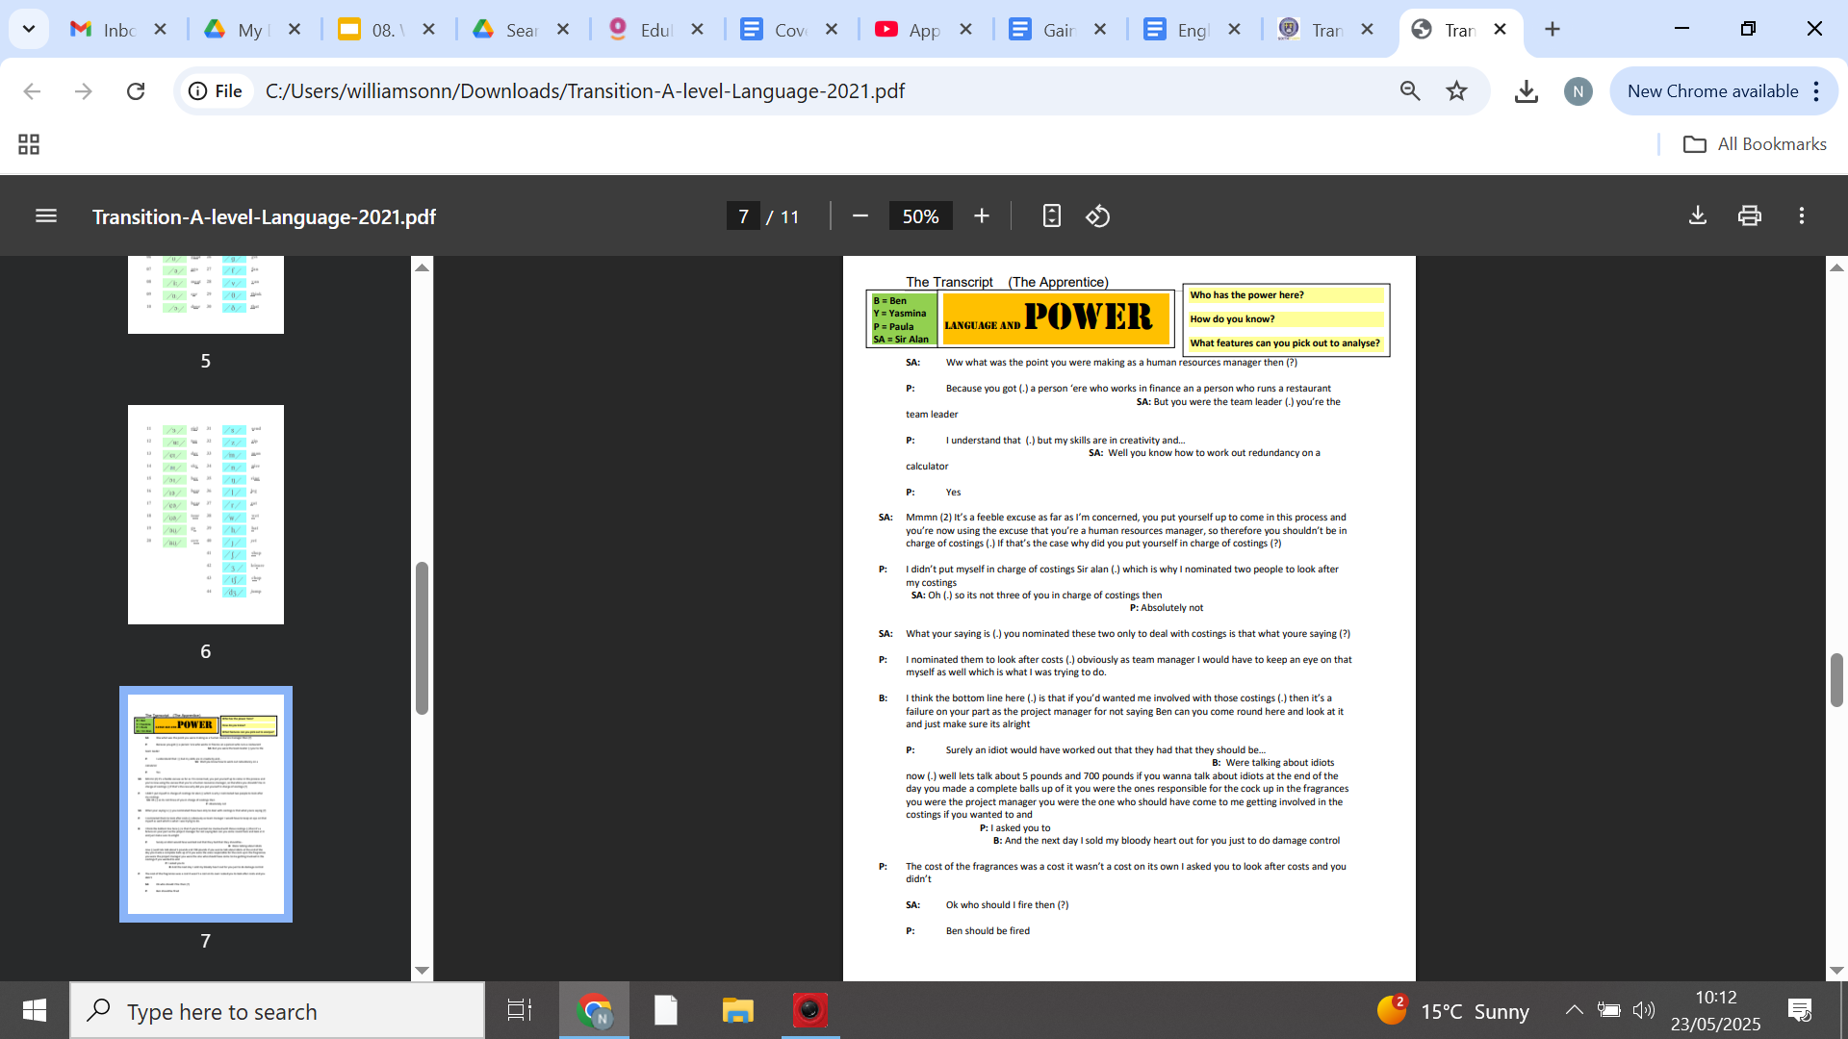

**YOUR language: what is it like?**

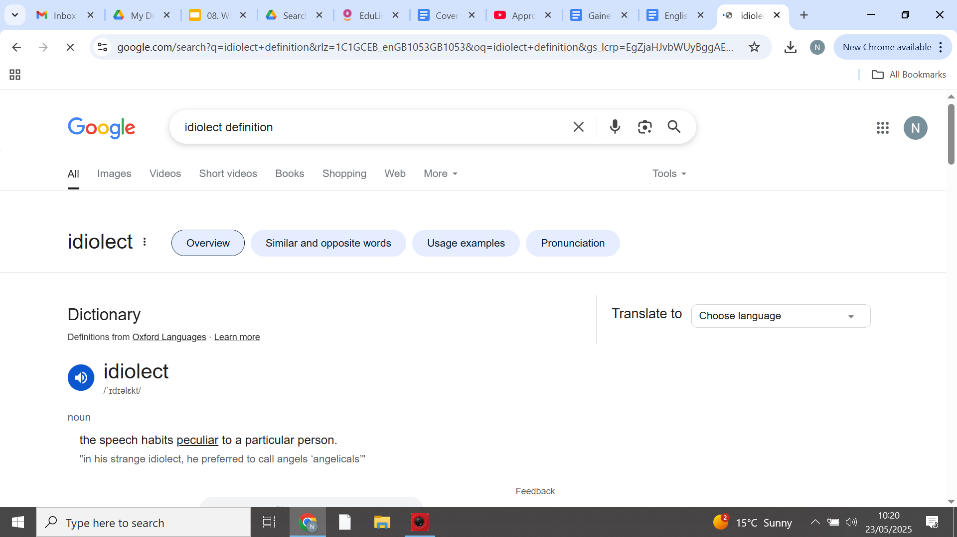

1. Do you use Twitter, Instagram, Snapchat, Facebook, or TikTok? What words do you most often use?

2. How long is your average update?

2. Do you use hashtags – not just for Twitter and Instagram?

3. What words or phrases are fashionable in your year group this year? Do you use them?

4. Do you use any words, grammar or pronunciations that drive your parents mad? What are they?

5. What’s your language history? What does your accent reveal about you/your parents/where you are from / which sounds you like and hate?

6. Do you have any family words that no one else uses? Where did they come from?

7. Look up the last 6 words to be admitted to the Oxford English Dictionary. Any surprises?

**The Lighter Side of Idiolects**

"'Zerts are what I call desserts. Tray-trays are entrees. I call sandwiches sammies, sandoozles, or Adam Sandlers. Air conditioners are cool blasterz, with a z. I don't know where that came from. I call cakes big ol' cookies. I call noodles long-ass rice. Fried chicken is fri-fri chickychick. Chicken parm is chicky chicky parm parm. Chicken cacciatore? Chicky catch. I call eggs pre-birds or future birds. Root beer is super water. Tortillas are bean blankies. And I call forks . . . food rakes."

(Aziz Ansari as Tom in Parks and Recreation, 2011)

**How is language shaped by those who use it?**

Using the information from the last pages, write an article for a student newspaper defending the creativity of modern ‘youth-speak’ OR condemning it.

You can use the following article and podcast to generate some ideas:

<https://www.theguardian.com/commentisfree/2013/oct/16/banning-slang-harris-academy-alienateyoung-people>

<https://www.bbc.co.uk/programmes/b08ffvp6>

| **Read** | | **Listen (podcasts)** |
| --- | --- | --- |
| *Non-fiction (useful for coursework)*  *Down and Out in Paris and London* by George Orwell  *Skating to Antarctica* by Jenny Diski  *Stuart A Life Backward* by Alexander Masters  *Hyperbole and a Half* by Allie Brosh  *The Lost Continent* by Bill Bryson  *I am The Secret Footballer* by Anon  *Stasiland* by Anna Funder  *Why Be Happy When You Could be Normal?* by Jeannette Winterson  *The Examined Life* by Stephen Grosz  *Twelve Years a Slave* by Solomon Northrop  *In Cold Blood* by Truman Capote  *What the Chinese Don’t Eat* by Xinran  *A Little Book of Language* by David Crystal  *Discover Grammar* by David Crystal  *Rediscover Grammar* by David Crystal  *The Frameworks of English* by Kim Ballard  *Advanced English Language* by Sara Thorne  *The Language Wars: A History of Proper English* by Henry Hitchings  *Mother Tongue* by Bill Bryson  *The Language Instinct* by Steven Pinker  *Eats, Shoots and Leaves: The Zero Tolerance Approach to Punctuation* by Lynne Truss  *The Etymologicon* by Mark Forsyth  *The Power of Babel* by John McWhorter  *Fantabulosa* by Paul Baker  Language Change - R L Trask  Online Sources:  [www.bbc.co.uk/education/asguru/english/language.shtml](http://www.bbc.co.uk/education/asguru/english/language.shtml)  <http://www.ucl.ac.uk/internet-grammar>  <http://englishlangsfx.blogspot.co.uk/>  <http://www.universalteacher.org.uk/lang/speech.htm>  <http://englishlangsfx.blogspot.co.uk/>  [www.babelzine.com](http://www.babelzine.com)  <http://www.putlearningfirst.com/language/index.html> | | *Linguistic*  Jean Aitchison’s series on BBC radio 4’s Reith Lectures  Lingthusiasm podcast  The Allusionist  The Vocal Fries  The History of English Podcast  Word of Mouth on BBC 4, [BBC Radio 4 - Word of Mouth - Available now](https://www.bbc.co.uk/programmes/b006qtnz/episodes/player)  Internet Fandom Language: [BBC Radio 4 - Word of Mouth, The Shipping Forecast: Internet Fandom](https://www.bbc.co.uk/programmes/m000vwsh)  LQBTQIA+ and Slang: [BBC Radio 4 - Word of Mouth, LGBTQIA+ slang](https://www.bbc.co.uk/programmes/m000s9vj)  Words used about women: [BBC Radio 4 - Word of Mouth, Words Used About Women](https://www.bbc.co.uk/programmes/m000l8pf)  Protest Slogans: [BBC Radio 4 - Word of Mouth, Protest Slogans](https://www.bbc.co.uk/programmes/m000m13r) |
| **Watch** |
| TEDxEastEnd - Paul Kerswill - Who's an Eastender now?  Crash Course Linguistics (series on Youtube)  Steven Pinker: Linguistics as a Window to Understanding the Brain  How language shapes the way we think | Lera Boroditsky |