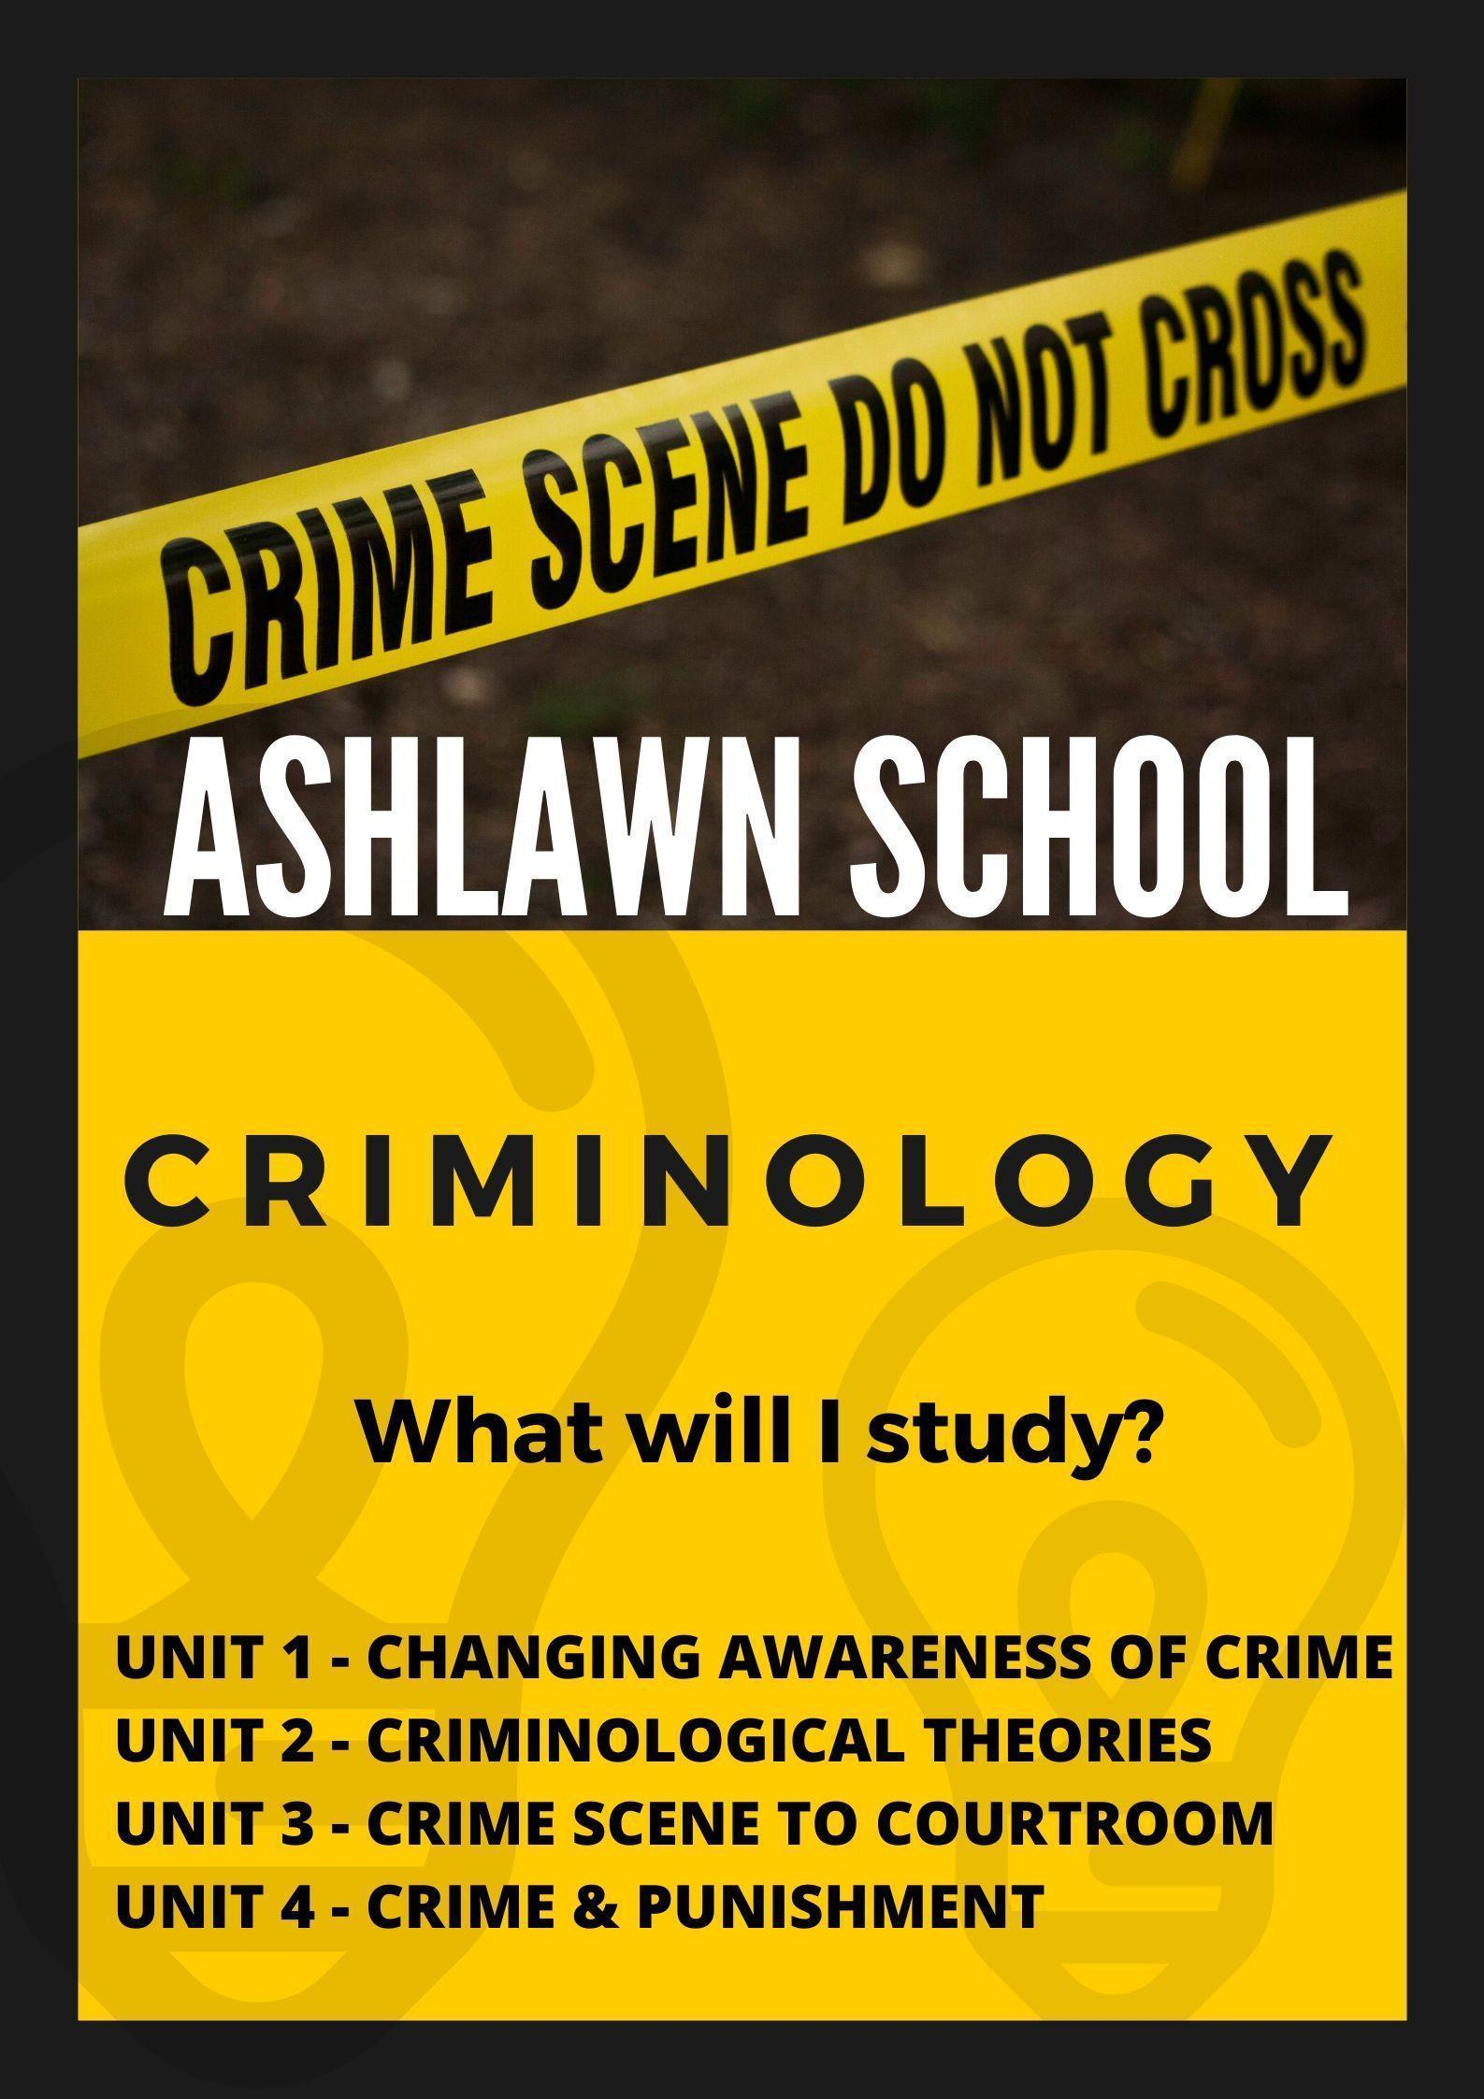

**Welcome to Criminology!**

This is an activity pack of things that you need to do before you start the course in the Autumn term. The deadline for submission of your tasks is Friday 12th of September 2025. You can do so via emailing them to me:

[wylupekp@ashlawn.tlet.org.uk](mailto:wylupekp@ashlawn.tlet.org.uk) or print the completed work out and bring it to school

**Key Information:**

We follow the WJEC examination board. <https://www.wjec.co.uk/en/qualifications/criminology-level-3#tab_overview>

**In year 12 you will study two units:**

1) Changing awareness of crime

2) Criminological theories.

**In year 13 you will study two units:**

1) Crime scene to courtroom

2) Crime and punishment.

In both year 12 and year 13 you will undertake a controlled assessment which will be worth **25%** of your overall grade, and **50%** of your grade for the year.   
This is a piece of coursework which takes place under exam conditions. You will be allowed to take unmarked class work into the controlled assessment, so it is important from day one your notes are well organised.

In the summer of both year one and year two, you will have an external examination, which will be worth **25%** of your overall grade, and **50%** of your grade for the year. This will be a formal exam under strict examination conditions.

If you would like to purchase a textbook, we recommend the textbook, “Criminology: Book one. For the WJEC Level 3 Applied Certificate & Diploma. Rob Webb and Annie Townend”.

**TASK ONE - Prepare**

One of the first things we would encourage you to do before starting in the Autumn term is to have an arch file folder with dividers. These 11 dividers should labelled as below (you can file your class notes in this folder which will then benefit your controlled assessment outcome)

1) AC 1.1: Analyse different types of crime.

2) AC 1.2: Explain the reasons that certain crimes are unreported.

3) AC 1.3: Explain the consequences of unreported crime.

4) AC 1.4: Describe media representation of crime.

5) AC 1.5: Explain the impact of media representations on the public perception of crime.

6) AC 1.6: Evaluate methods of collecting statistics about crime.

7) AC 2.1: Compare campaigns for change.

8) AC 2.2: Evaluate the effectiveness of media used in campaigns for change.

9) AC 3.1: Plan a campaign for change relating to crime.

10) AC 3.2: Design materials for use in campaigning for change.

11) AC 3.3: Justify a campaign for change. 

**TASK TWO:**

Under assessment criteria (AC) 1.1 we will look at a range of types of crime including:

* White collar crime
* Moral crime
* State crime
* Technological crime
* Individual crime: hate crime
* Individual crime: ‘honour’ crime
* Individual crime: domestic abuse

**MUST COMPLETE:** You should research the above types of crimes and find recent cases of each. Create a table where you include a summary of what happened and who was the victim and offender.

**COULD COMPLETE:** You should get familiar with the use of a program called canva. [www.canva.com](http://www.canva.com) - I encourage you to create an informative poster on one of your chosen types of crime in the above program.

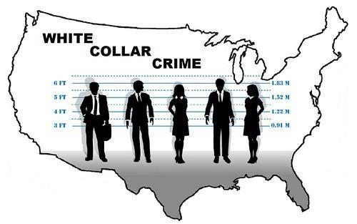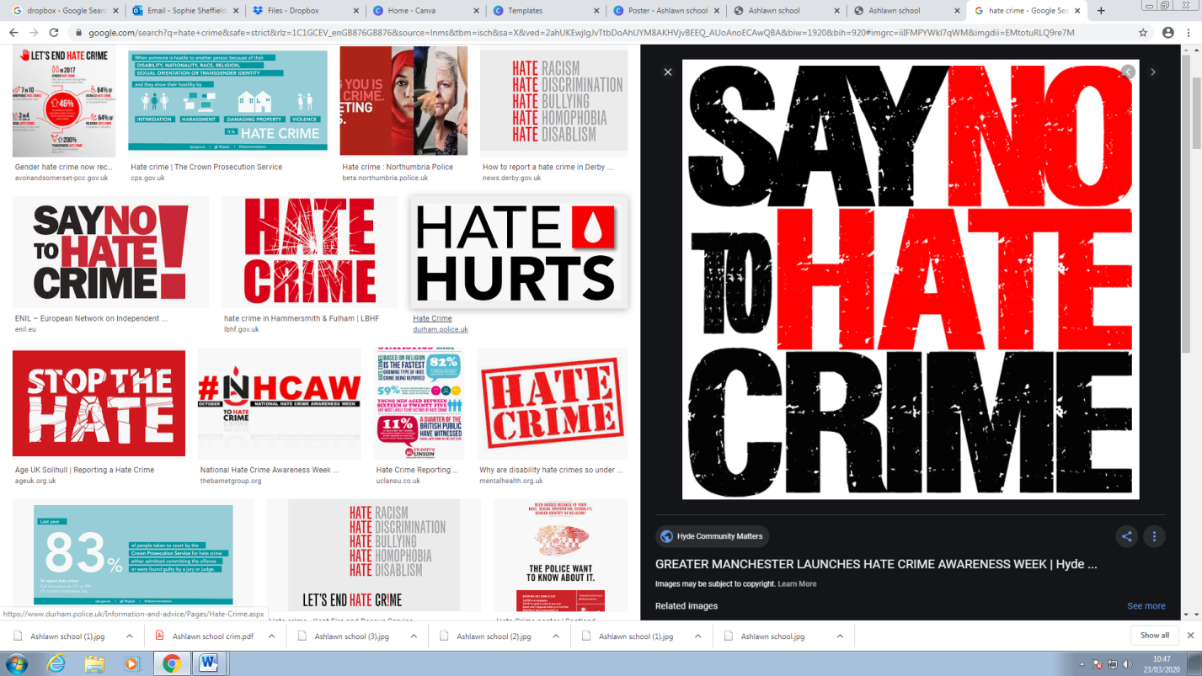

**TASK THREE:**

As part of AC 2.1 we look at a range of, ‘campaigns for change’.

Campaigns for change are when members of society want to bring about a change of some kind, and they do this by getting others to agree with what they want.   
  
**MUST COMPLETE:** read about the below two campaigns and answer:

1) What do they want to achieve and why?

2) Have they managed to change any laws/policies? Which ones?

* Unlock
* Sarah’s Law

**COULD COMPLETE:** You could also research the Double jeopardy campaign by Ann Ming, and/or Clare’s law. 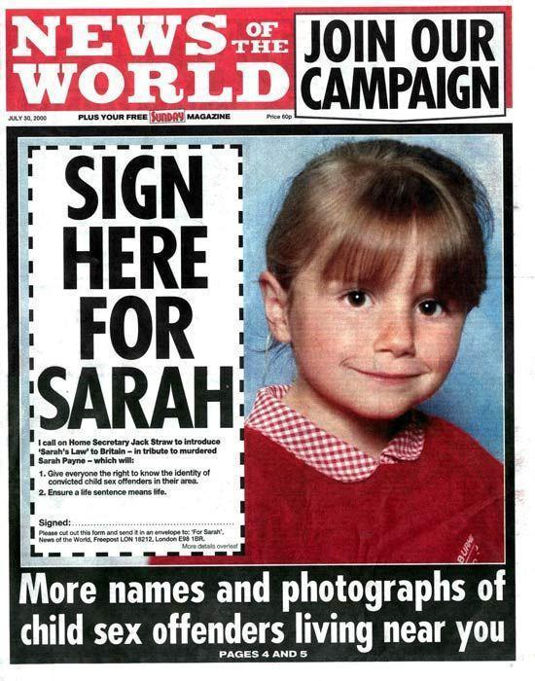

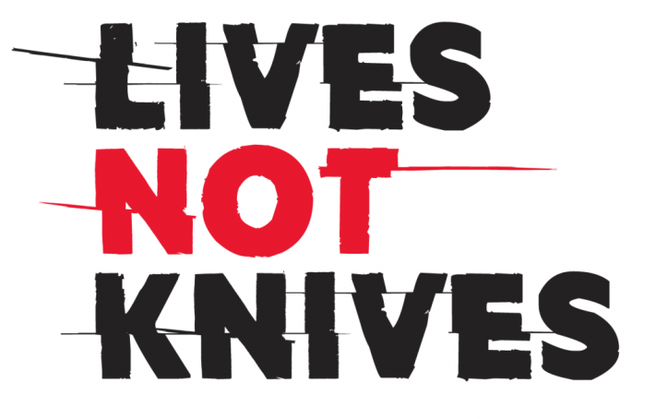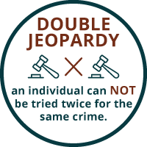

**TASK FOUR:**

As part of AC 1.6 you need to be able to evaluate different sources of crime statistics, the main two we are interested in are:

1) Home office statistics: Police recorded crime

2) The Crime survey for England and Wales.

**MUST COMPLETE:** Research the above types of statistics. Compare the following: how do they gather data? How is data collected by each used?



**TASK FIVE:**

As part of AC 1.5 you need to be able to understand what a moral panic is.

**MUST COMPLETE:**   
Research what a moral panic is, and find a case example that you write about. Write a small summary on what happened and how is this an example of moral panic.

**TASK SIX:**

You could watch the following clips/documentaries to gain an overall insight into

the area of Criminology.

**Honour crime**: “Culture must never be used as a justification for honour violence”

<https://www.youtube.com/watch?time_continue=38&v=nYqNM9SvRdY>

**Hate crime**: University of Leicester Criminology department. What is hate crime?

<https://www.youtube.com/watch?v=ipLfl1iH2xQ>

**The Amanda Knox documentary**: Learning about processes of crime.

<https://www.youtube.com/watch?v=erla7Ley4Tw>

**Hate crime**: The Stephen Lawrence case, “Crimes that shook Britain”.

https://www.youtube.com/watch?v=iFuniaRZnRM

**Campaigns for change**: Sarah’s law.

<https://www.youtube.com/watch?v=T4jgcWsbTj0>

**Campaigns for change/General Criminology**: Catching Britain’s killers: The crimes that changed us.

<https://www.bbc.co.uk/programmes/m00095qf>

**Unit 2: Theories of Criminality**: C4: What determines if someone will become a murderer?

<https://www.youtube.com/watch?v=pO-HcgATysQ>

**Unit 2: Theories of Criminality**: TED talk, “The surprising connection between brain injuries and crime”.

<https://www.youtube.com/watch?v=fO2htapfNhA>

Reading list suggestions

# The Job’s F****d: Secret Diary of a Police Officer - Jay Darkmoore

1. Prescription for murder - Brian Whittle

# Murder in the Name of Honour - Rana Husseini

1. [A Sense of Freedom by Jimmy Boyle](https://www.theguardian.com/books/2016/may/20/glasgow-gangster-jimmy-boyle-prisons-a-sense-of-freedom-1977-republished) and [Redeemable by Erwin James](https://www.theguardian.com/profile/erwinjames)
2. [The Profession of Violence by John Pearson](https://thecrimereview.com/2017/08/28/review-the-profession-of-violence-by-john-pearson/)
3. [Gone Shopping by Lorraine Gamman](http://www.goneshopping.org.uk/archive.html)
4. [East End Underworld by Raphael Samuel](https://academic.oup.com/hwj/article-abstract/64/1/347/600987?redirectedFrom=fulltext)
5. [Good Cop, Bad War by Neil Woods, with JS Rafaeli](https://guardianbookshop.com/good-cop-bad-war-477591.html)
6. [Strange Piece of Paradise by Terri Jentz](https://www.nytimes.com/2006/05/14/books/review/14roach.html?mtrref=www.google.com&gwh=FB9C4423257EBDEF6610ECBCD8B5711D&gwt=pay)
7. [Gentleman Thief by Peter Scott](https://www.telegraph.co.uk/news/obituaries/9949054/Peter-Scott.html)
8. [The Lost Girl by Caroline Roberts](http://news.bbc.co.uk/1/hi/magazine/3509899.stm)
9. [Murder in Notting Hill by Mark Olden](http://www.murderinnottinghill.com/)