Transition to
A level
Chemistry

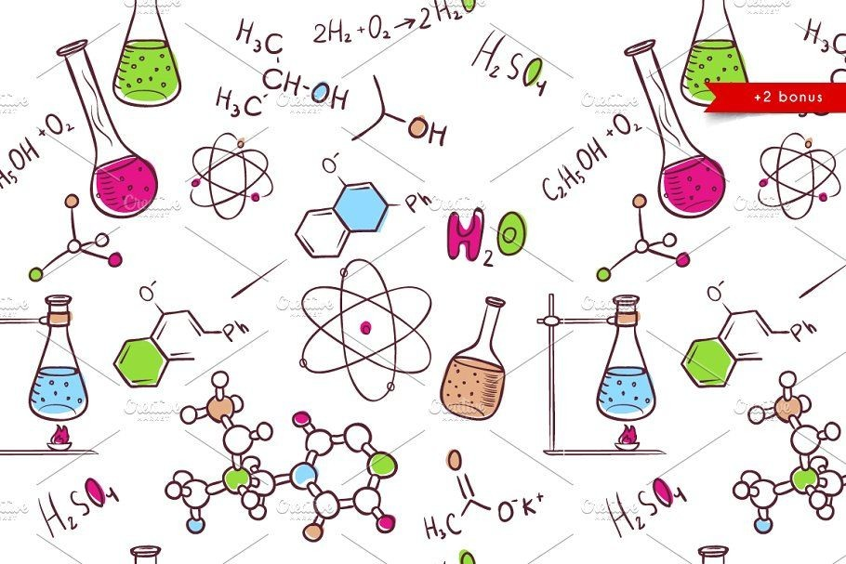

Contents page

Introduction and specification 3
Recommended Reading 4
Useful websites 5
Transition activities
Atomic structure 6
Bonding and structure 7
Amount of substance 11
Titration calculations 15
Oxidation and reduction 16
Balancing equations 18
Research projects ​20
Transition activities answers ​21

Introduction

The aim of this booklet is to ease you into A level Chemistry. The course we follow at Ashlawn School is OCR Chemistry A. There is a link to the specification at the bottom of​ this page. There is also some recommended reading. Some of these are books that could support you throughout the year.

The jump from GCSE to A level is huge and to be a successful chemist at A level it is essential you work on the key concepts such as bonding, calculations and redox reactions. Have a go at the activities in this booklet. Answers will be provided for you to check your understanding. These activities also extend into KS5 content to give you a bit of a challenge. Go to the useful websites page to support you with these activities.​

Once you have completed the transition activities, research into one of the projects suggested in this booklet.

You are expected to complete all work and bring it to your first lesson of Chemistry in September.

OCR CHEMISTRY A SPECIFICATION​

This is a​ two year linear course that comprises six content based modules that will be formally assessed at the end of the two year course. Students will also be trained and assessed across a range of practical skills, which is assessed separately as part of their practical endorsement.

https://www.ocr.org.uk/Images/171720-specification-accredited-a-level-gce-chemistrya-h432.pdf

Head of Chemistry: Mr Watts

Email: Wattsc@ashlawn.tlet.org.uk

Recommended reading

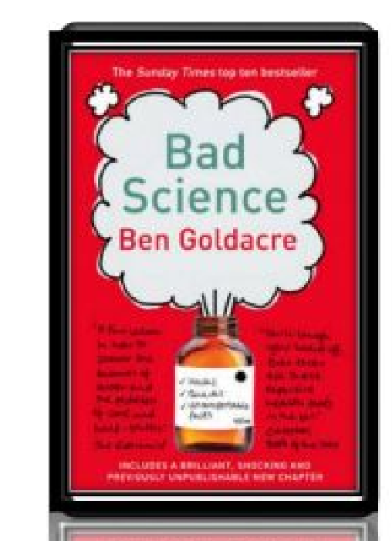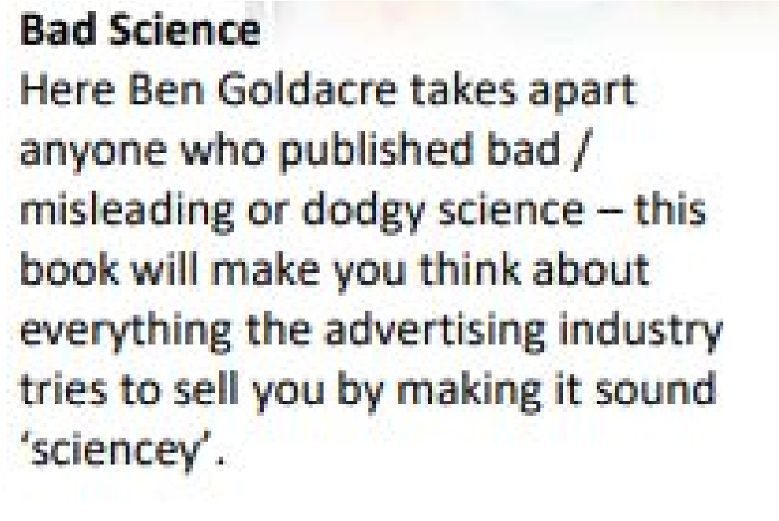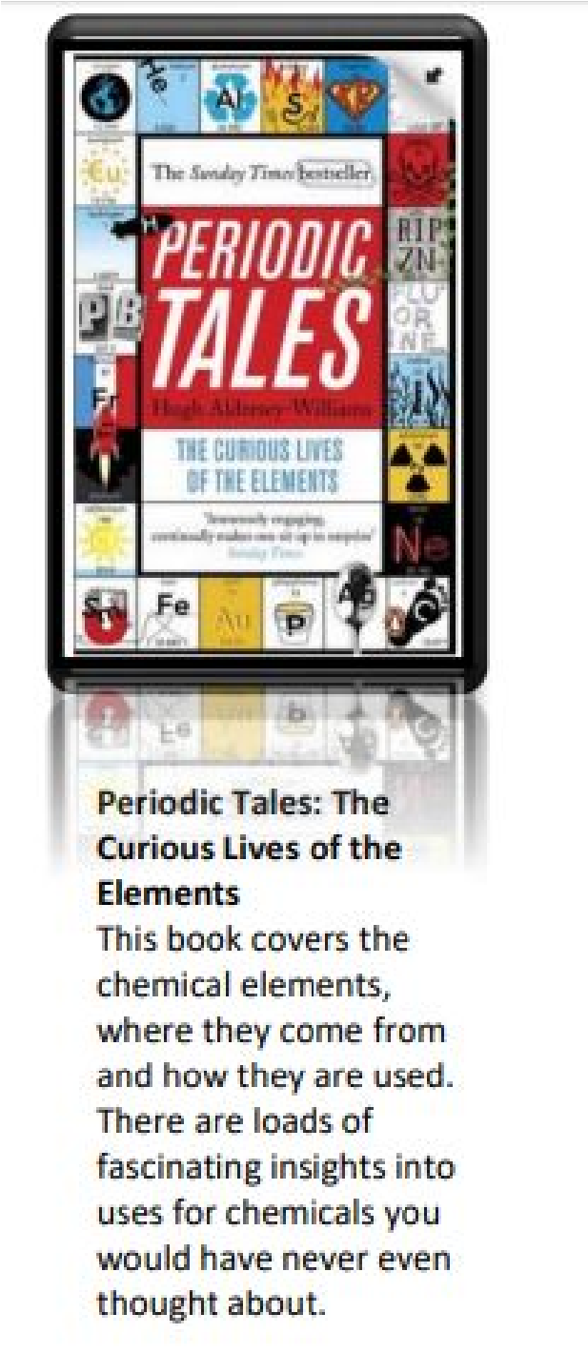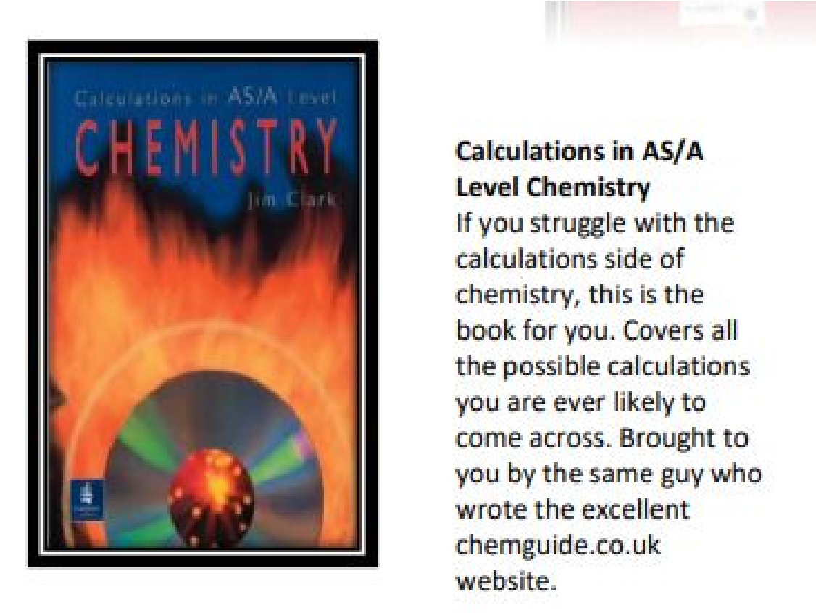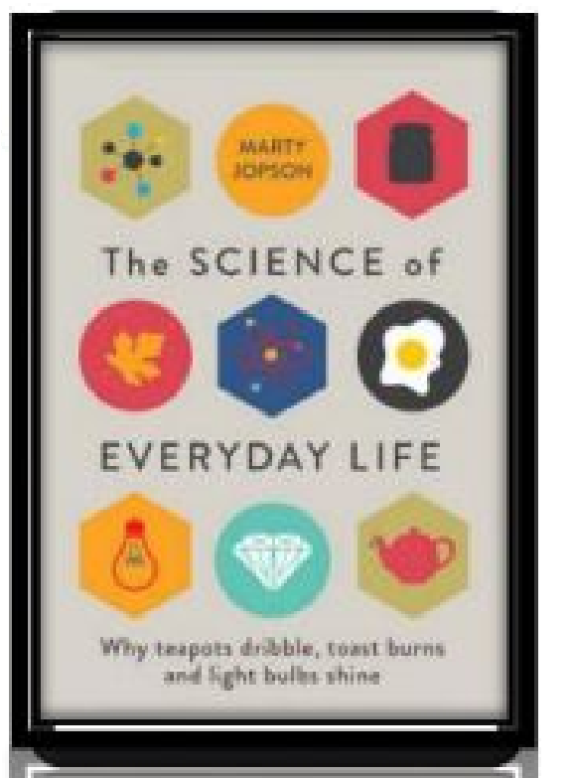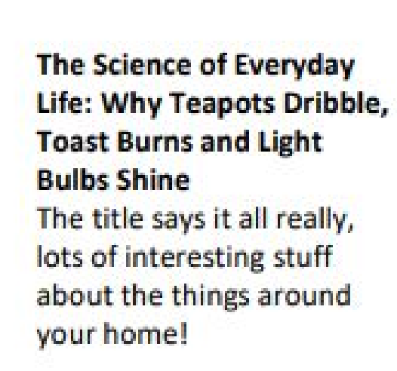

Useful websites
These websites are so useful in helping you create notes and give step by step examples. They will be helpful throughout the two year course.

This website is very detailed and identifies other resources which are sharing incorrect or outdated information and suggests the correct materials to use. The site also contains links to the syllabuses of many exam boards which means it is accessible and useful to all students. https://www.chemguide.co.u k/ | 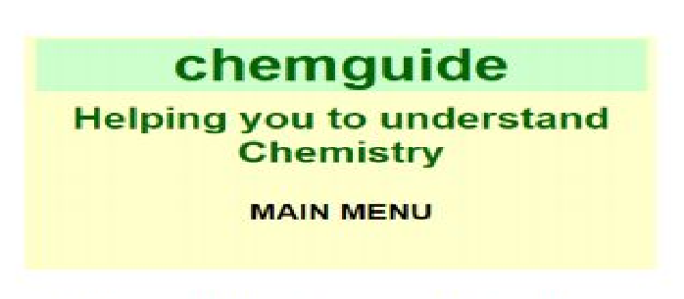
Doc Brown is a website dedicated to all three science subjects; physics, chemistry and biology. It provides the user with summarised notes (useful for making flash cards) and practice questions to further their knowledge and  understanding. The site provides resources from a wide range of exam boards including AQA, Edexcel, Chemistry, CCEA, OCR, WJEC, CIE and Salters from GCSE level to A2.  http://www.docbrown.info/ | 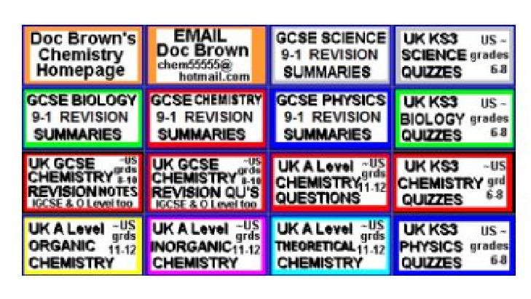
The site was first made to host revision guides that are written for AQA A-level Chemistry. These revision guides have already been circulating on the internet for a couple of years on places like student room. This will be the place for the most up to date versions of them. The site has now extended to  cover other exam boards. (OCR and Edexcel) https://chemrevise.org/ | 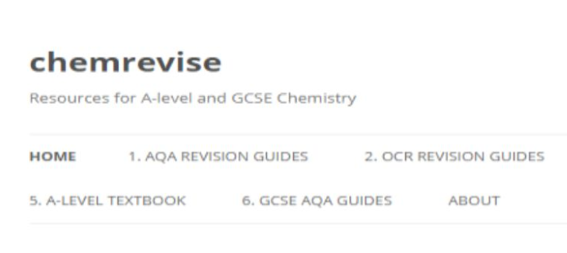
The free revision website for students studying GCSE and Alevels. S-cool provides revision guides, question banks, revision timetable and more  https://www.s-cool.co.uk/alevel/chemistry | 
Tons of awesome courses in one awesome channel! Check out the playlists for past courses in physics, philosophy, games, economics, U.S. government and politics, astronomy, anatomy & physiology, world history, biology, literature, ecology, chemistry, psychology, and of course, chemistry! https://www.youtube.com/user/crash course/featured | 

Transition activities - Atomic structure
Our current understanding of atomic structure is a result of the discoveries of several scientists over many years, each scientist adding to the model.
Complete the table below by adding the name of the scientist and the discovery made. Choose from the lists below the table. (9 marks)
Approx. year of discovery | Scientist | Addition made to our current understanding of atomic structure
1803 | John Dalton | Proposed that all matter is made up of tiny particles called atoms
1897
1911
1915
1924
1932
Scientists:
Ernest Rutherford; Wolfgang Pauli; J. J. Thomson; James Chadwick; Niels Bohr
Discoveries;
Proposed that the electrons orbit around the nucleus in orbits with a set size and energy
Discovered that atoms contain neutral particles called neutrons in their nucleus
Realised that atoms are divisible and contain very tiny, negatively charged particles called electrons
Discovered that an atom is made up of a nucleus and an extra-nuclear part. The central nucleus is positively charged and the negative electrons revolve around this central nucleus. Proposed the concept of electron spin

Bonding and structure
Draw dot and cross diagrams to illustrate the bonding in the following covalent compounds. If you wish you need only draw the outer shell electrons.
(2 marks for each correct diagram)
- Water, H​2O​

- Carbon dioxide, CO₂​

- Ethyne, C​2H​ ​2

- Phosphoryl chloride, POCl₃​

- Sulfuric acid, H​2SO​4​

Ionic dot and cross

Draw dot and cross diagrams to illustrate the bonding in the following ionic compounds.
(2 marks for each correct diagram)
1. Lithium fluoride, LiF

- Magnesium chloride, MgCl₂​

- Magnesium oxide, MgO

- Lithium hydroxide, LiOH

- Sodium cyanide, NaCN

Which type of bonding?
There are three types of strong chemical bonds; ionic, covalent and metallic.

- Sort the compounds below into groups within the circles below according to their chemical bonding.
sodium chloride, NaCl | magnesium, Mg | magnesium oxide, MgO
methane, CH₄​ | oxygen, O₂​ | barium iodide, BaI₂​
aluminium, Al | ammonia, NH₃​ | caesium, Cs
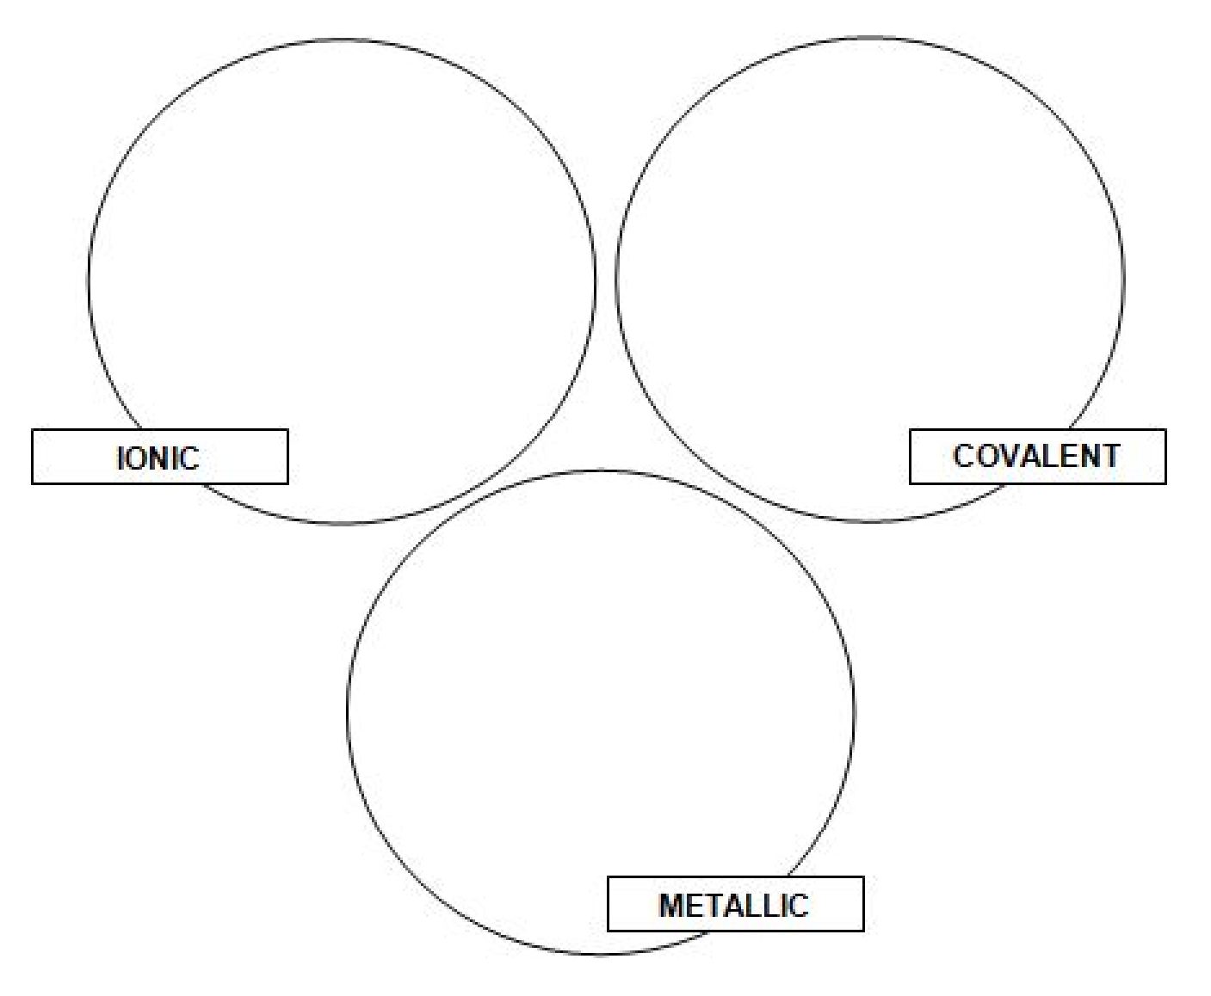
- For each of the types of compound, indicate if you would expect them to;
  - have a high or a low melting point
  - conduct electricity

Properties and bonding
Match the compound on the left to its correct structure from the middle bank of statements and one or more statements from the column on the right. Aluminium has been done for you

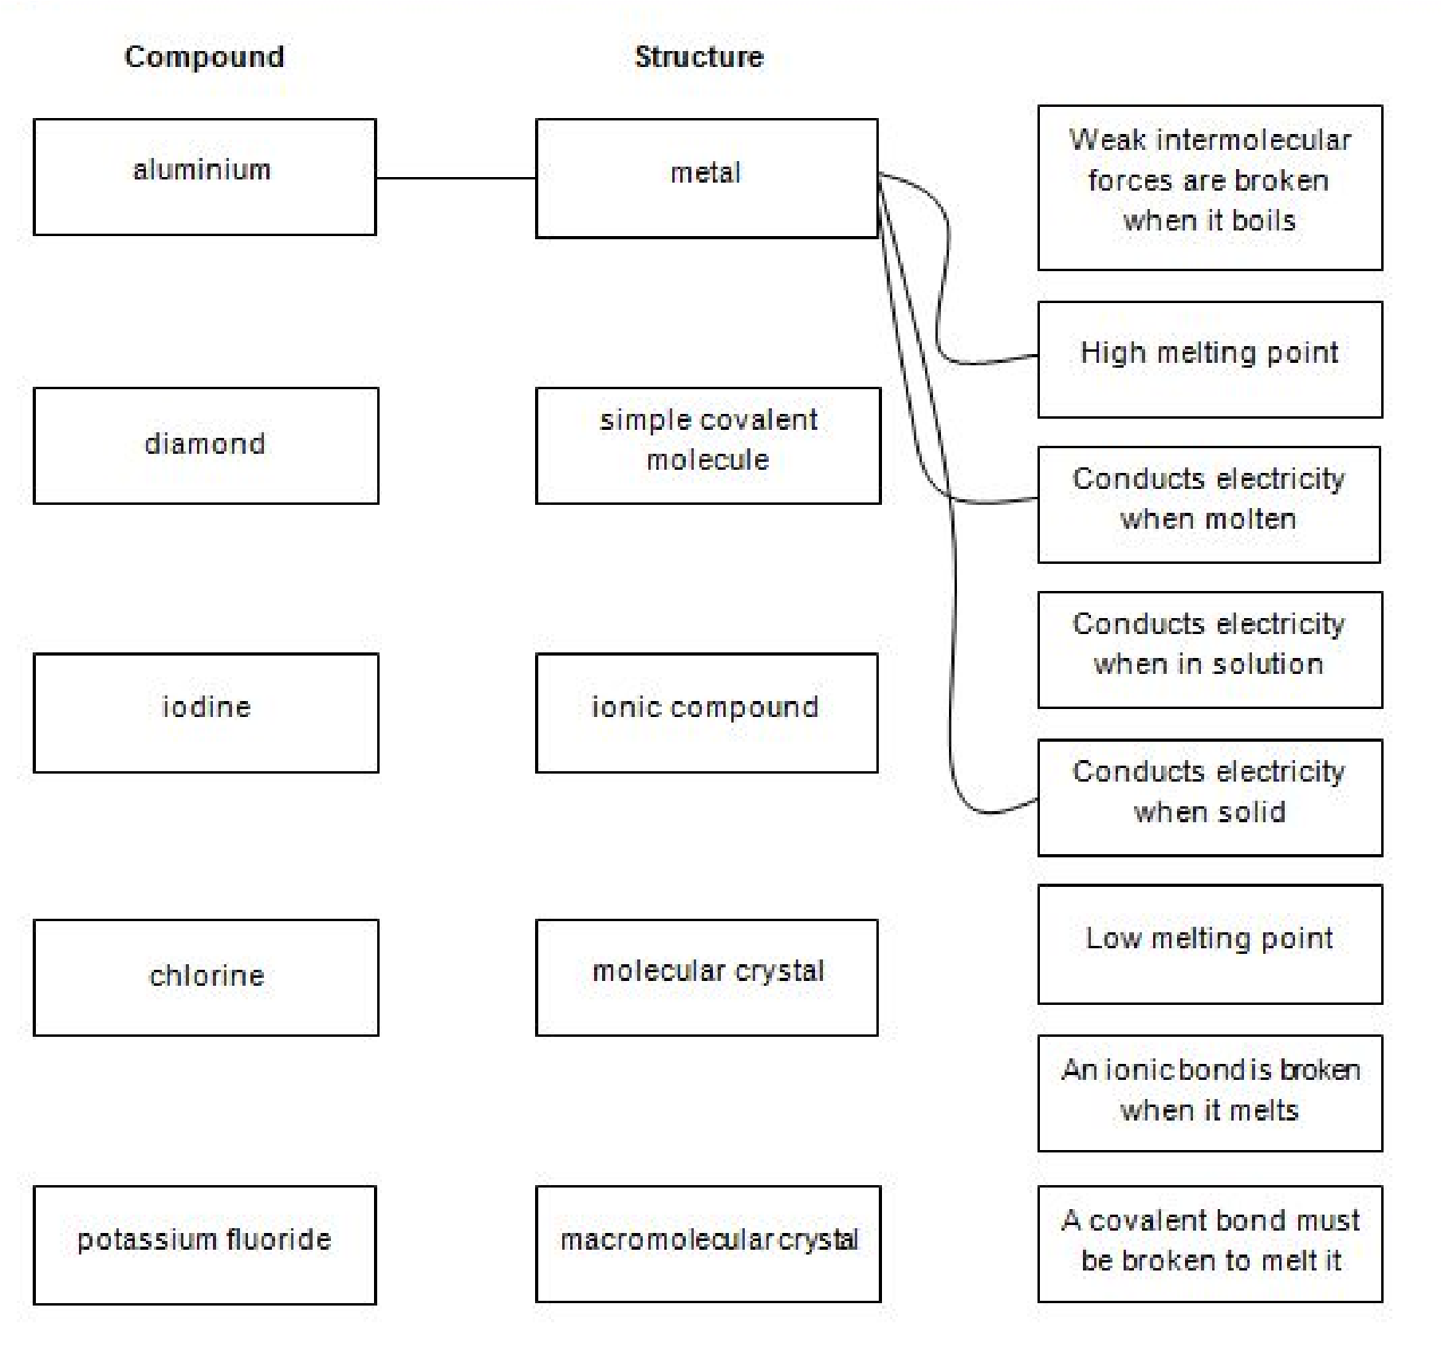

Amount of substance
The Mole
Moles and Mass
Work out the answers to the following simple calculations (1t = 1 tonne = 1,000 kg);

1. ​ No. of moles in 10.0 g of O​ ​2 + the mass in g of 2.41 moles of H​2O=
​ ​
(2 marks)

2. ​ Mass in g of 0.2 moles of K​ ​2CO​3+ mass in g of 0.5 moles of MgCO​3=
​ ​ ​
(2 marks)

3. ​ No. of moles in 12.4t of NaNO​ ​3÷ no. of moles in 12.4t of NaCl=
​
(2 marks)

4. ​ No. of moles in 25.9 g of sodium – no. of moles in 25.9 g of sodium​ chloride = (2 marks)

5. ​ ?× molar mass of in gmol​ ​^{-1​} of calcium carbonate = no. of moles in 4.2 kg of SiCl₄​

(2 marks)

Mass and concentration
Calculate the answers to the calculations below and place them (to the correct no. of sig. fig.) in the appropriate square. The arrows indicate the direction the numbers must follow. For the 10​^{th​} mark complete the remainder of the Sudoku grid.
(1 mark for each answer)
WARNING Take care with your significant figures and RAMs in order to avoid the wrong digit in the wrong square! (Relative atomic masses, H 1.0; O 16.0; Na 23.0; S 32.1; Cl 35.5; Fe 55.8; Cu 63.5)
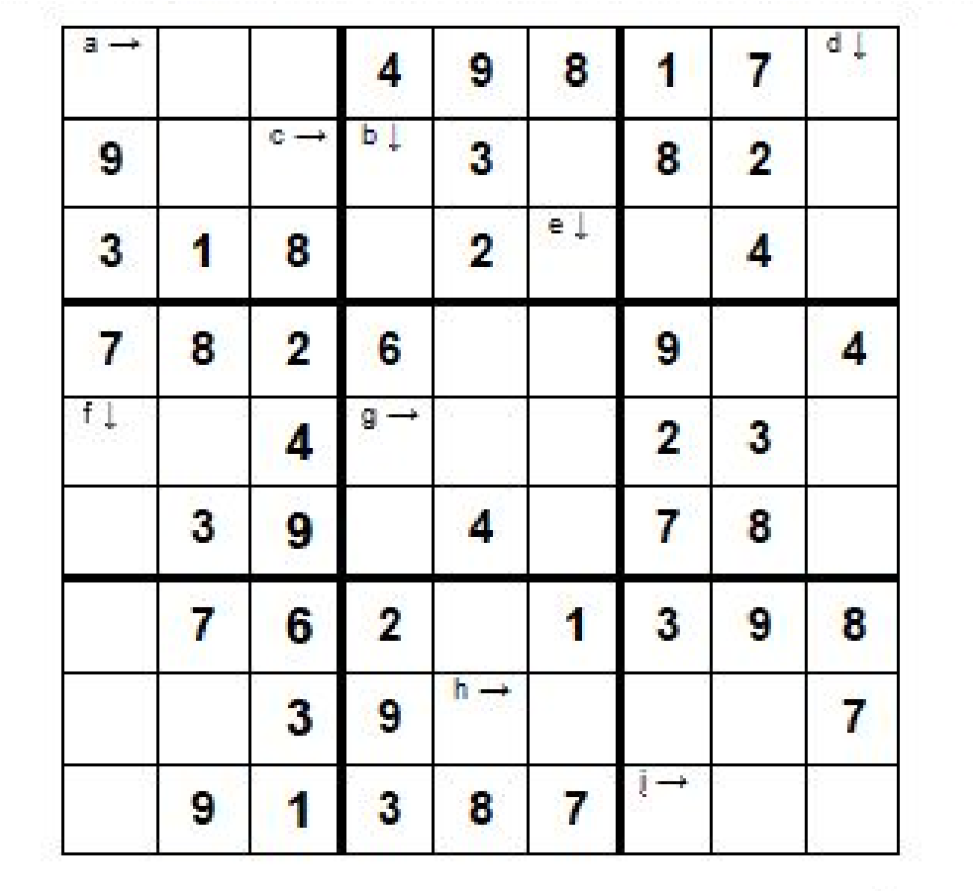
- The concentration of a solution of 265 moles of NaOH dissolved in 1 dm​^{3​} of water (3 sig. fig.)
- The volume of water in dm​^{3​} needed to dilute 176 moles of HCl to make a 1 mol dm​⁻³ solution (3 sig. fig.)
- The mass of H​₂SO​​₄ that should be dissolved in 1 dm​​^{3​} of water to make a solution of concentration 0.72 moldm​^{-3​} (2 sig. fig.)
- The volume of water in cm​^{3​} that must be added to 0.56 g of anhydrous CuSO​₄ to produce a​ 0.1 mol dm​^{-3​} solution (2 sig. fig.)
- The number of moles of ammonia that must be dissolved in 2,696 dm​^{3​} of water to produce 2.0 moldm​^{-3​} ammonia solution (4 sig. fig.)
- The concentration in moldm​^{-3​} of an accurate solution of concentration 16.48537 molcm​^{-3​} (5 sig. fig.)
- The mass of FeSO​4.7​H​2O that must be dissolved in 1,582 cm​ ​^{3​} of water to form a solution of concentration 2.0 moldm​^{-3​} (to 3 sig. fig.)
- The volume in dm​^{3​} of water that 10 moles of NaCl must be dissolved in to produce a 0.0155 mol dm​^{-3​}solution of brine (3 sig. fig.)
- The concentration in moldm​^{-3​} of a solution of NaOH with a concentration of 18,480 kg m​^{-3 ​}(3 sig.fig.)

Empirical and molecular formulae
The technicians at the University have discovered a number of bottles containing amino acids which have lost their labels. To identify them, they carried out elemental analyses. Use the information provided to match the compound to its label;
- mark for each correct empirical formula, 1 mark for each correct match)

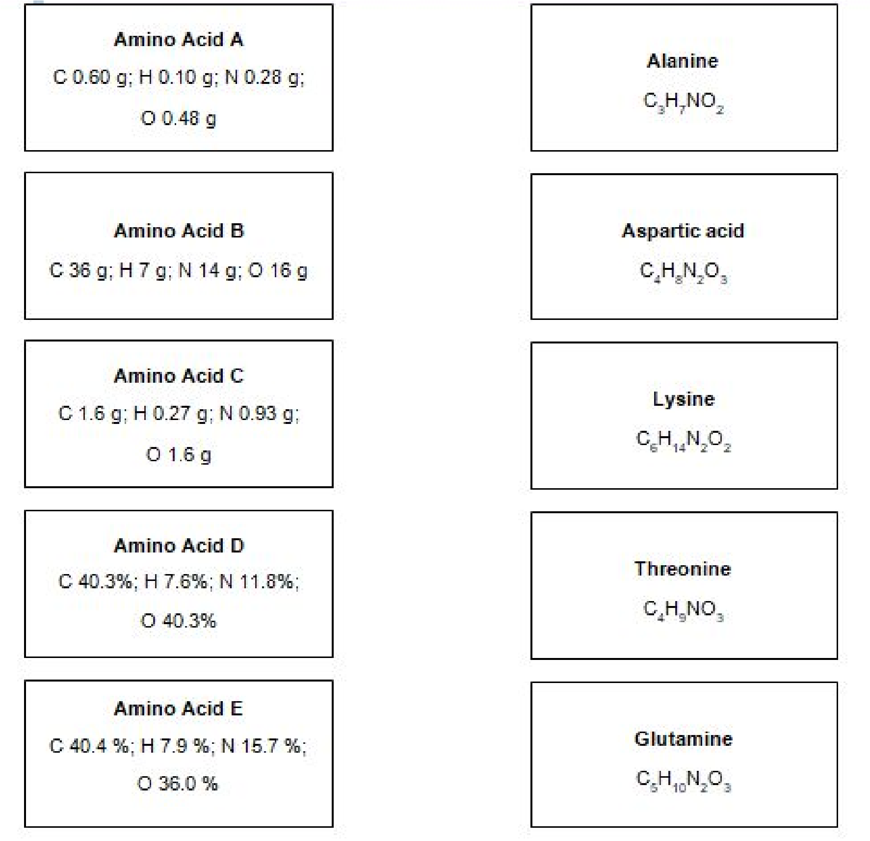

Titration calculations (Triple students only)
On Friday 23​^{rd​} June the police found John Smith collapsed at his dining table over his plate of fish and chips. He had been poisoned. Police took vinegar samples from the three local fish and chip shops and, in an attempt to isolate the origin of poor John’s fish and chips, analysed the concentration of the ethanoic acid in the vinegar by titration against NaOH of known concentration.
Help the police out by calculating the concentration of ethanoic acid in each of the vinegar samples;
- marks for each correct concentration)
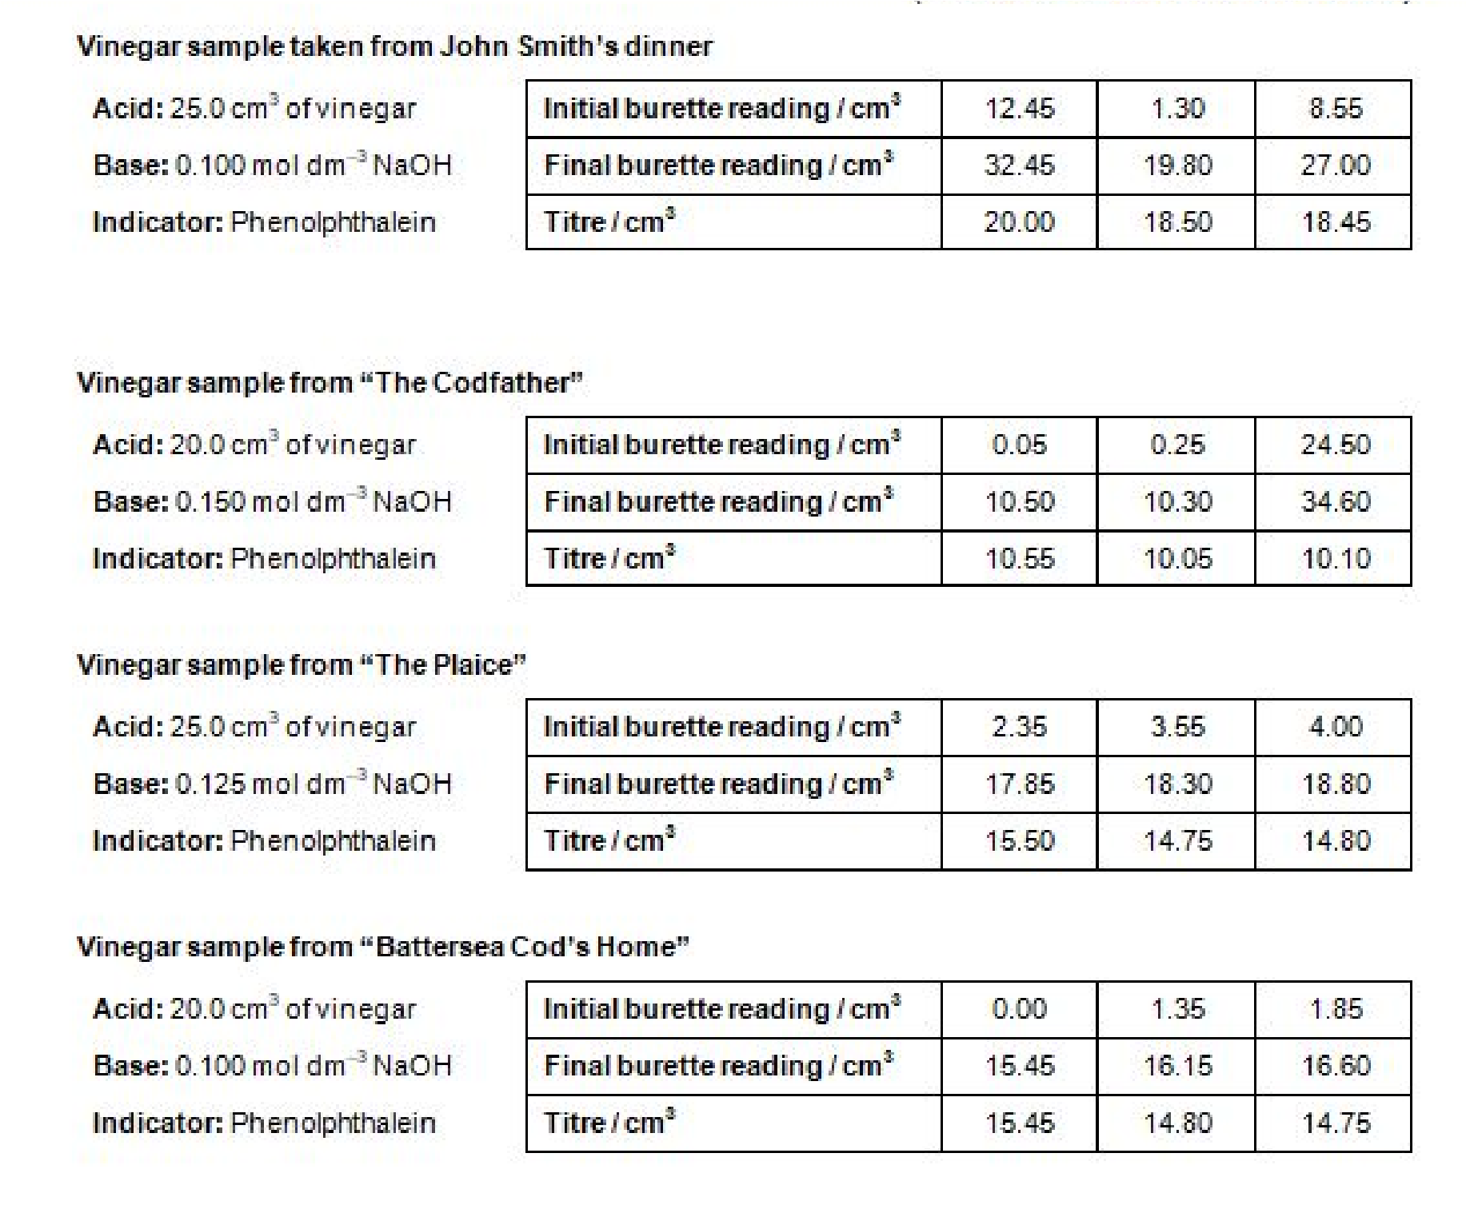
John Smith’s fish and chips had come from
............................................................................................................................................
(2 marks)

Displacement reactions
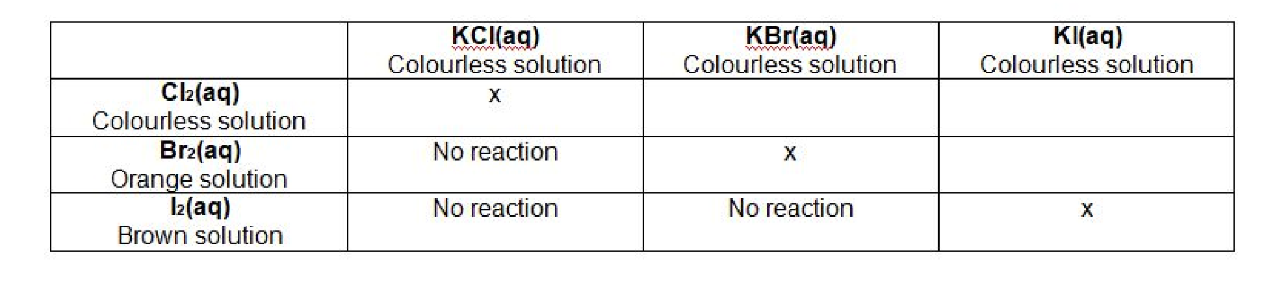
1. A more reactive halogen will displace a less reactive halide form its salt. The table​ above shows the results from displacement reactions of the halogens. Complete the table to show what you would see if you carried out the reactions.
(3 marks)

2. ​Write ionic equations for these displacement reactions.​ (3 marks)
3. Using the reaction of Br_{​2} with KI as an example, describe why displacement reactions​are redox processes. (1 mark)

4. ​ When the halogens react they gain an electron. Explain why iodine is the least​

reactive halogen. (2 marks)
5. If you were able to use a solution of fluorine water to react with the halide solutions​ shown above which ones would you expect to show a reaction? (1 mark)

Balancing equations

1. …..C + …..O₂​ | → | …..CO
2. …..Ba + …..H​2O  ​ | → | …..Ba(OH)​2 + …..H​  ​ 2
3. …..C​2H​6 + …..O​  ​ ​ 2 | → | …..CO​2 ^{+ …..H}​2O  ​ ​
4. …..HCl + …..Mg(OH)₂​ | → | …..MgCl​2 + H​2O  ​ ​
5. …..N​2 + …..O​  ​ 2 | → | …..NO
6. …..Fe​2O​3 + …..C  ​ ​ | → | …..Fe + …..CO₂​
7. …..CH​3CH​2OH + …..[O] →  ​ ​ |  | …..CH​3COOH + …..H​2O  ​ ​
8. …..HNO​3 + …..CuO →  ​ |  | …..Cu(NO​3)​2 + H​2O  ​ ​ ​
9. …..Al​^{3+​} + …..e​– → |  | …..Al

Writing equations from text
The following questions contain a written description of a reaction. In some cases the products may be missing as you will be expected to predict the product using your prior knowledge.
For more advanced equations you may be given some of the formulae you need.
For each one, write a balanced symbol equation for the process. (10 marks)

- The reaction between silicon and nitrogen to form silicon nitride Si​3N​4. ​ ​
............................................................................................................................................
- The neutralisation of sulfuric acid with sodium hydroxide.
............................................................................................................................................
- The preparation of boron trichloride from its elements.
............................................................................................................................................
- The reaction of nitrogen and oxygen to form nitrogen monoxide.
............................................................................................................................................
- The combustion of ethanol (C​2H₅​ OH) to form carbon dioxide and water only. ​ ​
............................................................................................................................................
- The formation of silicon tetrachloride (SiCl​4) from SiO​2 using chlorine gas and carbon. ​ ​
............................................................................................................................................
- The extraction of iron from iron(III) oxide (Fe​2O​3) using carbon monoxide. ​ ​
............................................................................................................................................
- The complete combustion of methane.
............................................................................................................................................
- The formation of one molecule of ClF​3 from chlorine and fluorine molecules.

............................................................................................................................................
- The reaction of nitrogen dioxide with water and oxygen to form nitric acid.
............................................................................................................................................

Research projects
Catalyst magazine is aimed at students aged 14-19. It is packed with interesting articles on cutting-edge science, interviews and new research written by leading academics. It also includes a booklet of teacher's notes, full of ideas and lesson plans to bring the articles to life in the classroom. From the following topics, pick one​ research topic. Once​ you have read the article you need to use the resources to produce one page of Cornell style notes. Use the links of scan the QR code to take you to the resources.
Bring this to your first lesson of chemistry in September.
Cornell Note
Research, reading and note making are essential skills for A level chemistry study. For the following task you are going to produce ‘Cornell Notes’ to summarise your reading.

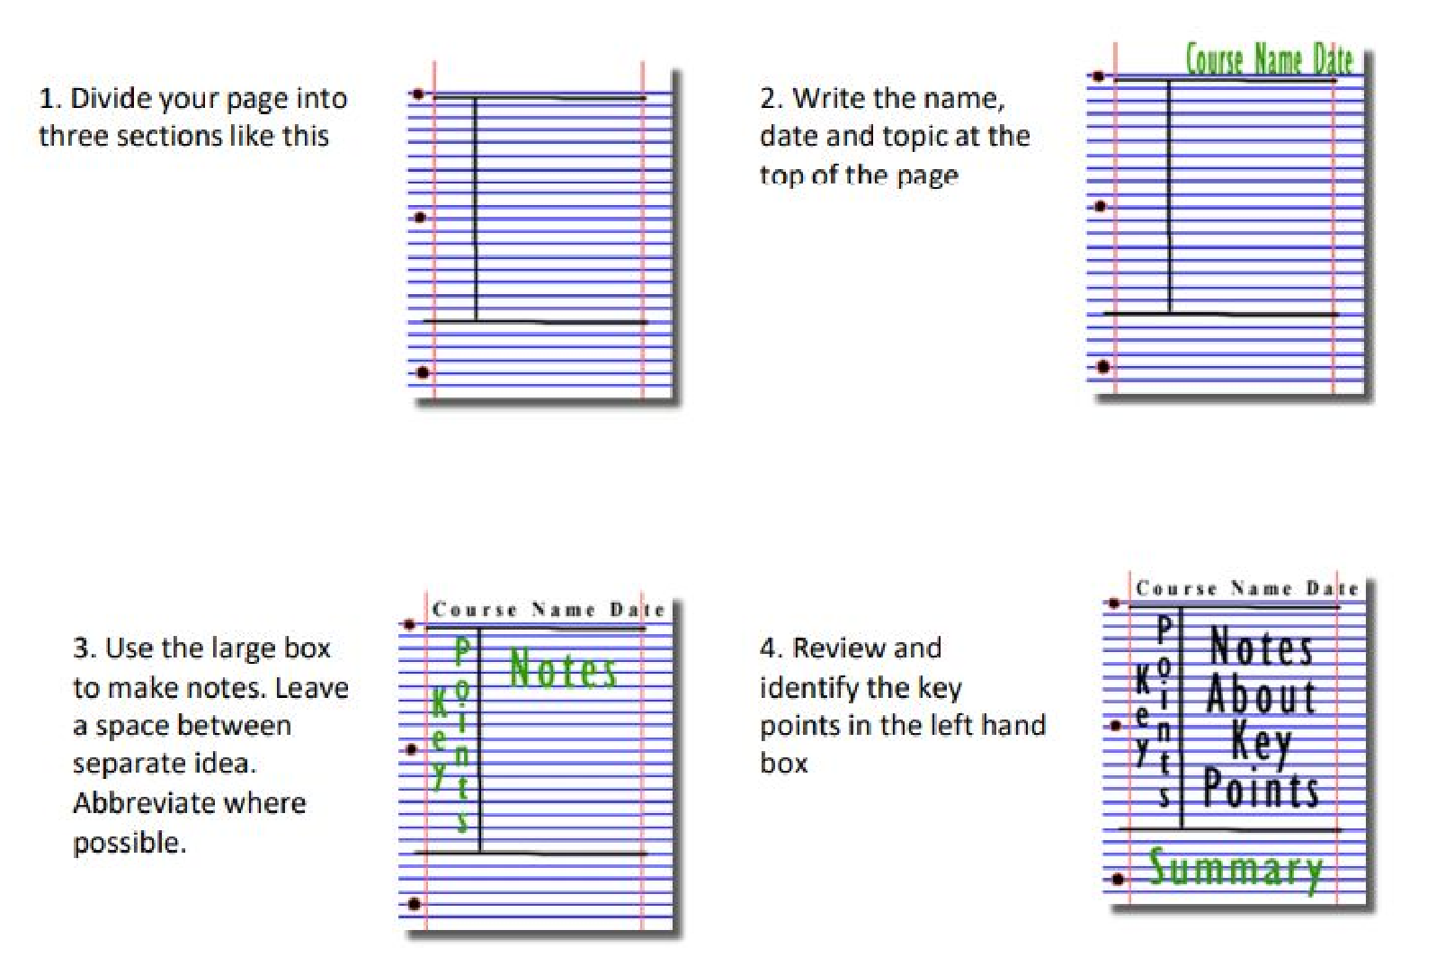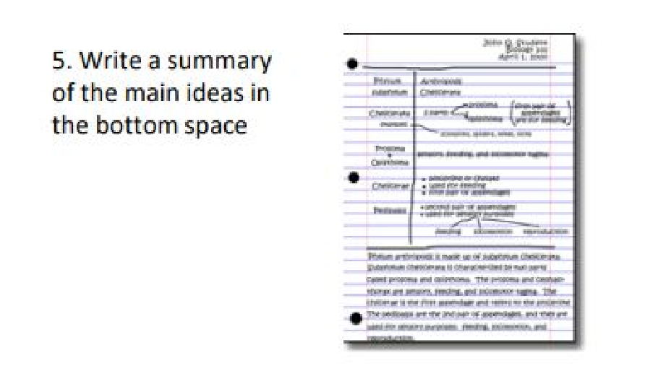

Catalyst research projects
Topic 1: Using Plastics in the Body:  https://www.stem.org.uk/resources/elibrary/resourc e/382317/using-plastics-body  This Catalyst article looks at how scientists are learning to use polymers for many medical applications, including implants, bone repairs and reduction in infections. | 
Topic 2: Catching a Cheat  https://www.stem.org.uk/system/files/elibraryresources/20  17/03/Catching%20a%20cheat.pdf  This Catalyst article looks at analytical chemists who are involved in many kinds of testing, including drug testing to catch cheats in sport. | 
Topic 3: Diamond: More than just a gemstone  https://www.stem.org.uk/system/files/elibraryresources/20  17/02/Diamond%20more%20than%20j ust%20a%20gemstone.pdf  This Catalyst article looks at diamond and graphite which are allotropes of carbon. Their properties, which depend on the bonding between the carbon atoms, are also examined. | 
Topic 4: The Bizarre World of High Pressure Chemistry https://www.stem.org.uk/system/files/elibraryresources/20  16/11/Catalyst27_1_the_bizarre_world  _of_high_pressure_chemistry.pdf  This Catalyst article investigates high pressure chemistry and discovers that, when put under extreme pressure, the properties of a material may change ^{dramatically}​ | 
Topic 5: Microplastics and the Oceans  https://www.stem.org.uk/system/files/elibraryresources/20  16/11/Catalyst27_1_microplastics_%20 and_the_oceans.pdf  This Catalyst article looks at microplastics. Microplastics are tiny particles of polymer used in many products. They have been found to be an environmental pollutant especially in oceans. | 

Transition activity answers
Atomic structure

Approx. year of discovery | Scientist | Addition made to our current understanding of atomic structure
1803 | John Dalton | Proposed that all matter is made up of tiny particles called atoms
1897 | J. J. Thomson | Realised that atoms are divisible and contain very tiny, negatively charged particles called electrons
1911 | Ernest Rutherford | Discovered that an atom is made up of a nucleus and an extra-nuclear part.The central nucleus is positively charged and the negative electrons revolve around this central nucleus.
1915 | Niels Bohr | Proposed that the electrons orbit around the nucleus in orbits with a set size and energy
1924 | Wolfgang Pauli | Proposed the concept of electron spin
1932 | James Chadwick | Discovered that atoms contain neutral particles called neutrons in their nucleus

- mark for each correct row; 4 marks for the correct order of statements,3 marks if one statement in incorrect position, 2 marks if two statements in incorrect position, 1 mark if any pair of statements follow on correctly from each other)
BONUS MARK:​ Niels Bohr was indeed a keen football player and was the goalkeeper in the Danish team Akademisk Boldklub.Although Akademisk Boldklub were, at the time, one of the best clubs in Denmark, he never made it to the national team.

Bonding and structure
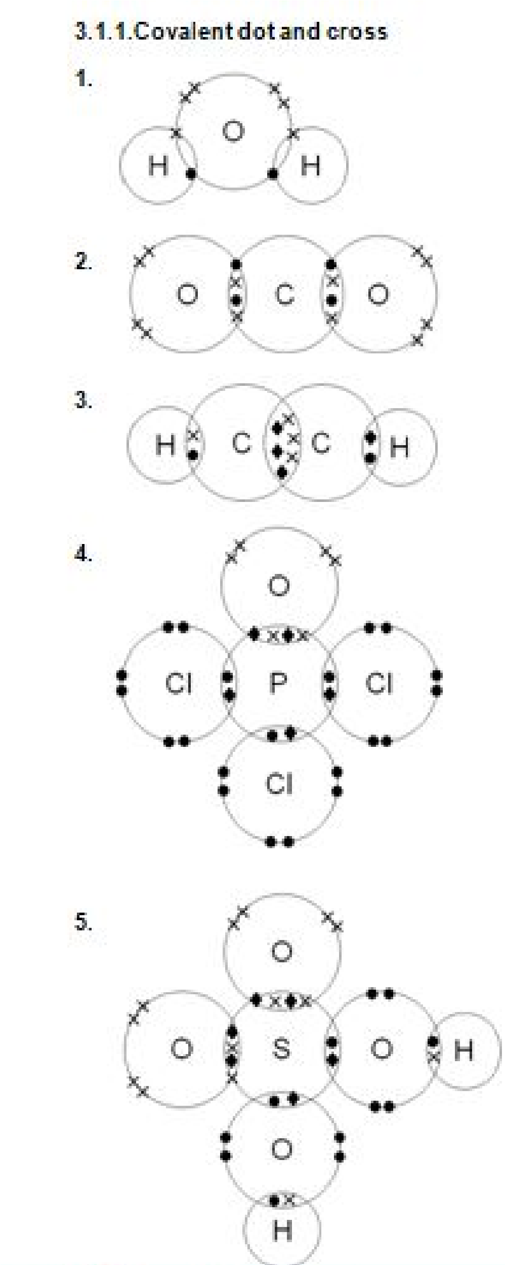
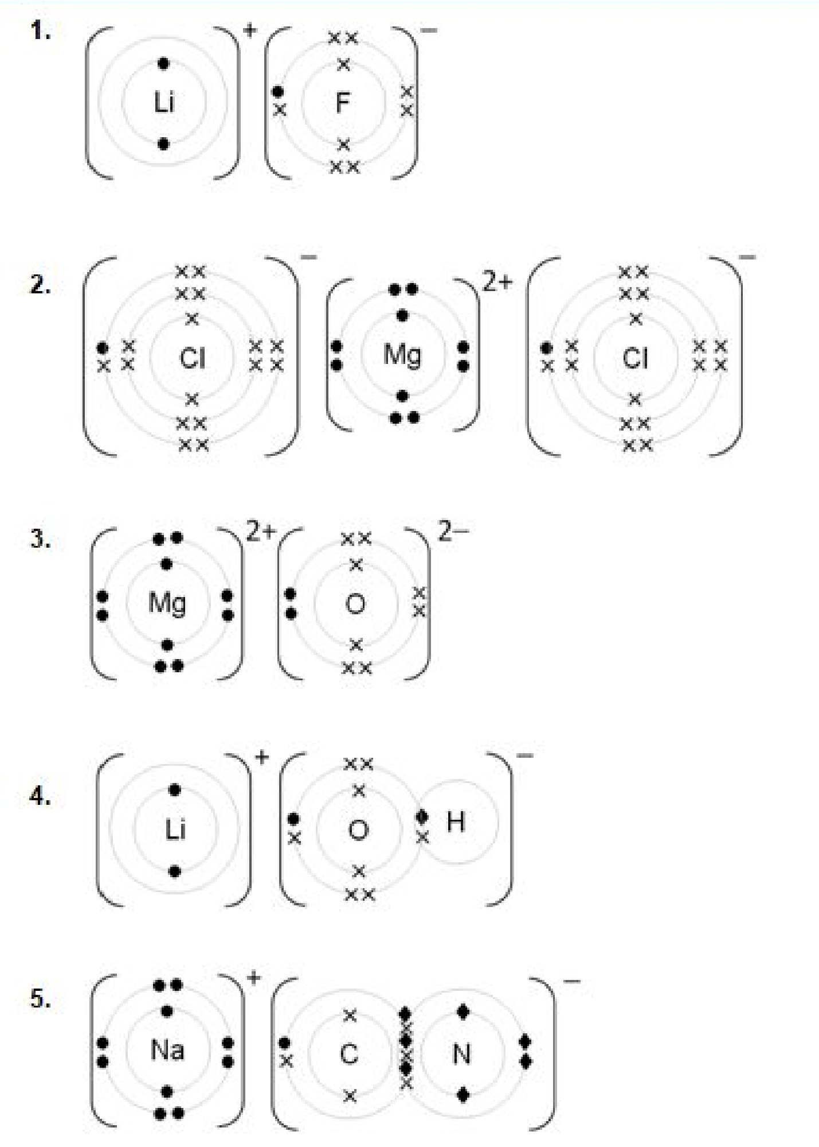

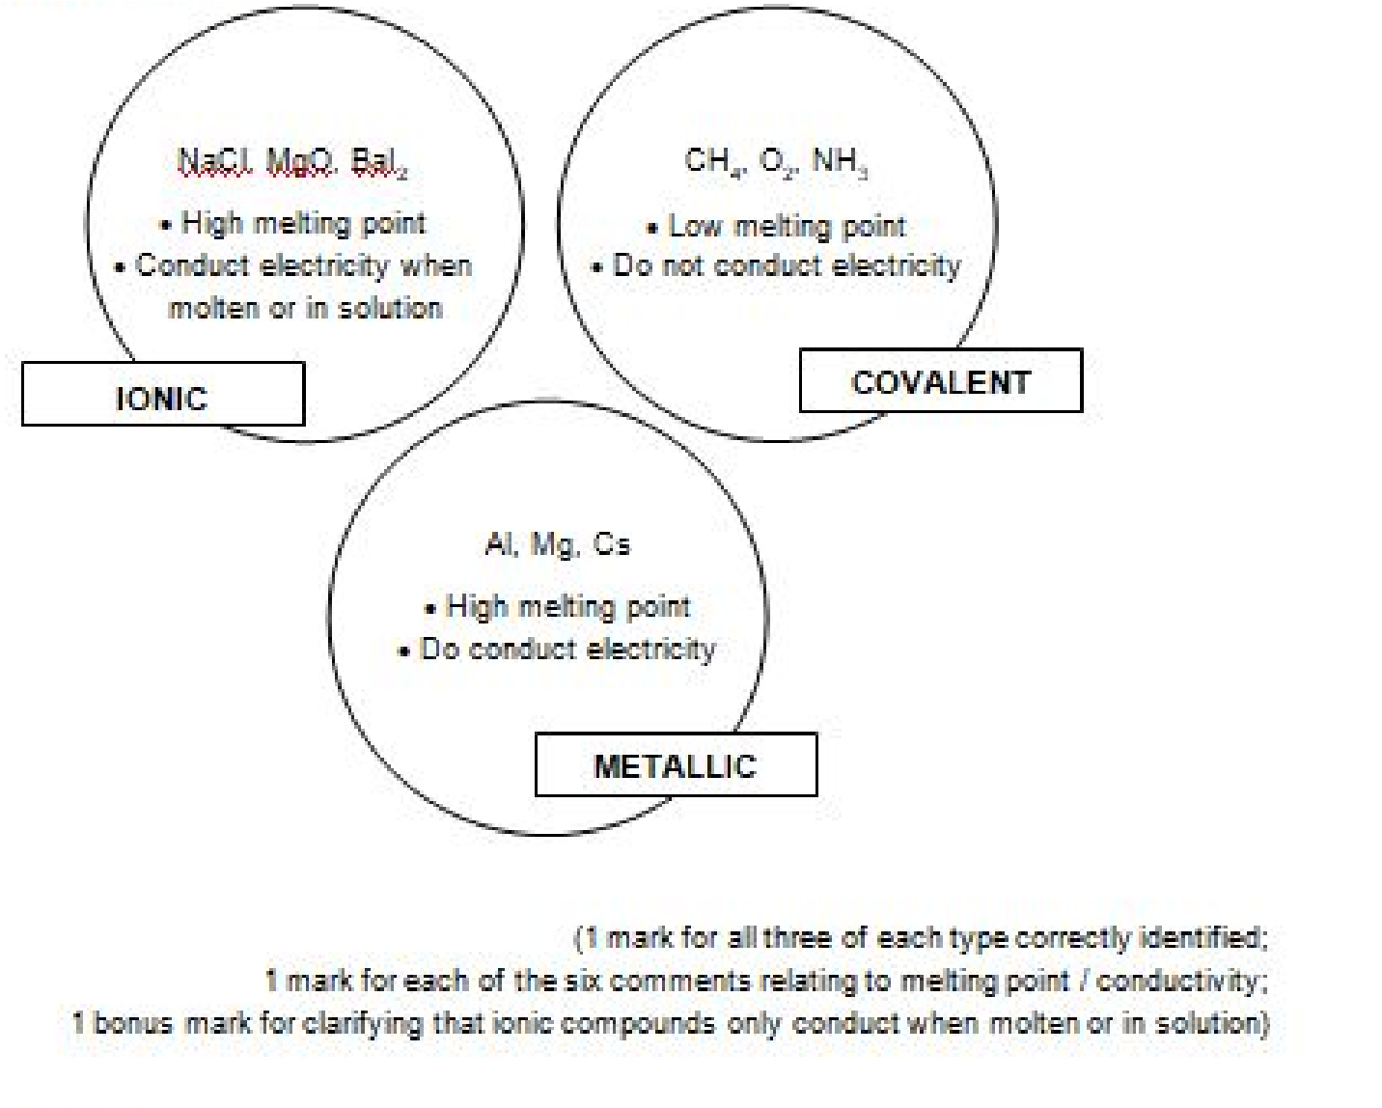
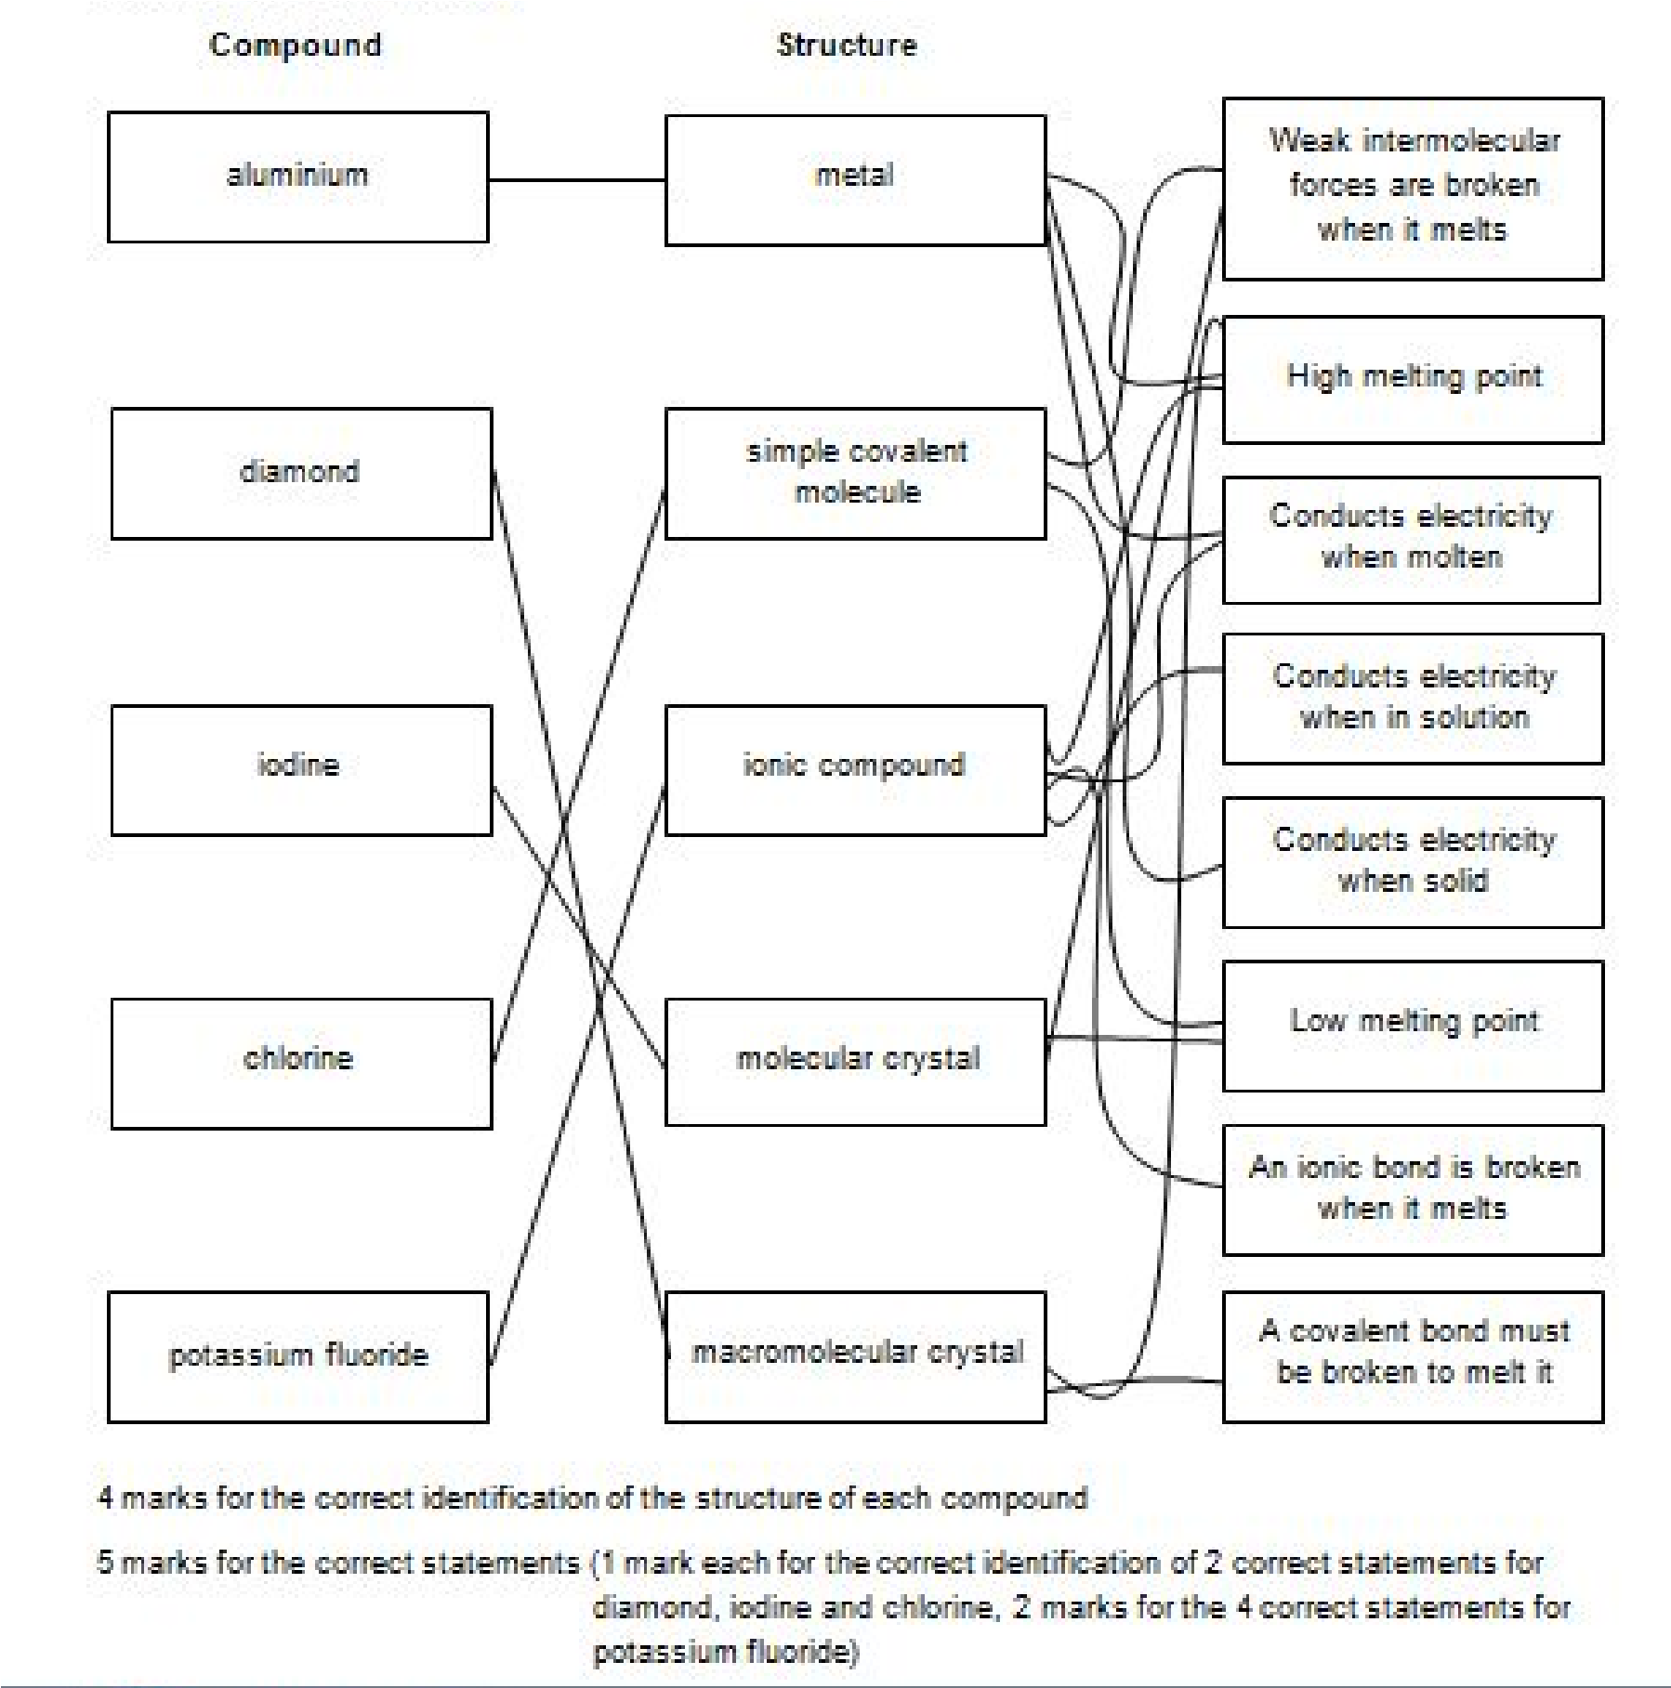

The mole
Moles and maths
  - 43.7
  - 69.8
  - 0.688
  - 0.683
  - 0.25
Moles and concentration
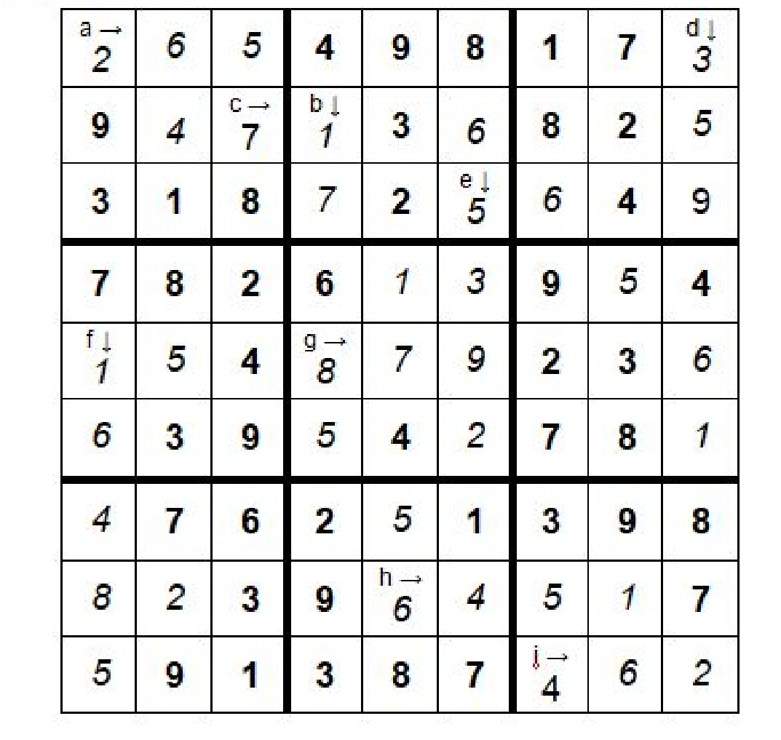
1.4 Empirical and molecular formulae
Amino acid A has an empirical formula of C​5H​10N​2O​3and is therefore glutamic acid
​ ​ ​ ​
Amino acid B has an empirical formula of C​3H​7NOand is therefore lysine
​ ​
Amino acid C has an empirical formula of C​4H​8N​2O​3 and is therefore aspartic acid
​ ​ ​ ​
Amino acid D has an empirical formula of C₄​ H​ 9​ NO​ 3​ and is therefore threonine​
Amino acid E has an empirical formula of C₃​ H​ 7​ NO​ 2​ and is therefore alanine​

1.6 Titration calculations
Concentration of vinegar taken from John Smith’s dinner;
Average titre = 18.475 cm³​
No. of moles of NaOH = 1.85 × 10​^{–3​} moles
\Concentrationof vinegar = 0.0739 moldm^{–3}​

Concentration of vinegar taken from “The Codfather”;
Average titre = 10.075 cm³​
No. of moles of NaOH = 1.51 × 10​^{–3​} moles
\Concentrationof vinegar = 0.0756 moldm^{–3}​

Concentration of vinegar taken from “The Plaice”;
Average titre = 14.775 cm³​
No. of moles of NaOH = 1.85 × 10​^{–3​} moles
\Concentrationof vinegar = 0.0739 moldm​^{–3}
Concentration of vinegar taken from “Battersea Cod’s Home”;
Average titre = 14.775 cm³​
No. of moles of NaOH = 1.48 × 10​^{–3​} moles
\Concentrationof vinegar = 0.0739 moldm^{–3}​

Therefore, John Smith’s fish and chips had come from either “The Plaice” or “Battersea Cod’s
Home”
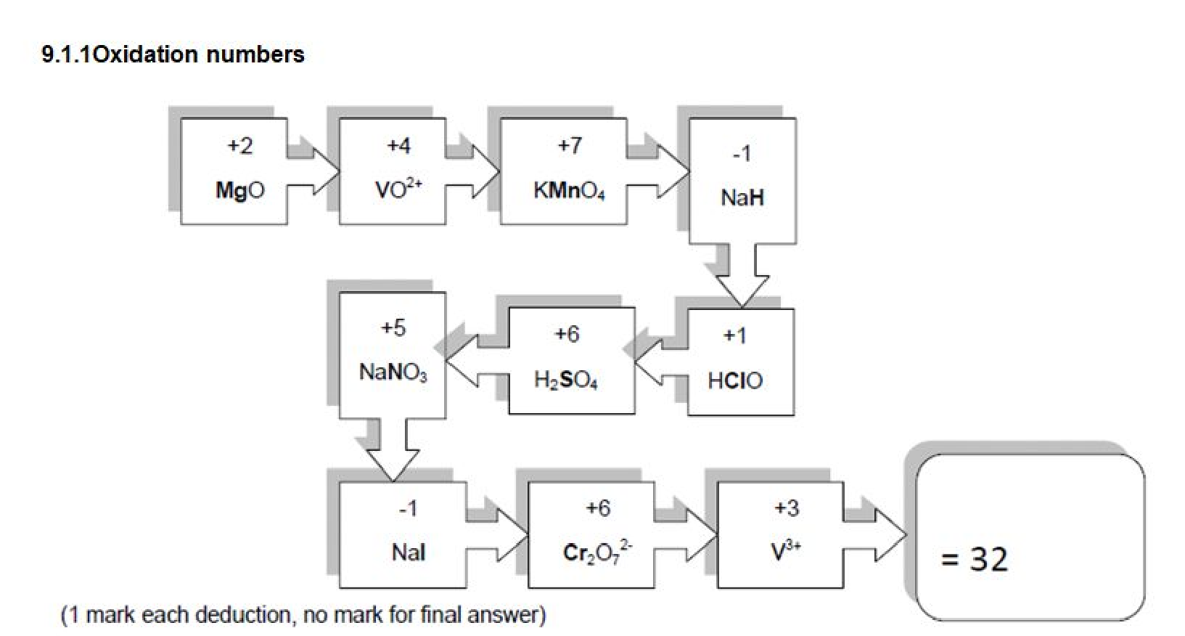
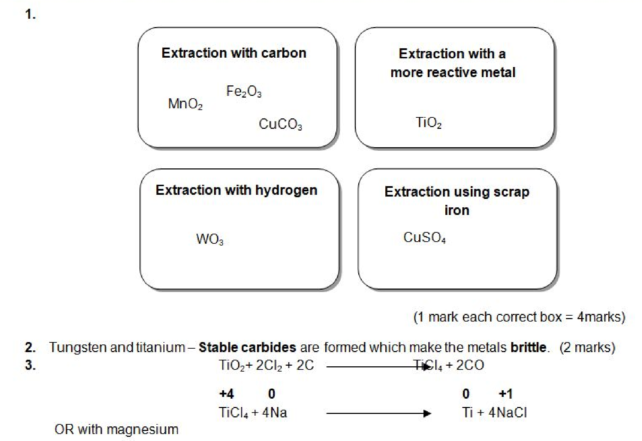
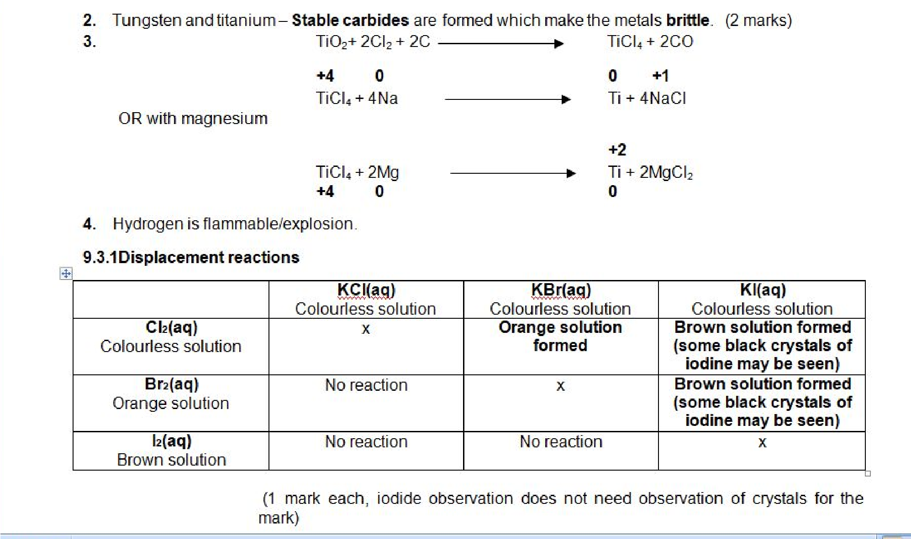
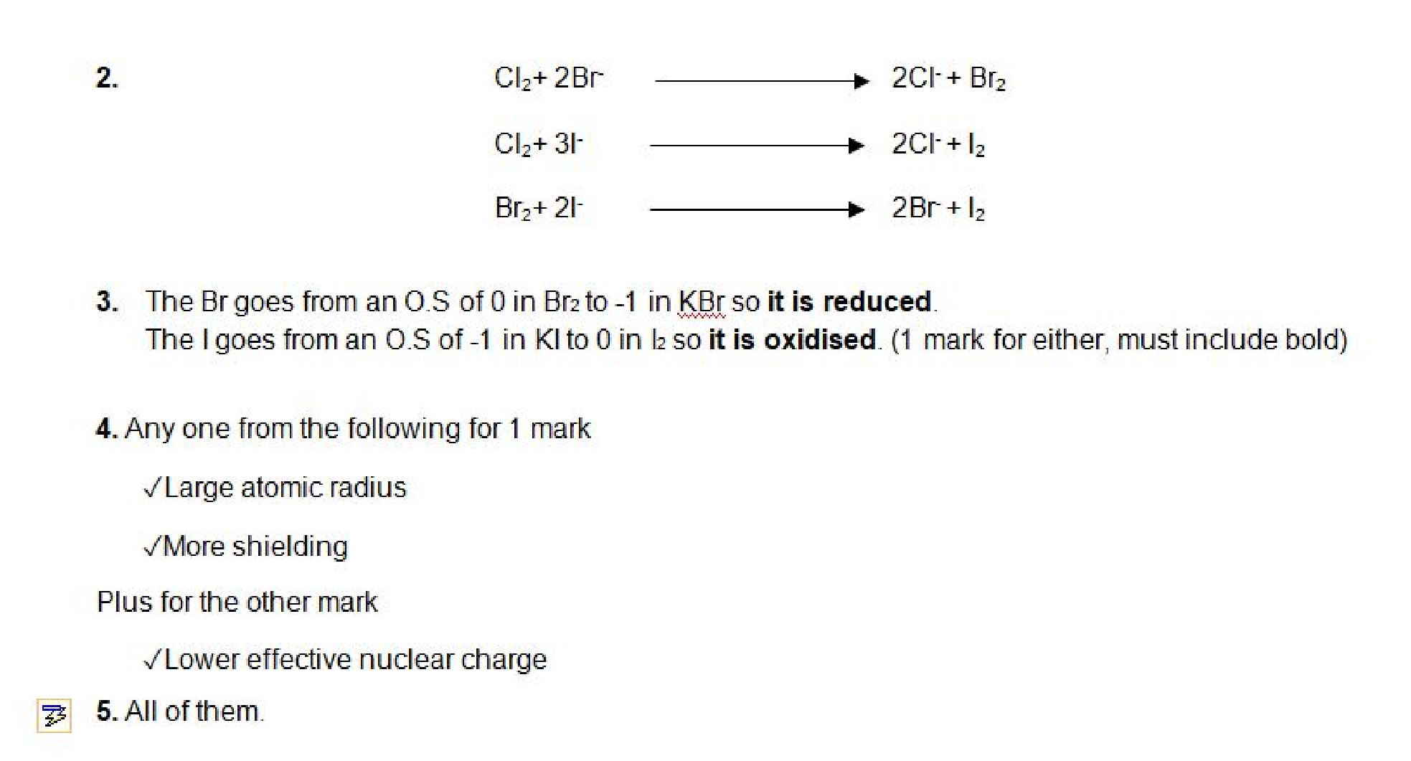

Balancing equations
1. ​2​C + …..O​2 | → | 2​CO
2. …..2Ba + ….2H​2O  ​ | → | 2Ba(OH)​ ​2 + …..H​  ​ 2
3. …..C​2H​ ​6 + ​ ​3.5​O​2 | → | 2​CO​2 + ​ ​3​H​2​O
4.​2​HCl + …..Mg(OH)​2 | → | …..MgCl​2 + ​ ​2​H​2O​
5. …..N​2 + …..O​  ​ 2 | → | 2​NO
6.​2​Fe​2O​ ​3 + …​ ​3​C | → | 4​Fe + ​3​CO​2
7. …..CH​3CH​ ​2OH + ​ ​2​[O] | → | …..CH​3COOH + …..H​2O  ​ ​
8.​2​HNO​3 + …..CuO​ | → | …..Cu(NO​3)​2 + H​2O  ​ ​ ​
9. …..Al​^{3+​} + ​3​e​– | → | …..Al

Writing equations from text
1 mark each, accept multiples for all except question 9.
1. 3Si + 2N₂​ | → | Si​3N​ ​ 4
2. H​2SO​4 + 2NaOH  ​ ​ | → | Na​2SO​4 + 2H​2O  ​ ​ ​
3. B + 1.5Cl₂​ | → | BCl₃​
4. N​2 + O​  ​ 2 | → | 2NO
5. C​2H​5OH + 3O​  ​ ​ 2 | → | 2CO​2 + 3H​2O  ​ ​
6.SiO​2 + C + 2Cl​  ​ 2 | → | SiCl​4 + CO​  ​ 2
7. Fe​2O​3 + 3CO  ​ ​ | → | 2Fe + 3CO₂​
8. CH​4 + 2O​  ​ 2 | → | CO​2 + 2H​2O  ​ ​
9. 0.5Cl​2 + 1.5F​  ​ 2 | → | ClF₃​
10. 2NO​2 + H​2O + 0.5O​  ​ ​ 2 | → | 2HNO₃​

