Progression to Post-16 Study in A Level Business

Course Outline
The business course has four themes. They are:
- Marketing and people – This theme enables you to understand how businesses identify opportunities and to explore how businesses focus on developing a competitive advantage through interacting with customers. You will develop an understanding of how businesses need to adapt their marketing to operate in a dynamic business environment. This theme also considers people, exploring how businesses recruit, train, organise and motivate employees, as well as the role of enterprising individuals and leaders. You must investigate different types and sizes of organisation in various business sectors and environments, and in local, national and global contexts.

- Managing business activities – This theme enables you to develop an understanding of raising and managing finance, and measuring business performance. The theme outlines the importance of using resources efficiently within a business to ensure that goods or services can be delivered effectively and efficiently, and to a high quality. You also consider the external influences that have an impact on businesses, including economic and legal factors. You must investigate different types and sizes of organisation in various business sectors and environments, and in local, national and global contexts.

- Business decisions and strategy – This theme moves from functions to strategy, enabling you to develop your understanding of the core concepts and to take a strategic view of business opportunities and issues. You analyse corporate objectives and strategy against financial and non-financial performance measures and how businesses grow, and develop an understanding of the impact of external influences. The theme covers the causes and effects of change and how businesses mitigate risk and uncertainty. You must investigate different types and sizes of organisation in various business sectors and environments, and in local, national and global contexts.

- Global business – This theme moves from functions to strategy, enabling you to develop your understanding of the core concepts and to take a strategic view of business opportunities and issues. You analyse corporate objectives and strategy against financial and non-financial performance measures and how businesses grow, and develop an understanding of the impact of external influences. The theme covers the causes and effects of change and how businesses mitigate risk and uncertainty. You must investigate different types and sizes of organisation in various business sectors and environments, and in local, national and global contexts.

Recommended Resources
https://www.bbc.co.uk/bitesize/subjects/zpsvr82 - the business area of BBC bitesize. Whilst aimed at GCSE, this will also provide useful information on many areas, especially if you did not do GCSE
www.tutor2u.net – website which includes a Business area. Full of blog posts, resources and definitions
https://www.bbc.co.uk/news/business - the business area of the BBC news site for unbiased up to date news on the economy, businesses and money
https://www.economicshelp.org/ - a website to help with the economic aspects of the business course
https://businesscasestudies.co.uk/ - a website with detailed information about some businesses related to specific areas of business theory

Various revision guides
YouTube has some great videos. I’d recommend looking for the following first:
- Tutor2u
- Two teachers
- Taking the biz
- Bizconsesh
- Time2resources

It is expected that you will complete the transition work included and bring with you to your first lesson.

Preparatory Activities
Activity 1:Global Brands quiz
Below are some of the top most valued brands in 2020. However, they are not in the correct order.


1 | 2 | 3 | 4 | 5
6 | 7 | 8 | 9 | 10
11 | 12 | 13 | 14 | 15

Activity 2
Enterprise
To have a successful business you need 4 factors of production: land, labour and enterprise. An entrepreneur is a person who can organise these four factors of production whilst taking risks.

Use the suggested weblinks, plus youtube videos and your own knowledge to complete the following task:
- What are the key characteristics and skills an entrepreneur will need to be successful?
- Select TWO entrepreneurs, e.g. Alan Sugar, Elon Musk, Kylie Jenner, Steve Jobs, Oprah Winfrey
- For EACH one
  - explain what business they set up, assuming I have never heard of them
  - how they demonstrated the characteristics and skills of an entrepreneur
  - when they have failed, and how they overcame this
  - evidence that they are successful
  - any else that you think is interesting or relevant

Activity 3:

Q1 | The chart below shows the number of hot tubs Bubblicious sold between 2020 and 2023. The owner estimates that in 2024, hot tub sales will be 5% lower than in 2023.  Calculate the average annual sales of hot tubs between 2020 and 2024.  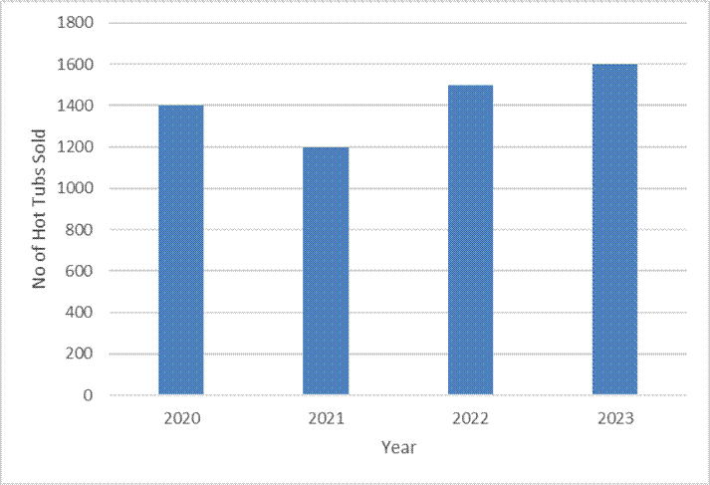
Your workings:

Q2 | Melchester Rovers Football Club can seat 42,000 spectators. Last week, when they played Harrogate Town, there were 36,960 spectators.  Calculate the percentage of empty seats.
Your workings:

Q3 | Cast Your Mind Back is a manufacturer of fishing equipment located in Sunderland. The unit cost of manufacturing their fishing rods is £25. Cast Your Mind Back sells its fishing rods to retailers for 45% more than the unit cost.  Calculate the selling price of a fishing rod.
Your workings:

Q4 | A family of four, on holiday in the UK from Spain, visited the ‘Whale of a Time’ sea life centre in London. The total entrance cost for the family was £90.  Assuming an exchange rate of £1: €1.08, calculate the total entrance cost in Euros.
Your workings:

Q5 | Loft in Space, a manufacturer of loft insulation, took 80 of its employees on a two-day team building trip to an outdoor activity centre in the Lake District. The total cost of the trip was £9,600. The accommodation cost per employee was 3/5 of the total cost per employee.  Calculate the accommodation cost per employee.
Your workings:

Q6 | Tea-Total is a café in Cumbria. Below is a pie chart showing the percentage of drinks purchased for a group of 200 customers.  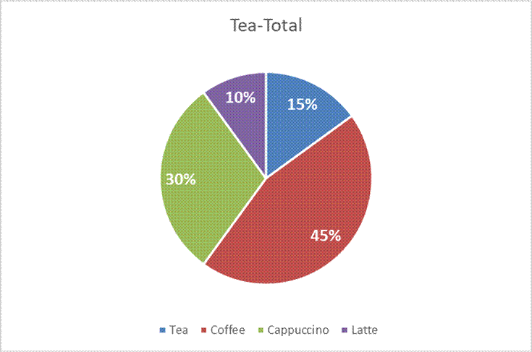  (A) Calculate how many customers purchased a coffee  (B) Calculate how many customers did not purchase a tea  (C) Calculate the fraction of customers that purchased a Latte
Your workings:

Activity 4: Application Exercise
When answering these, there may not be a simple answer. At this level you will need to consider more than just one factor.
- Read this article: https://www.bbc.co.uk/news/business-52508010. Clearly the demand for cars has fallen due to the pandemic. What other markets could be affected by this fall in demand?

- Using your knowledge and understanding, explain what has happened to demand for online shopping services, such as Amazon during the pandemic and why.

- Like myself ☹ many people have had or will have overseas holidays cancelled. Analyse how this could affect the demand for other goods and services.

- Many staff have been furloughed or even lost their jobs. Analyse the impact of this on the demand for goods and services

