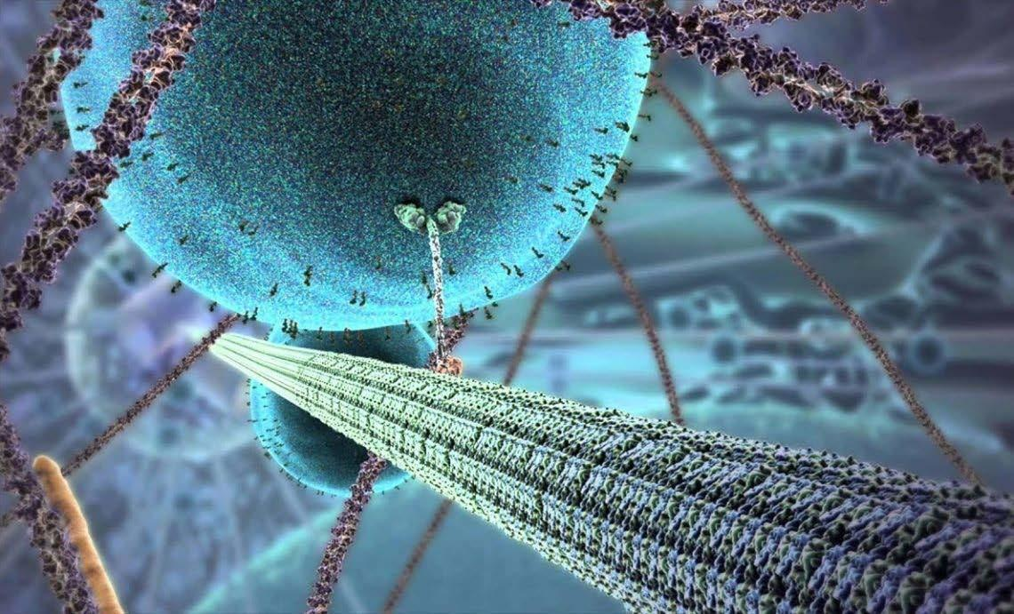
A LEVE | L BIOLOGY
INDUC | TION HANDBOOK 2025-2026
Teaching team
Course leader | Mrs Johnson-Slaney
Teaching team | Mrs E Johnson-Slaney  Mrs E Holmes  Mr Hillman  Miss Lodge | johnsonslaneye@ashlawn.tlet.org.uk  holmese@ashlawn.tlet.org.uk  hillmanl@ashlawn.tlet.org.uk  lodgek@ashlawn.tlet.org.uk

Biology at TLET Sixth Form
The study of Biology forms the basis of new and exciting fields, such as: Biotechnology, Biomedical science, Genomics and Conservation. It also provides a useful background to a wide variety of higher education courses including; radiography, nursing, physiotherapy, pharmacology, pharmacy, psychology, forensic science, archaeology, marine biology, ecology, sports studies, biochemistry, teaching and even law.
This guide has been put together to provide an overview to the A Level Biology course taught at TLET and aims to provide students with the guidance needed to be successful in their future studies.

Specification
Students studying A level Biology at TLET will be following the OCR Biology A specification. This is a two year course that encompasses six content based modules that will be assessed at the end of the two year course. Students will also be trained and assessed across a range of practical skills, which is assessed separately as part of their practical endorsement.
https://www.ocr.org.uk/Images/687834-download-a-level-specification.pdf
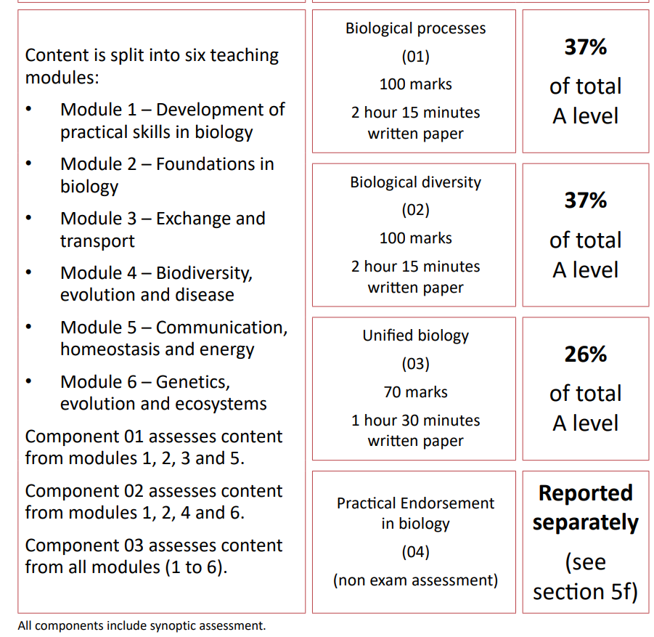
Content

You will have the opportunity to study a wide range of biological topics that will allow them to broaden and deepen their understanding of the biological world. You will examine the structure and role of key biological macromolecules including proteins, carbohydrates and lipids and nucleic acids. You will also explore the ultrastructure of cells and examine how cellular communication and cooperation allows organisms to carry out fundamental life processes.
You will also have the opportunity to learn about the structure, function and role of communication, exchange and transport systems and will examine these systems in a variety of living organisms. In addition to this, you will explore the causes of disease and the effects they have on organisms. At a higher level you will look at the evolutionary processes that have led to the great wealth of diversity we see in the natural world, in addition to exploring how this diversity can be studied and manipulated through the use of genomics and biotechnology.

Practical endorsement and PAGs
A PAG is a key lab skill that is recognised as important to the study and understanding of Biology. Within the OCR A Biology specification there are 12 PAG’s that you must develop competency in, in order to achieve their practical endorsement.
While the practical endorsement does not directly count towards your overall grade, the knowledge and skills learnt through practical training will be assessed in the final exams, accounting for 15% of the total marks.
You will be fully supported in the process of how to complete a PAG.

Contact time
Throughout TLET students and staff work on a two week timetable. You will have 10 hours of teacher contact time every two weeks. This content time will be split between two teachers, with each teacher usually delivering five lessons over a fortnight. In addition to the timetabled contact time, students can also receive additional support through Google Classroom.

Independent study
A level Biology has a greater level of conceptual challenges compared to GCSE Biology and consequently bridging the gap between GCSE’s and A levels is often a struggle for students starting sixth form.
Teachers within the Biology team have high expectations of their students' work ethic. In order to succeed in A level Biology, students must be dedicated and motivated to develop and apply their understanding both within and outside of lessons. We have found that students who succeed in Biology are those who developed a routine way of working in their own time and consequently independent learning and organisation are highly valued skills.
In addition to the work completed within lessons, teachers will expect that students complete at least 5 hours per week of independent study to aid their learning. Upon starting lessons students will receive a structured homework timetable designed to support and guide them to become more independent learners.

Preparing to start the course
Students can find starting the A-level Biology course challenging, if not prepared. In order to make the transition easier we recommend students consider the following.

Resources
Students should ensure that the following resources are available for every lesson.
❏ Notebook or lined paper
❏ Writing pens
❏ Pencils and rubber
❏ Ruler
❏ Calculator
❏ Electronic device (chromebook or laptop NOT mobile phone)
Textbooks
Please note that students will not be provided with a class textbook. Teachers will provide slides and past paper questions for lessons. In addition to independent learning resources in line with the homework timetable. All resources will be distributed to students electronically through Google Classroom. In addition to these resources students should purchase a textbook to support their independent learning.
Choose one of the following recommended text books:
Oxford University Press, A Level Biology A for OCR: Student book, ISBN-13: 978-0198351924
Or
CGP books, A-Level Biology: OCR A Year 1 & 2 Complete Revision & Practice w/Online Ed (For exams from 2025) ISBN: 9781837741359
In addition, to support the Maths element of the course, the following book is also highly recommended, particularly if you do not study maths/core maths:
CGP books, New A-level Biology: Essential Maths Skills, ISBN-13: 978-1847623232

Summer work
Below is a variety of resources for you to look through to help prepare you for September, some of the knowledge beyond the course requirements but should support the wider learning
Read | Watch | Listen
Head Start to A level biology  Using AI models in genome sequencing  Eliminating cancer with revolutionary Immunology | Any David Attenborough Documentary  DNA Family Secrets (BBC)  Unnatural Selection | Curious Cases- Dara O’Brian  The Rest Is Science

The following is your compulsory requirement. This will be assessed during your first two weeks of the course.
A scientific presentation is a visual representation of scientific research in a standard form. It is commonly used at scientific conferences, in addition to lectures. This format is an excellent way of presenting students’ research work.
Over the summer, you will need to research ‘the importance of water to the biological world’ and present this research as a scientific poster in Google Slides. It should be a single slide only. This must include references that show where you found the information. This poster will need to be submitted to your class teacher on the first lesson of the course.
The minimum requirements are:
- Introduction
- Main content (what you have found researching)
- Images/diagrams
- Conclusion
- References

There are examples below to give you an overview of how to present your work.

Example layout
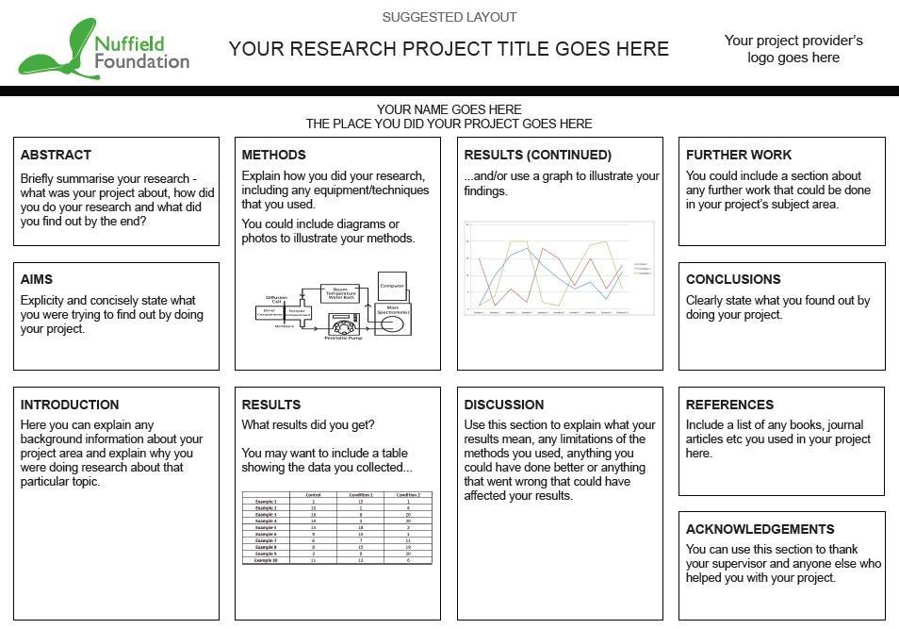
Example poster
