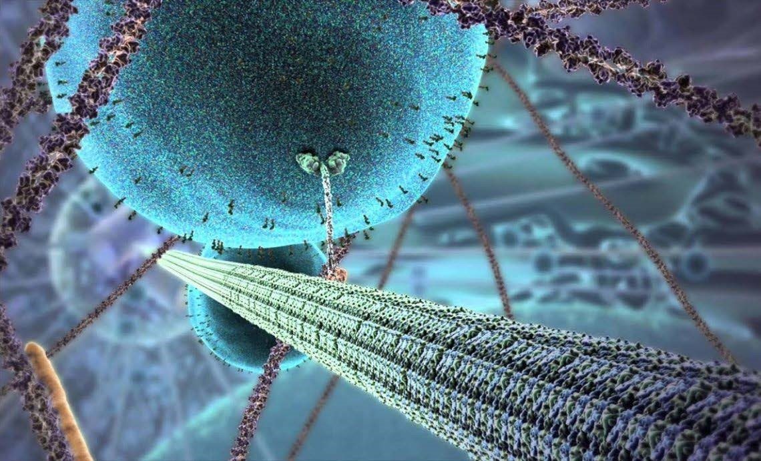

|  |  |
| --- | --- |
| A L E VE | L BI OL OGY |
| I NDUC | T I ON H ANDBOOK 2025- 2026 |
|  |  |

Teaching team

|  |  |  |
| --- | --- | --- |
| Course leader | Mrs H Parker |  |
| Teaching team | Mrs Parker  Mrs E Johnson-Slaney  Mrs E Holmes  Mr Hillman | [parkerh@ashlawn.tlet.org.uk](mailto:parkerh@ashlawn.tlet.org.uk)  [johnsonslaneye@ashlawn.tlet.org.uk](mailto:johnsonslaneye@ashlawn.tlet.org.uk)  [holmese@ashlawn.tlet.org.uk](mailto:holmese@ashlawn.tlet.org.uk)  hillmanl@ashlawn.tlet.org.uk |

# Biology at Ashlawn Sixth Form

Biology continues to be a highly popular subject for A-level students at Ashlawn School. As a core Science, Biology is usually studied in combination with Chemistry and Physics. However, as a natural Science, Biology is also complemented by the study of Geography, Maths, P.E and Psychology. The study of Biology forms the basis of new and exciting fields, such as: Biotechnology, Biomedical science, Genomics and Conservation. It also provides a useful background to a wide variety of higher education courses including; radiography, nursing, physiotherapy, pharmacology, pharmacy, psychology, forensic science, archaeology, marine biology, ecology, sports studies, biochemistry, teaching and even law.

Having made the decision to continue their studies and gain a higher qualification in Biology students often feel nervous about what’s to come. This guide has been put together to provide an overview to the A Level Biology course taught at Ashlawn School and aims to provide students with the guidance needed to be successful in their future studies.

## Specification

Students studying A level Biology at Ashlawn school will be following the OCR Biology A specification. This is a two year linear course that encompasses six content based modules that will be formally assessed at the end of the two year course. Students will also be trained and assessed across a range of practical skills, which is assessed separately as part of their practical endorsement.

<https://www.ocr.org.uk/Images/687834-download-a-level-specification.pdf>

## Formal assessments

Although progress throughout the course will be continually monitored through internal assessments, the linear nature of this course means that all formal assessments will take place at the end of year 13. For a breakdown of assessment by exam see Table 1.

## Content

Throughout the A Level Biology course taught at Ashlawn Sixth Form students will have the opportunity to study a wide range of biological topics that will allow them to broaden and deepen their understanding of the biological world. Students will examine the structure and role of key biological macromolecules including proteins, carbohydrates and lipids and nucleic acids. They will also explore the ultrastructure of cells and examine how cellular communication and cooperation allows organisms to carry out fundamental life processes.

Through this course students will also have the opportunity to learn about the structure, function and role of communication, exchange and transport systems and will examine these systems in a variety of living organisms. In addition to this, students will explore the causes of disease and the effects they have on organisms. At a higher level students will look at the evolutionary processes that have led to the great wealth of diversity we see in the natural world, in addition to exploring how this diversity can be studied and manipulated through the use of genomics and biotechnology. For a breakdown of content by module see Table 1.

## Practical endorsement and PAGs

A PAG is a key lab skill that is recognised as important to the study and understanding of Biology. Within the OCR A Biology specification there are 12 PAG’s that students must develop competency in, in order to achieve their practical endorsement.

While the practical endorsement does not directly count towards students' overall grade, the knowledge and skills learnt through practical training will be assessed in formal assessment, accounting for 15% of the total marks. Furthermore any students hoping to continue in the sciences at degree level will need to be able to show competency and understanding of experimental design.

Students will receive PAG training throughout their first year of the A level Biology course. Key lab workshops are embedded into the curriculum and students will need to complete a lab book and a key skills audit to demonstrate how their skills and understanding have developed through the training.

T able 1: Course overview for OCR Biology A

|  |  |  |
| --- | --- | --- |
| Content | Assessment overview | |
| Module 1  Development of practical skills    Module 2  Foundations in biology  2.1 Cell structure  2.2 Biological molecules  2.3 Nucleotides and nucleic acids  2.4 Enzymes  2.5 Biological membranes  2.6 Cell division, diversity and organisation    Module 3  Exchange and transport  3.1 Exchange surfaces  3.2 Transport in animals  3.3 Transport in plants    Module 4  Biodiversity, evolution and disease | Paper (01)  Biological processes  100 marks  2 hours 15 minutes    Content from modules 1,2,3  and 5 | 37% of total grade |
| Paper (02)  Biological diversity  100 marks  2 hours 15 minutes    Content from modules 1,2,4  and 6 | 37% of total grade |
| 4.1 Communicable disease, disease prevention and the immune system  4.2 Biodiversity  4.3 Classification and evolution    Module 5  Communication, homeostasis and energy  5.1.1 Communication and homeostasis  5.1.2 Excretion  5.1.3 Neuronal communication  5.1.4 Hormonal communication  5.1.5 Plant and animals responses  5.2.1 Photosynthesis  5.2.2 Respiration    Module 6  Genetics, evolution and ecosystems  6.1.1 Cellular control  6.1.2 Patterns of inheritance  6.1.3 Manipulating genomes  6.2.1 Cloning and biotechnology  6.2.2 Population and sustainability  6.2.3 Ecosystems | Paper (03)  Unified biology  70 marks  1 hours 30 minutes    Content from modules  1,2,3,4,5 and 6 | 26% of total grade |
| Practical endorsement | Reported separately Pass/ Fail |

## Contact time

Throughout Ashlawn school students and staff work on a two week timetable. Students taking A level Biology at Ashlawn school will have 10 hours of teacher contact time every two weeks. This content time will be split between two teachers, with each teacher delivering five lessons over a fortnight. In addition to the timetabled contact time, students can also receive additional support through their Google Classroom feed, subject specific mentoring and after school drop in sessions (Friday after school).

Google platforms will be used for all Biology lessons and therefore students will be expected to have an electronic device (e.g. chromebook or laptop). Key resources will be distributed over Google Classroom and created in Google Docs, Sheets and Slides. As such, students should familiarise themselves with these platforms prior to starting the course.

## Independent study

A level Biology has a greater level of conceptual challenges compared to GCSE Biology and consequently bridging the gap between GCSE’s and A levels is often a struggle for students starting sixth form. When starting A level Biology students are often shocked at the depth and breadth of which their learning needs to extend. Students can struggle with the pace of learning and consequently may feel overwhelmed.

Teachers within the Biology team have high expectations of their students' work ethic. In order to succeed in A level Biology, students must be dedicated and motivated to develop and apply their understanding both within and outside of lessons. We have found that students who succeed in Biology are those who developed a routine way of working in their own time and consequently independent learning and organisation are highly valued skills.

In addition to the work completed within lessons, teachers will expect that students complete at least 5 hours per week of independent study to aid their learning. Upon starting lessons students will receive a structured homework timetable designed to support and guide them to become more independent learners.

## Preparing to start the course

Students can find starting the A-level Biology course challenging. In order to make the transition easier we recommend students consider the following.

Resources

It is an expectation that students supply their own stationary within lessons. Students should ensure that the following resources are available for every lesson.

❏ Notebook or lined paper

❏ Writing pens

❏ Pencils and rubber

❏ Ruler

❏ Calculator

❏ Electronic device (chromebook or laptop NOT mobile phone)

Textbooks

Please note that students will not be provided with a class textbook. Teachers will provide slides and past paper questions for lessons. In addition to independent learning resources in line with the homework timetable. All resources will be distributed to students electronically through Google Classroom. In addition to these resources students should purchase a textbook to support their independent learning.

The textbooks recommended for the course are:

Oxford University Press, A Level Biology A for OCR: Student book, ISBN-13: 978-0198351924

Or

CGP books, A-Level Biology: OCR A Year 1 & 2 Complete Revision & Practice w/Online Ed (For exams from 2025) ISBN: 9781837741359

In addition, to support the Maths element of the course, the following book is also highly recommended:

CGP books, New A-level Biology: Essential Maths Skills, ISBN-13: 978-1847623232

Electronic Platforms

All A-level Biology resources at Ashlawn will be designed and distributed electronically. Prior to starting the course students should familiarise themselves with the following platforms:

❏ Google Drive

❏ Google Docs

❏ Google Sheets

❏ Google Slides

❏ Coggle

❏ Quizlet

Summer work

A scientific presentation is a visual representation of scientific research in a standard form. It is commonly used at scientific conferences, in addition to lectures, in view of the growing amount of research work and the desire to provide opportunities for all of it to be displayed. This format is an excellent way of presenting students’ research work. It necessitates a brief and fluent formulation, setting out all the stages of the research in a condensed, clear and interesting form. The process requires thought and planning on selection of information and on design.

Over the summer, students will need to research ‘the importance of water to the biological world’ and present this research as a scientific poster in Google Slides. It should be a single slide only. This must include references that show where the student has found the information. This poster will need to be submitted to the class teacher on the first lesson of the course and will be used to assess a student's eligibility for the course. If you have any questions, or would like to submit this over the holidays, please email Mrs Parler.

There are examples below to give you an overview of how to present your work.

Example layout

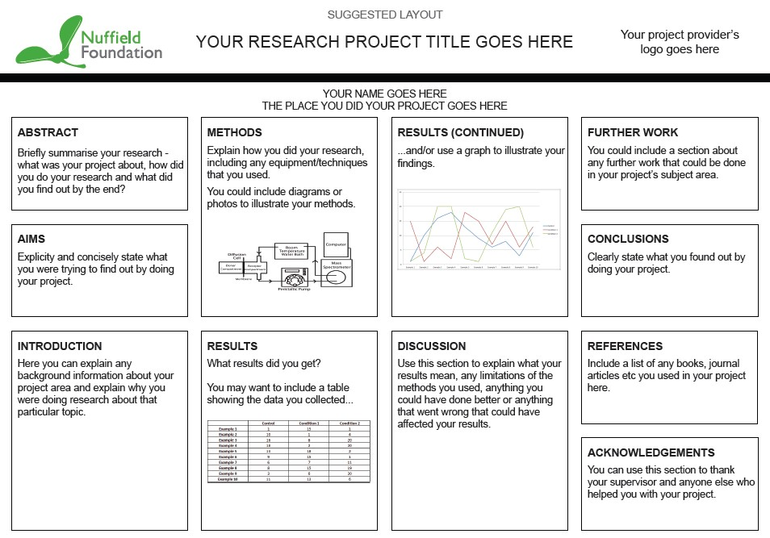

Example poster

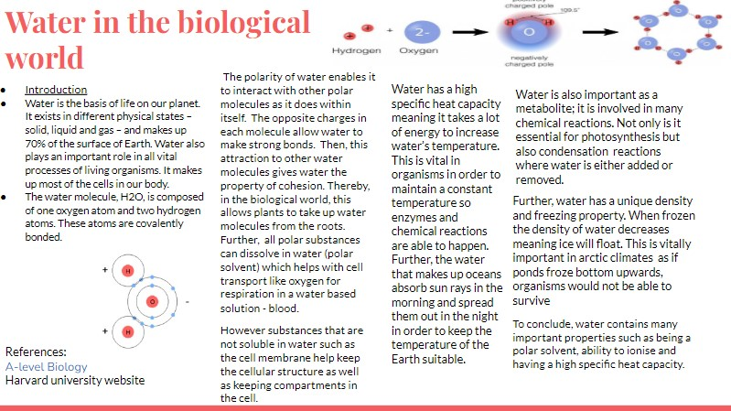

10

|  |  |  |
| --- | --- | --- |
| Read | Listen | Watch |
| "The Selfish Gene" by Richard Dawkins  "The Immortal Life of Henrietta Lacks" by Rebecca Skloot  "Why We Sleep" by Matthew Walker | Podcast- Huberman Labs | The Human Body: Secrets of Your Life Revealed (BBC)  The Gene: An Intimate History (youtube) |