
Progression to Post-16 Study in BTEC Business

Course Outline
The business course has four units. They are:
- Investigating Business – an internally assessed unit where you will compare and contrast two businesses, analyse their organisation and investigate the external factors that affect them. In addition, we will look at how businesses use innovation and enterprise, and justify why it is necessary for many businesses

- Developing a Marketing Campaign – in this unit you will need to learn about the 7 Ps of marketing, as well as the aims of specific marketing campaigns whilst considering the budget and timescales of campaigns. In an externally assessed assignment you will need to apply this learning to a specific business as well as research the market that the business operates in

- Personal and Business Finance – this unit enables you to learn about personal as well as business finance, introduces you to accounting and requires you to evaluate financial sources for a specific business situation. For this unit, you will sit an external written examination

- Recruitment – in this unit you will learn about the recruitment and selection process, whilst applying this knowledge and understanding to a specific business of your choice. As part of the assessment you will have to apply for a vacancy, take part in interviews and consider your own personal strengths, weaknesses and areas for development.

As well as this business knowledge you will need to be able to use IT effectively. Skills you will use and develop are:
- Internet research – being discerning, selective and sourcing correctly

- Word processing – your coursework will need to be presented using a computer. Being able to use word processing software quickly and in a professional manner will be important

- Spreadsheets – you will need to be able to enter data and use spreadsheet skills to create visual ways of representing this data

- Referencing sources – this must be done using the Harvard referencing system. Information on how to do this can be found here https://www.ukessays.com/referencing/harvard/

Recommended Resources
https://www.bbc.co.uk/bitesize/subjects/zpsvr82 - the business area of BBC bitesize. Whilst aimed at GCSE, this will also provide useful information on many areas, especially if you did not do GCSE
www.tutor2u.net – website which includes a Business area. Full of blog posts, resources and definitions
www.beebusinessbee.co.uk/ - a website specifically for BTEC Business courses
https://www.bbc.co.uk/news/business - the business area of the BBC news site for unbiased up to date news on the economy, businesses and money
https://www.economicshelp.org/ - a website to help with the economic aspects of the business course
https://businesscasestudies.co.uk/ - a website with detailed information about some businesses related to specific areas of business theory

Various revision guides

YouTube has some great videos. I’d recommend looking for the following first:
- Tutor2u
- Two teachers
- Taking the biz
- Bizconsesh
- Time2resources

It is expected that you will complete the transition work included and bring with you to your first lesson.

Preparatory Activities
Activity
Enterprise
To have a successful business you need 4 factors of production: land, labour and enterprise. An entrepreneur is a person who can organise these four factors of production whilst taking risks.

Use the suggested weblinks, plus youtube videos and your own knowledge to complete the following task:
- What are the key characteristics and skills an entrepreneur will need to be successful?
- Select TWO entrepreneurs, e.g. Elon Musk, Oprah Winfrey, Clive Sinclair, Jamie Oliver, Alan Sugar
- For EACH one
  - explain what business they set up, assuming I have never heard of them
  - how they demonstrated the characteristics and skills of an entrepreneur
  - when they have failed, and how they overcame this
  - evidence that they are successful
  - any else that you think is interesting or relevant

Activity - Inside Aldi: Britain’s Biggest Discount Store

Part A: BEFORE you start to watch
A good business student not only knows their theory, i.e. the content that is on the specification, but also thinks business. Business is a subject that surrounds us all day every day. We start to spot the actions taken by businesses and ask “Why?”; we start to question how we interact with business and the factors that influence our decisions; we start to question what is happening in society and the economy. A good business student is inquisitive.

https://www.my5.tv/inside-aldi-britain-s-biggest-budget-supermarket/season-1/inside-aldi-britain-s-biggest-budget-supermarket

- Start by thinking about what you already know and what your perceptions are. In less than 15 words sum up what you think about Aldi.

- Who are the key players in the UK’s supermarket industry?

The pie chart below shows what % of the market the 6 biggest UK supermarket chains control.
- Use your existing knowledge of the industry to try and identify which segment of the chart represents which supermarket chain. 10% of the chart can just be labelled ‘other’.

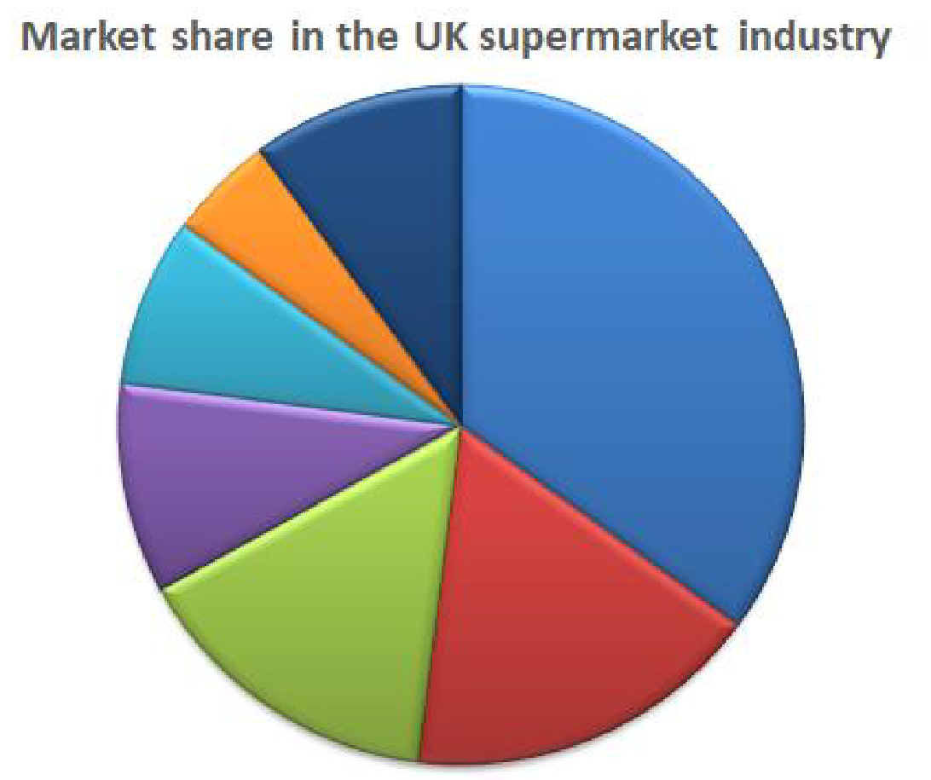
Market share is the % of an industry controlled by one business. In the example above we could say that:

- _____________ is the dominant business in the UK supermarket industry with a market share of ____ %. We call this application, applying our knowledge to a specific business or industry.

- We would describe the industry as competitive. What do you think this means?

A business will therefore take actions to try and gain market share by having a competitive advantage. This means a feature or features of the business that allows it to perform better than others in the industry.

Part B: First part of the documentary
Watch the first part (approx. 15 mins.) of the Channel 5 documentary “Inside Aldi”.

- Draw a spider diagram to show any actions that you think Aldi takes to gain a competitive advantage.
Aldi’s Competitive Advantage

Whilst watching this video you were introduced to some key business concepts.
The marketing mix is the combination of elements of marketing that are used to influence customers buying habits. The four Ps of the marketing mix are product, place, price and promotion. In your course, you will have to learn about the extended marketing mix: the 7 Ps. this includes people, physical environment and process.

- Is there anything you could now add to your spider diagram?

Aldi gains a competitive advantage by charging low prices. It achieves this by making cost savings.

- Watch this short YouTube video to learn about total costs. YouTube https://www.youtube.com/watch?v=CJEkTyj_3Fg&t=5s

In the first part of the programme you watched, a statement made about the growth of Aldi in the UK was “It is nothing but good for the supermarket industry and for shoppers”. Here the industry would include competitors and suppliers. Shoppers would include customers and the community. These are called stakeholder groups.

A stakeholder is anyone who is affected by or interested in the actions of a business.

- Consider the extent to which you agree with this statement based on each stakeholder’s point of view. Justify your decisions.

Stakeholder | Strongly Agree Strongly disagree
Competitors | 10 | 9 | 8 | 7 | 6 | 5 | 4 | 3 | 2 | 1
Justification

Suppliers | 10 | 9 | 8 | 7 | 6 | 5 | 4 | 3 | 2 | 1
Justification

Customers | 10 | 9 | 8 | 7 | 6 | 5 | 4 | 3 | 2 | 1
Justification

Community | 10 | 9 | 8 | 7 | 6 | 5 | 4 | 3 | 2 | 1
Justification

Part C: Second part of the documentary
An important skill to practise and develop over your studies is the ability to make judgements and fully justify these. We call this skill evaluation.

- Watch the second part (approx. 15 mins.) of the Channel 5 documentary “Inside Aldi”. Add to your spider diagram to show any actions that you think Aldi takes to gain a competitive advantage

- What evidence is there of Aldi successfully cutting costs and increasing efficiency?

A topic you will study is motivation. Motivation is the reasons why people behave in the manner that they do. A business that can motivate the workforce is likely to gain a competitive advantage. Motivation can take the form of financial incentives e.g. bonuses and non-financial incentives e.g. increased responsibility

- What evidence is there of Aldi motivating its workforce?

Business is sometimes a power battle. Big businesses will use their power to influence suppliers. This can be in the form of forcing suppliers to offer lower prices or, in the video you have viewed, forcing suppliers to stop supplying products to a competitor.

- Why do big businesses have power?

Ethics is behaving in a way that is thought to be morally correct.
- To what extent do you think the big supermarkets behaved in an ethical manner when faced with the threat of Aldi entering their market?

Branding is a promotional method that involves the creation of an identity for the business that distinguishes the business and its products from its competitors.

How important is branding to you?
- For each of the following products, rate how important brand is to you: 10 being I only ever buy one brand and 1 I will buy any brand. If you have a favourite brand what is it and why?

Product | Importance of brand 1-10 | What brand and why?
Baked beans
Cola drink
Bottled water
Trainers
Chewing gum
Chocolate
Pens
Note pads
Batteries
Smartphone

- How has Aldi challenged our perception of brands?

In 2013 Aldi had 300 stores in the UK. By 2017 this had increased to 2017 and 874 by 2020. An important quantitative skill in Business is the ability to calculate percentage change.

- Fill in the table below to show percentage change between these years. If you are unsure how to do this watch the following YouTube clip https://www.youtube.com/watch?v=FOsrkEiZUlg

2013 | 2017 | 2020
300 stores | 600 stores | 874 stores
% change:

